­­

Capstone Project Final Report

KAJKAI

|  |  |  |  |  |  |  |  |  |
| --- | --- | --- | --- | --- | --- | --- | --- | --- |
| |  |  | | --- | --- | | **KAJKAI Team** | | | **Group Members** | Trần Đức Minh - SE02995  Phạm Hoàng Đại – SE61517  Lý Hoàng Long - SE03712  Nguyễn Văn Từ Thiện – SE90219 | | **Supervisor** | Lecturer: Nguyễn Tất Trung | | **Capstone Project code** | KAJKAI | |

**Hanoi, August 20th, 2017**

Table of contents

Table of contents 2

Acknowledgements 5

Definitions and Acronyms 6

Chapter 1 : Introduction 7

1.1 Purpose 7

1.2 Project Information 7

1.3 The people 7

1.3.1 Supervisor 7

1.3.2 Team members 7

1.4 Background 7

1.4.1 Problems from buyers 8

1.4.2 Problems from sellers 9

1.4.3 Current buying process 10

1.5 Proposal of system 10

1.5.1 System functions 10

1.5.2 The ordering process system 11

1.5.3 The subscribing process system 11

1.5.4 Out of scope functions 12

1.5.5 Special approaches 12

Chapter 2 : Project Plan 13

2.1 Project Organization 13

2.1.1 Purpose 13

2.1.2 Software Process Model 13

2.1.3 Roles and Responsibilities 14

2.1.4 Tools and Techniques 14

2.2 Project Management Plan 15

2.2.1 Tasks 15

2.2.2 Meeting Minutes 16

2.2.3 Coding Conventions 17

2.2.4 Risk Management Plan 17

2.2.5 Communication Plan 18

Chapter 3 : Software Requirement Specification 19

3.1 Purpose 19

3.2 Functional Requirements 19

3.2.1 Use Case Diagram 19

3.2.2 Business Rules 19

3.2.3 Use Cases 20

3.3 Non-functional Requirement 59

3.3.1 Security 59

3.3.2 Maintainability & Extensibility 60

3.3.3 Availability and Scalability 60

3.3.4 Performance 60

3.3.5 Usability 60

3.4 Database document diagram 61

Chapter 4 : Software Design 63

4.1 Purpose 63

4.2 Architecture Overview 63

4.2.1 System Architecture 63

4.2.2 System Architecture Explanation 65

4.3 Design of KAJKAI System 69

4.3.1 Architecture Layers Design 69

4.3.2 Database Design 71

4.3.3 Common Design 82

4.3.4 Detail Design 92

Chapter 5 : Software Testing Documentation 202

5.1 Introduction 202

5.1.1 Purpose 202

5.1.2 Scope of testing 202

5.2 Test plan 203

5.2.1 Testing tools and environment 203

5.2.2 Resources and responsibilities 205

5.2.3 Test strategy 206

5.2.4 Features to be tested 209

5.2.5 Features not to be tested 210

5.3 Test Case 210

5.3.1 Automation testing with API testing and Unit testing 210

5.3.2 System testing 216

5.3.3 Acceptance testing 216

5.3.4 Defect Log 217

5.4 Test Report 218

5.4.1 Automation test case report 218

5.4.2 Automation test report 219

5.4.3 System test case report 220

5.4.4 System test report 227

5.4.5 Benchmarks 228

Chapter 6 : User manual 231

6.1 Deployment guidelines 231

6.1.1 Environment for development 231

6.1.2 Environment for deployment 233

6.2 User guidelines 237

6.2.1 Guest 237

6.2.2 User 239

6.2.3 Seller 245

6.2.4 Admin 251

Acknowledgements

*We wish to express our deepest gratitude to our supervisor Mr. Nguyen Tat Trung for his continuously sharing and motivating throughout the project. Under the instructions of Mr. Trung, the project team has always felt comfortable and confident. Apart from all the technologies and methodologies, Mr. Trung shared with us the philosophy of keeping the right attitude towards problems. We believe that was the most important factor that led to the success of this project.*

*We would also like to thank the instructors at FPT University for all the classes. We hope you will find this project as a reflection of the knowledge and experiences you have given us during this period of four years.*

*Finally, we truly appreciate the random fellows on the internet who has discussed with us. Without them, it would have likely been a real struggle to solve every tiny problem.*

Definitions and Acronyms

|  |  |  |
| --- | --- | --- |
| **Acronym** | **Definition** | **Note** |
| API | Application Programming Interface |  |
| BDD | Behavior-Driven Development |  |
| CPU | Central Processing Unit |  |
| CQRS | Command Query Responsibility Segregation |  |
| DBMS | Database Management System |  |
| DOM | Document Object Model |  |
| FU | FPT University |  |
| GUI | Graphical User Interface |  |
| HDD | Hard Disk Drive |  |
| HTTP | Hypertext Transfer Protocol |  |
| HTTPS | Hypertext Transfer Protocol Secure |  |
| IDE | Integrated Development Environment |  |
| N/A | Not Available |  |
| OS | Operating System |  |
| PM | Project manager |  |
| REST | Representational State Transfer |  |
| SRS | Software Requirement Specification |  |
| TDD | Test-Driven Development |  |
| UC | Use Case |  |
| UI | User Interface |  |
| UX | User Experience |  |
| URL | Uniform Resource Locator |  |

# : Introduction

* 1. Purpose

This chapter provides an overview of the project including background information, a literature review of the existing system and raising a proposal for ideas of improvement.

* 1. Project Information
* Project name: **KajKai**
* Project code: **KajKai**
* Project group name**: KajKai**
* Product type: **Website application**
* Timeline: **May 8th 2017 - August 20th 2017**
  1. The people
     1. Supervisor

|  |  |  |  |  |
| --- | --- | --- | --- | --- |
|  | **Full name** | **Phone** | **E-Mail** | **Title** |
| Supervisor | Nguyễn Tất Trung | 0904399139 | trungnt77@fe.edu.vn | Lecturer |

Table 1‑1: Supervisor’s information

* + 1. Team members

|  |  |  |  |  |  |
| --- | --- | --- | --- | --- | --- |
|  | **Full name** | **Student code** | **Phone** | **E-mail** | **Role in Group** |
| 1 | Trần Đức Minh | SE02995 | 01655791021 | [minhtdse02995@fpt.edu.vn](mailto:minhtdse02995@fpt.edu.vn) | Leader |
| 2 | Phạm Hoàng Đại | SE61517 | 01694767998 | [daiphse61517@fpt.edu.vn](mailto:daiphse61517@fpt.edu.vn) | Member |
| 3 | Lý Hoàng Long | SE03712 | 0989810194 | [longlhse03712@fpt.edu.vn](mailto:longlhse03712@fpt.edu.vn) | Member |
| 4 | Nguyễn Văn Từ Thiện | SE90219 | 01212529461 | [thiennvtse90219@fpt.edu.vn](mailto:thiennvtse90219@fpt.edu.vn) | Member |

Table 1‑2: Team member’s information

* 1. Background

In early 2014, on FPT University Hoa Lac Campus, it started to form a “trading platform” among students. Since then, all trading activities have taken place in a Facebook group named “FU – Hòa Lạc”, which has nearly 6000 members, most of them are FU students.

There are nowadays more and more selling and buying activities in the group. Student can order whatever they want in real-time on “FU – Hòa Lạc”. However, that is also the reason make it harder for sellers to manage hundreds of orders in only a Facebook post. In other words, it does not have the most basic functionalities of an e-commerce system. For example:

* + 1. Problems from buyers
       1. There is no Category-Focused Search System

Buyers always have to read every post to know if there is any shop that serves their current dorm. Facebook Group system also does not have searching functionality to help users quickly find a specific kind of category product.

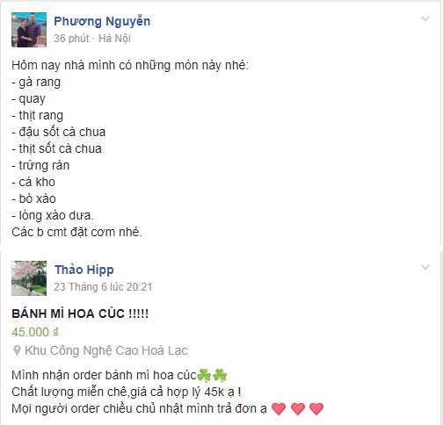

Figure 1‑1: User has to manually browse to find what they want

* + - 1. There is no Order System

Buyer has to barely comment in a post to place orders and wait for the seller to “Like” or reply those comments to know that the seller accepts or rejects their orders.

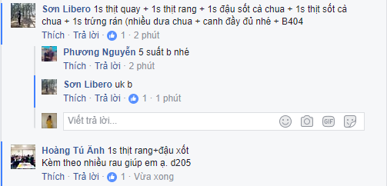

*Figure 1‑2: User has to comment to place order and wait for seller to like or reply*

* + - 1. There is no way to SUBSCRIBE CATEGORY

Buyers are usually interested in some type of categories, but in the group there is no such way for buyers to follow the categories they like. They can only look for what they want by skimming through lots of post in “ FU – Hòa Lạc” or by receiving all notifications from all posts in the group, which is really annoying, but not much information about product type for them except they know that there is a new post in the group.



*Figure 1‑3: User receives so many poor-info notifications*

* + 1. Problems from sellers
       1. There is no Efficient Post Creating System

Seller publishes information about what they sell in only one post like a Facebook normal status, which is usually a few lines of personal thought, not intended for selling activity. Seller has to write line by line in their post for easier reading. However, it is still really hard to catch up several information about product, price, sale off, … in just one Facebook normal post.

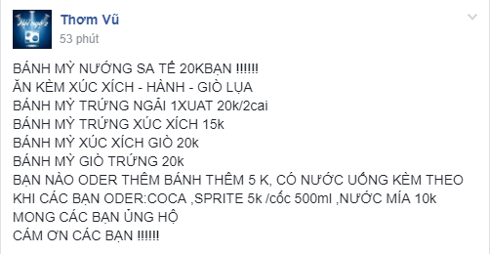

Figure 1‑4: All information in one Facebook normal post

* + - 1. There is no Order Management System

At the moment, sellers have to manage orders manually. When there is a new comment of ordering, they have to memorize it or note it into other tools. Because of this unorganized way of managing orders, sellers usually forget orders or even serve wrong buyers. In summary, they do not have a “built-in” Order Management System to help them manage status of orders: accepted, shipping, completed...



Figure 1‑5: Seller does not have order management system lead to forgetting buyer’s order

* + 1. Current buying process

The current buying process can be visualized as the below figure. This process causes many problems for both buyers and sellers:

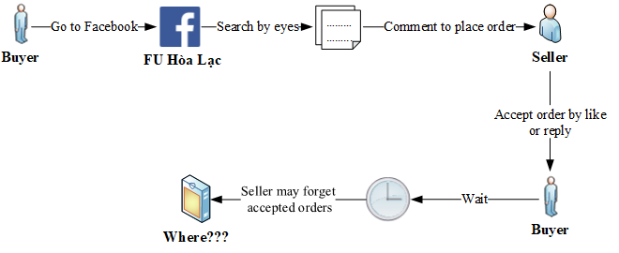

Figure 1‑6: The buying process on the Facebook Group “FU – Hòa Lạc”

From those studies, our group came up with an idea: to build a REAL-TIME E-COMMERCE SYSTEM that eliminates all problems of current “FU – Hòa Lạc” group and develop its strengths. Everyone in Vietnam will be able to participate in our system, where everything is updated in real-time accurately. We call it **“KajKai”**.

* 1. Proposal of system

After reviewing all properties of the current system as well as our target customer being everyone in Vietnam, we have come to a decision to choose which features and functions we will provide in our system.

* + 1. System functions
* Allow user to sign up a new KajKai account by email.
* Allow user to log in by registered account, by Gmail, or by Facebook.
* Allow user to search for user, store and sellpost by text and visual address on map.
* Allow user to subscribe to the categories they are interested in, in some specific geographic area.
* Allow user to like, follow feedback a store or a sellpost of store.
* Allow user to order product in each sellpost of store.
* Allow user to create a new store to sell their products.
* Allow user to interact in real time under each store sellpost or chat in private.
* Allow seller to have their own Store page to manage their store:
  + Edit basic information.
  + Create sellpost to sell their products.
  + Manage orders.
  + View some basic statistics.
  + View store photo.
* Allow user to receive notifications related to their activities and their subscribed topics.
* Allow admin to manage user and feedback.
  + 1. The ordering process system

Our project aims to develop “KajKai”, contribute to the growth of Vietnam market basing on “FU – Hòa Lạc” strengths and improve its weaknesses. This process can be visualized by the figure:

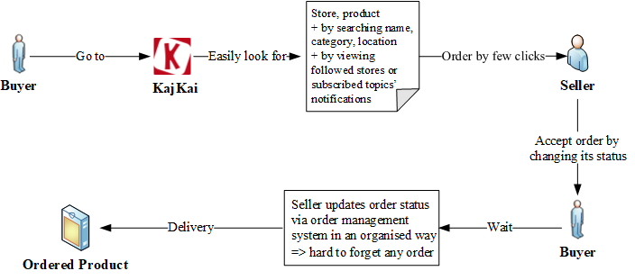

Figure 1‑7: The ordering process on KajKai

Users can now find store and product more easily with our search system. After buyers have ordered, sellers will immediately receive notifications for new incoming orders. Sellers are able to manage all orders in an organized way using order management system. Besides, buyers also receive notifications for their orders status. This way helps sellers avoid missing order and improve buyers’ satisfaction.

* + 1. The subscribing process system

The subscribing can be illustrated as the figure below:

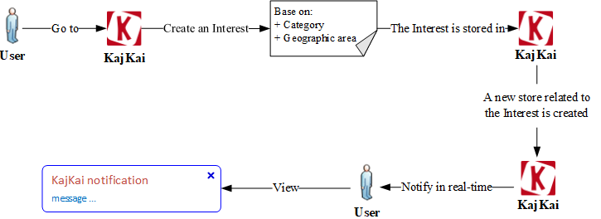

Figure 1‑8: The subscribing process on KajKai

Users now can subscribe exactly the categories they are interested in and in some specific area they like. When there is any store related to the areas and categories users subscribe, they will receive notifications in real-time.

* + 1. Out of scope functions

Because of the time limitation, we will not implement these following functions, although we are aware that they are also important to an e-commerce system:

* The system to collect user behaviors to suggest products for them.
* The payment system.

Finally, we use some new approaches to solve the stated problems. Having awareness of the importance of new technologies, we aim at applying them to our project.

* + 1. Special approaches
* For backend system:
  + Using microservice architecture and CQRS pattern.
  + Using Redis in-memory data structure store for caching and communicating between services.
  + Using real-time WebSocket technology with Socket.IO library.
  + Using Elasticsearch for searching.
  + Using Amazon web service for media storage, hosting and deployment.
* For frontend system:
  + Using ReactJS for web component rendering.
  + Using Redux for managing application state.

# : Project Plan

* 1. Project Organization
     1. Purpose

This chapter provides an overview of the project plan including project organization and project management plan.

* + 1. Software Process Model

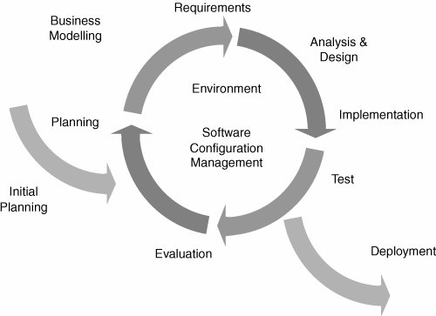

Figure 2‑1: Iterative and Incremental Software Process Model

KajKai project uses the Iterative and Incremental Software Process Model.

The Iterative and Incremental Software Process Model is mostly used when the scope of the project is big, the major requirements are defined clearly, some more details will be added later in software development. By using this software process model, we break down the developing system task into series of smaller tasks which will be completed separately, allowing us to take advantage of what was learned during development of earlier parts of the system. In addition, the iterative model is easier than other models when the issues are discovered. They are fed back to the team, and solutions will be found while the project is still in development.

* + 1. Roles and Responsibilities
       1. Organization Structure

|  |  |
| --- | --- |
| **Role** | **Responsibility** |
| Project Manager | Planning, developing schedules, coordinating communication, generally responsible for keeping the team’s focus on the main goal. |
| Technical Leader | Responsible for choosing and deciding what technologies should be used, as well as for overseeing the work being done by other developers. |
| Quality Assurance Manager | Ensuring the product meets the certain standards of quality from requirements. |
| Test Leader | Responsible for test execution, including test set-up and test run, evaluation of test run and error recovery, defect logging and test results recording. |
| Developer | Involve to code the product and review code of other developers. |
| Designer | Involve to design product’s user interface. |
| Tester | Involve to test the product. |
| Business Analyst | Analyzes an organization or business domain and documents its business or processes or systems. |

Table 2‑1: Project Structure

* + - 1. Project Team Member

|  |  |
| --- | --- |
| **Team Member** | **Role** |
| MinhTD | Project Manager, Business Analyst, Developer, Designer |
| DaiPH | Developer, Quality Assurance Manager, Tester |
| LongLH | Developer, Tester Leader, Designer |
| ThienNVT | Technical Leader, Developer, Tester |

Table 2‑2: Project Team Member

* + 1. Tools and Techniques

|  |  |
| --- | --- |
| **Programming languages** | NodeJS, JavaScript |
| **Framework** | ExpressJS, Socket.IO, Elasticsearch |
| **Software architecture** | Redux, Microservices |
| **IDEs/Editors** | Atom |
| **UML tools** | Microsoft Visio |
| **DBMS** | MongoDB |
| **Deployment server** | Amazon S3, Amazon EC2 |
| **Project management tool** | JIRA |
| **Process model** | Iterative and Incremental Software Process Model |
| **Development process** | Test-driven development, Behavior Driven Development |

Table ‑: Project Team Member

* 1. Project Management Plan
     1. Tasks

Refers to “KAJKAI_ProjectManagement.mpp” file.

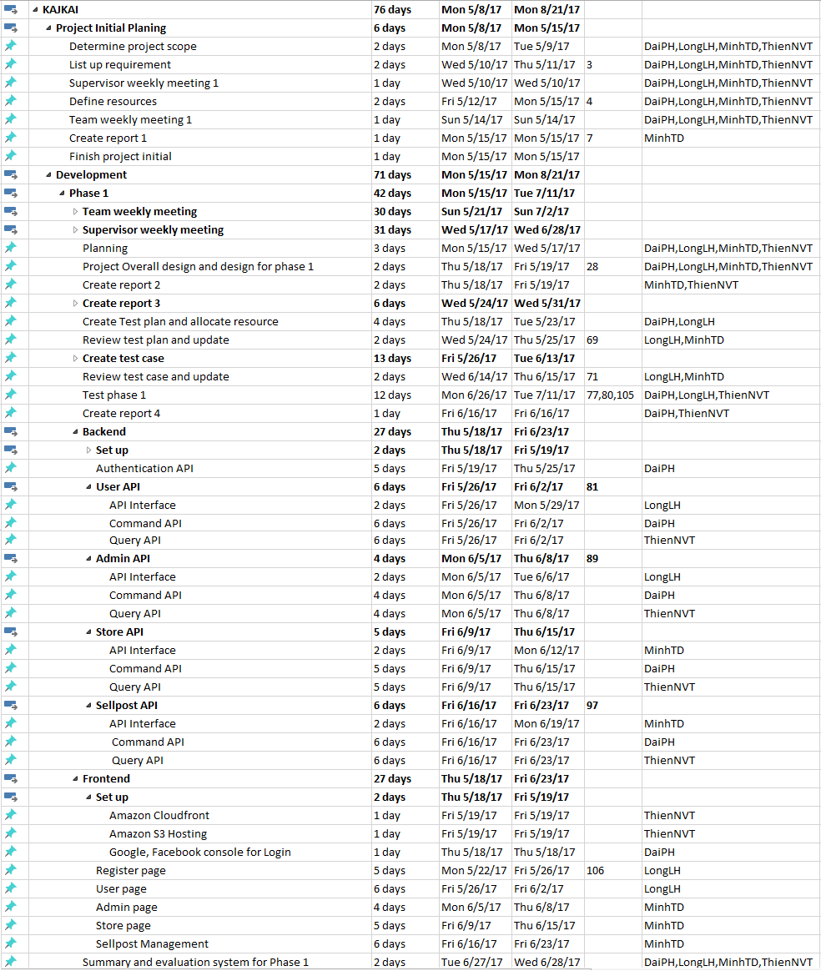

Figure 2‑2: KAJKAI Project Management file

* + 1. Meeting Minutes

All meeting minutes will be written following this template:

|  |  |  |  |  |  |
| --- | --- | --- | --- | --- | --- |
| ***Meeting/Project Name:*** | *KajKai* | | | | |
| ***Date of Meeting:*** | *28/05/2017* | | ***Time: (Type)*** | *1 hours (Face-to-face)* | |
| ***Meeting Called by:*** | *MinhTD* | | ***Location:*** | *FPT University‘s Library* | |
| ***Note Taker:*** | *LongLH* | | ***Time Keeper:*** | *MinhTD* | |
| 1. Meeting Objective | | | | | |
| 1. Assign new task for member 2. Do report No.2 | | | | | |
| 2. Attendance | | | | | |
| ***Name*** | ***Roles*** | ***E-mail*** | | | ***Phone*** |
| Tran Duc Minh | Project Manager | mintdse02995@fpt.edu.vn | | | 01655791021 |
| Pham Hoang Dai | Developer | daiphse61517@fpt.edu.vn | | | 01694767998 |
| Ly Hoang Long | Tester | longlhse03712@fpt.edu.vn | | | 0989810194 |
| Nguyen Van Tu Thien | Developer | thiennvtse90219@fpt.edu.vn | | | 01212529461 |
| 3. Done task | | | | | |
| 1. Build project structure 2. Configure git repository with security 3. Do report No.1 | | | | | |
| 4. New task | | | | | |
| 1. Backend    1. Setup environment    2. Code Authentication API       1. Signup API       2. Login by KajKai account       3. Login by Facebook       4. Login by Gmail 2. Frontend    1. Setup environment    2. Code Homepage    3. Code Signup/Login page 3. Do report No.2 | | | | | |
| 5. Risk & Difficulty | | | | | |
| N/A | | | | | |

Table 2‑4: Meeting Minutes Template

* + 1. Coding Conventions

We strictly follow Airbnb JavaScript Style Guide.

Please refer to **JavaScript Style Guide - Airbnb.pdf** file or the official website at <https://github.com/airbnb/javascript>

* + 1. Risk Management Plan

|  |  |  |  |  |  |
| --- | --- | --- | --- | --- | --- |
| **No** | **Name** | **Probability** | **Prevention** | **Correction** | **Impact** |
| R1 | **Internet interruptions** | Medium | All developers have to setup local developing environment and save offline copy of documentation also. | Always prepare backup plan to connect internet, such as 3G, 4G. | High |
| R2 | **Illness or absence of team members** | Low | Member has to notice to the team as soon as possible if member need to absence. | Make sure absence of a member will not impact on other member’s performance. Always plan time and resource to deal with this problem. | High |
| R3 | **Business problem** | Medium | Every ideas, comment need to meet reality and possibility | Make sure idea’s business logic is carefully analyzed. | High |
| R4 | **Requirement changed** | Low | Every new update of requirement has to be reviewed by all team members and supervisor. Team member has to analyze requirement carefully before raise up to team | If requirement has new update, all members have to join the meeting to aware and make decision | High |
| R5 | **Miscommunication** | Low | Everything must be documented. Every team member have to express clearly and carefully | Make sure any miscommunication has to be resolved. | High |
| R6 | **New technology** | Medium | Team member’s qualification must be defined before choose technology. Every member need to nurture by self-study. Always ready to share and support others | When someone chooses a new technology, he/she has to explain to all team members about the decision. | Medium |

Table 2‑5: Risk Management

* + 1. Communication Plan

*Weekly meeting schedule:* We use Iterative and Incremental Process Model, then we divide the system into two sub-systems (KajKai Backend and KajKai Frontend), each sub-system is divided into a series of small tasks. Each task is logged to JIRA then estimated depending on difficulty and the amount of work by the whole team, after that the task will be assigned to team members by the Team Leader and depending on difficulty the Technical Leader will assign deadlines for each task. We will have a meeting every Sunday to inform to all team about what each member finished last week, the status (fast, on time or slow), the issues met and how to solve them. If any member raises any issue, the whole team will help to find out a solution together. After that, the team will define detailed stories for next week tasks.

*Daily meeting schedule*: Each sub-system has one development team with different schedule. When starting work-day, each team will have a stand-up meeting to inform to others: “What did I do yesterday?”, “What will I do today?” and “Is there any difficulty?”. By focusing on what each person accomplished yesterday and will accomplish today, the team gains an excellent understanding of what has been done and what remains.

*Unscheduled meeting*: If someone has an important problem that he wants to solve immediately, we will have a meeting for discussion, usually via some online channel: Slack, Facebook or Phone.

*Communication channel*: Our main communication channel is [Slack](https://kajkai.slack.com),. On the other hand, we use face-to-face meeting, Facebook group and comment on JIRA issues. However, we sometimes make a phone call or instant message if someone has a problem.

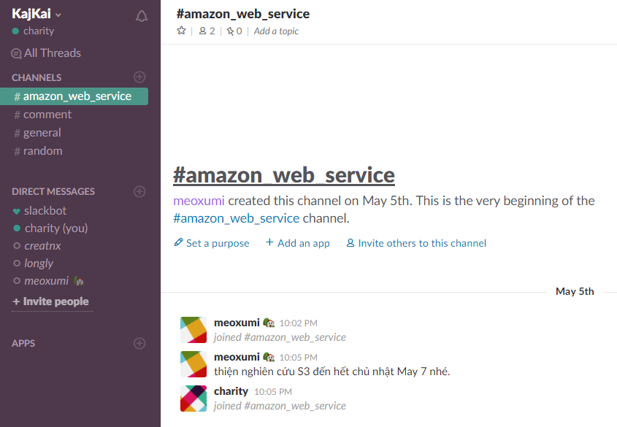

Figure 2‑3: Communication via Slack

# : Software Requirement Specification

* 1. Purpose

This chapter outlines functional and non-functional requirements of our website. It also provides some format constraints in common requirements and project success criteria. All members will work based on the information provided in this chapter.

* 1. Functional Requirements
     1. Use Case Diagram

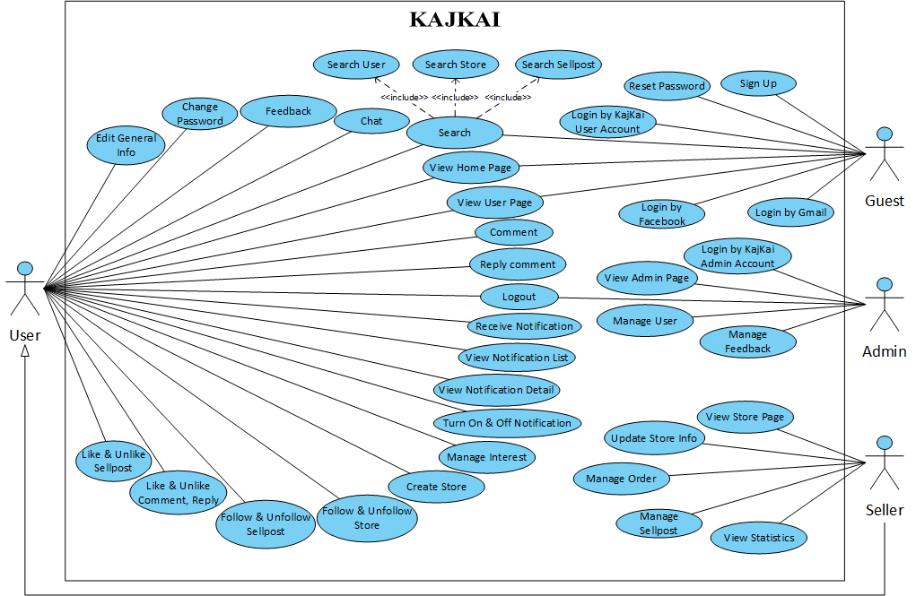

*Figure 3-1: Use case diagram of KAJKAI system*

* + 1. Business Rules

|  |  |
| --- | --- |
| **No** | **Description** |
| **B1** | The email must be valid. |
| **B2** | User’s name length must contain only letter and space, and there must be no two consecutive space characters. |
| **B3** | The password length must not be less than 6. |
| **B4** | Search result must be at most 5 items. |
| **B5** | Feedback content must not be empty. |
| **B6** | The email is registered in KajKai system |
| **B7** | Text length must be in range from 5 to 45 |
| **B8** | Gmail account is valid |
| **B9** | Facebook account is valid |
| **B10** | Message must not be blank |
| **B11** | Length of store name must be greater than 6 |
| **B12** | Length of store url name must be greater than 4 |
| **B13** | Store url name is allowed to contains alphabet only |
| **B14** | First category cannot be empty |
| **B15** | Secondary category cannot be empty |
| **B16** | Category in text cannot be empty |
| **B17** | Phone number must be valid |
| **B18** | Phone number must be confirmed |
| **B19** | Store position in map must not be empty |
| **B20** | Length of store address must be greater than 6 |
| **B21** | KajKai administration account must be valid |
| **B22** | Username must not be blank |
| **B23** | Password must not be blank |
| **B24** | Admin decision/reason must not be blank |
| **B25** | Phone number must be a numeric string only |
| **B26** | Length of search keyword must be smaller than 256 |

Table ‑: Business rules

* + 1. Use Cases

|  |  |
| --- | --- |
| **Actor** | **Description** |
| Guest | Everyone |
| User | Everyone who has a Gmail, Facebook or KajKai User Account |
| Seller | Seller is a user and owns at least one store at KajKai |
| Admin | A person who has the highest permission level and is responsible for managing the website |

Table ‑: Actor description

|  |  |  |
| --- | --- | --- |
| **ID** | **Actor** | **Name** |
| UC-1.0 | Guest | Sign up |
| UC-2.0 | Guest | Reset password |
| UC-3.0 | Guest | Login by KajKai user account |
| UC-4.0 | Guest | Login by Gmail |
| UC-5.0 | Guest | Login by Facebook |
| UC-6.0 | User | View Home page |
| UC-7.0 | User | View User page |
| UC-8.0 | User | Edit general info |
| UC-9.0 | User | Change password |
| UC-10.0 | User | Search user |
| UC-11.0 | User | Search store |
| UC-12.0 | User | Search sellpost |
| UC-13.0 | User | Chat |
| UC-14.0 | User | Comment |
| UC-15.0 | User | Reply comment |
| UC-16.0 | User | Like and unlike comment, reply |
| UC-17.0 | User | Like and unlike sellpost |
| UC-18.0 | User | Manage interest |
| UC-19.0 | User | Receive notification |
| UC-20.0 | User | View notification list |
| UC-21.0 | User | View notification detail |
| UC-22.0 | User | Turn on and off notification |
| UC-23.0 | User | Create store |
| UC-24.0 | User | Follow and unfollow store |
| UC-25.0 | User | Follow and unfollow sellpost |
| UC-26.0 | User | Feedback |
| UC-27.0 | User | Logout user |
| UC-28.0 | Seller | View Store page |
| UC-29.0 | Seller | Update Store Info |
| UC-30.0 | Seller | Manage sellpost |
| UC-31.0 | Seller | Manage order |
| UC-32.0 | Seller | View statistics |
| UC-33.0 | Admin | Login by KajKai admin account |
| UC-34.0 | Admin | View Admin page |
| UC-35.0 | Admin | Manage user |
| UC-36.0 | Admin | Manage feedback |
| UC-37.0 | Admin | Logout admin |

Table ‑: Use Case list

* + - 1. Guest

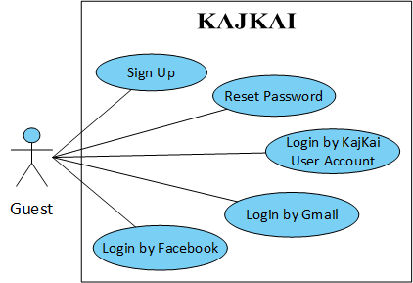

*Figure 3-2: Use case diagram of Guest actor*

* + - * 1. Sign up

*Use Case Specification*

|  |  |  |  |
| --- | --- | --- | --- |
| UC ID and Name: | **UC-1.0 Sign up** | | |
| Created by: | **ThienNVT** | Date Created: | **24/05/2017** |
| Primary Actor: | **Guest** | Secondary Actors: |  |
| Trigger: | N/A | | |
| Description: | Allow Guest who has an email can sign up a KajKai account | | |
| Preconditions: | **PRE-1.1.** Guest has an email account. | | |
| Post conditions: | **POST-1.1.** The guest is logged into KajKai successfully.  **POST-1.2.** System displays User page.  **POST-1.3.** System saves the new user data to database. | | |
| Normal Flow: | **1.0 Sign Up**   1. Guest visits website and click Login button in Navigation Bar. 2. System displays Register page. 3. User enters name, email and password, then clicks Create Account button. 4. System displays a message that asks the guest to check email and follow instruction. 5. The guest clicks on the link in email. 6. System displays User page. | | |
| Alternative Flows: | **1.0 Guest violates some business rule in step 3**   1. System displays help message under each input area. 2. Guest enters name, email and password complying the business rules, then clicks Create Account button. 3. Go to step 4 in normal flow. | | |
| Exceptions: | **1.0-E1 – Cannot communicate with server.**   1. KajKai displays error message. | | |
| Priority: | High | | |
| Frequency of Use: | High | | |
| Business Rules: | **B1, B2, B3, B7** | | |
| Other Information: |  | | |
| Assumptions: |  | | |

* + - * 1. Reset password

*Use Case Specification*

|  |  |  |  |
| --- | --- | --- | --- |
| UC ID and Name: | **UC-2.0 Reset password** | | |
| Created by: | **DaiPH** | Date Created: | **24/05/2017** |
| Primary Actor: | **Guest** | Secondary Actors: |  |
| Trigger: | N/A | | |
| Description: | Allow Guest to reset password | | |
| Preconditions: | **PRE-2.1**. Guest signs up successfully | | |
| Post conditions: | **POST-2.1**. New password is reset and sent to user via registered email | | |
| Normal Flow: | **2.0 Reset password**   1. Guest visits page 2. System displays Home page 3. In Bar navigation, guest clicks Login button 4. System displays Login page 5. Guest click Forgot password 6. System sends new password to guest’s email and displays message: “Your password has been reset. Please check new password in your registered email!” | | |
| Alternative Flows: | N/A | | |
| Exceptions: | **2.0-E1 – Cannot communicate with server.**   1. KajKai displays error message. | | |
| Priority: | Medium | | |
| Frequency of Use: | Low | | |
| Business Rules: | **B6** | | |
| Other Information: |  | | |
| Assumptions: |  | | |

* + - * 1. Login by KajKai account

*Use Case Specification*

|  |  |  |  |
| --- | --- | --- | --- |
| UC ID and Name: | **UC-3.0 Login by KajKai account** | | |
| Created by: | **DaiPH** | Date Created: | **24/05/2017** |
| Primary Actor: | **Guest** | Secondary Actors: |  |
| Trigger: | N/A | | |
| Description: | Allow Guest who has KajKai account login. | | |
| Preconditions: | **PRE-3.1**. Guest signup KajKai account successfully | | |
| Post conditions: | **POST-3.1**. The guest is logged into KajKai successfully.  **POST-3.2**. System displays User Page. | | |
| Normal Flow: | **3.0 Login by KajKai account**   1. Guest visits website and click Login button in Navigation Bar. 2. System displays Login page 3. Guest fills valid email and password then clicks Login 4. System displays User page | | |
| Alternative Flows: | N/A | | |
| Exceptions: | **3.0-E1 – Cannot communicate with server.**   1. KajKai displays error message. | | |
| Priority: | High | | |
| Frequency of Use: | Medium | | |
| Business Rules: | **B1, B2, B3, B7** | | |
| Other Information: |  | | |
| Assumptions: |  | | |

* + - * 1. Login by Gmail

*Use Case Specification*

|  |  |  |  |
| --- | --- | --- | --- |
| UC ID and Name: | **UC-4.0 Login by Gmail** | | |
| Created by: | **DaiPH** | Date Created: | **24/05/2017** |
| Primary Actor: | **Guest** | Secondary Actors: |  |
| Trigger: | N/A | | |
| Description: | Allow Guest who has a Gmail account can login | | |
| Preconditions: | **PRE-4.1**. Guest has a Gmail account. | | |
| Post conditions: | **POST-4.1**. The guest is logged into KajKai successfully.  **POST-4.2**. System displays User Page.  **POST-4.3**. System saves the new user data to database if this is the first time login by this Gmail. | | |
| Normal Flow: | **4.0 Login by Gmail**   1. Guest visits website and click Login button in Bar. 2. System displays Register Page. 3. Guest clicks on Google button 4. System displays home page for user | | |
| Alternative Flows: | **4.0 Guest does not have KajKai account with guest’s Gmail account**   1. System creates new account with guest’s Gmail account for user 2. Go to step 4 in normal flow. | | |
| Exceptions: | **4.0-E1 – Cannot communicate with server.**   1. KajKai displays error message. | | |
| Priority: | High | | |
| Frequency of Use: | Medium | | |
| Business Rules: | **B1, B8** | | |
| Other Information: |  | | |
| Assumptions: |  | | |

* + - * 1. Login by Facebook

*Use Case Specification*

|  |  |  |  |
| --- | --- | --- | --- |
| UC ID and Name: | **UC-5.0 Login by Facebook** | | |
| Created by: | **MinhTD** | Date Created: | **24/05/2017** |
| Primary Actor: | **Guest** | Secondary Actors: |  |
| Trigger: | N/A | | |
| Description: | Allow Guest who has a Facebook account can sign up a KajKai account | | |
| Preconditions: | **PRE-5.1**. Guest has a Facebook account. | | |
| Post conditions: | **POST-5.1**. The guest is logged into KajKai successfully.  **POST-5.2**. System displays User page.  **POST-5.3**. System saves the new user data to database. | | |
| Normal Flow: | **5.0 Login by Facebook**   1. Guest visits website and click Login button in Navigation Bar. 2. System displays Register Page. 3. Guest clicks on Facebook button 4. System displays home page for user | | |
| Alternative Flows: | **5.0 Guest does not have KajKai account with guest’s Facebook account**   1. System creates new account with guest’s Facebook account for user 2. Go to step 4 in normal flow. | | |
| Exceptions: | **5.0-E1 – Cannot communicate with server.**   1. KajKai displays error message. | | |
| Priority: | High | | |
| Frequency of Use: | Medium | | |
| Business Rules: | **B1, B9** | | |
| Other Information: |  | | |
| Assumptions: |  | | |

* + - 1. User

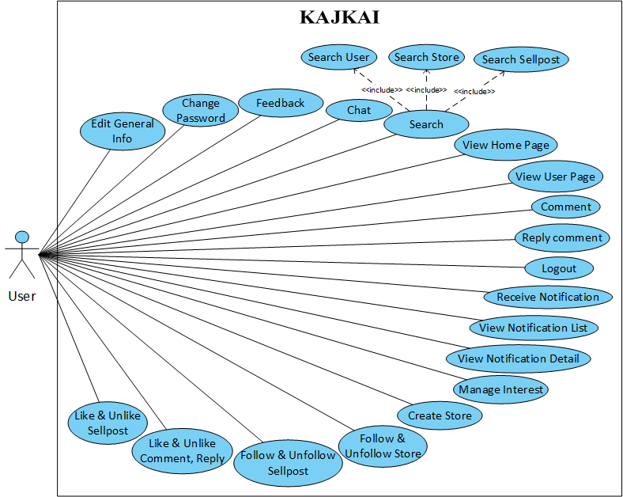

*Figure 3-3: Use case diagram of User actor*

* + - * 1. View Home page

*Use Case Specification*

|  |  |  |  |
| --- | --- | --- | --- |
| UC ID and Name: | **UC-6.0 View Home page** | | |
| Created by: | **MinhTD** | Date Created: | **26/05/2017** |
| Primary Actor: | **User** | Secondary Actors: | **Guest, Seller** |
| Trigger: | N/A | | |
| Description: | Allow every actor to view Home page | | |
| Preconditions: | **PRE-6.1.** User logins successfully | | |
| Post conditions: | **POST-6.1.** System displays home page. | | |
| Normal Flow: | **6.0 View home page.**   1. Guest clicks KajKai icon in Navigation Bar 2. System displays Home page | | |
| Alternative Flows: | N/A | | |
| Exceptions: | **6.0-E1 – Cannot communicate with server.**   1. KajKai displays error message. | | |
| Priority: | Medium | | |
| Frequency of Use: | High | | |
| Business Rules: |  | | |
| Other Information: |  | | |
| Assumptions: |  | | |

* + - * 1. View User page

*Use Case Specification*

|  |  |  |  |
| --- | --- | --- | --- |
| UC ID and Name: | **UC-7.0 View User page** | | |
| Created by: | **ThienNVT** | Date Created: | **26/05/2017** |
| Primary Actor: | **User** | Secondary Actors: | **Guest, Seller** |
| Trigger: | N/A | | |
| Description: | Allow every actor to view User page | | |
| Preconditions: | **PRE-7.1.** User logins successfully | | |
| Post conditions: | **POST-7.1.** System displays User page | | |
| Normal Flow: | **7.0 View User page**   1. Guest visits website. 2. System displays User page. | | |
| Alternative Flows: | N/A | | |
| Exceptions: | **7.0-E1 – Cannot communicate with server.**   1. KajKai displays error message. | | |
| Priority: | Low | | |
| Frequency of Use: | Low | | |
| Business Rules: |  | | |
| Other Information: |  | | |
| Assumptions: |  | | |

* + - * 1. Edit general info

*Use Case Specification*

|  |  |  |  |
| --- | --- | --- | --- |
| UC ID and Name: | **UC-8.0 Edit general info** | | |
| Created by: | **LongLH** | Date Created: | **26/05/2017** |
| Primary Actor: | **User** | Secondary Actors: | Seller |
| Trigger: | N/A | | |
| Description: | Allow User to edit general information | | |
| Preconditions: | **PRE-8.1.** User is not banned.  **PRE-8.2.** User logins successfully. | | |
| Post conditions: | **POST-8.1.** New user profile is saved into database.  **POST-8.2.** New updated profile is displayed in user page. | | |
| Normal Flow: | **8.0 View setting**   1. On Navigation Bar, user clicks on avatar icon. 2. System displays User page with following tab:    * + Interest      + About      + Setting 3. User clicks Setting tab. 4. System displays user’s Setting tab.   **8.1 Edit general information**   1. In setting tab, user clicks Edit button. 2. System allows user to edit profile information. 3. User changes needed information then clicks Save button. 4. System saves new data into database then displays updated profile information. | | |
| Alternative Flows: | N/A | | |
| Exceptions: | **8.0-E1 – Cannot communicate with server.**   1. KajKai displays error message. | | |
| Priority: | Medium | | |
| Frequency of Use: | Low | | |
| Business Rules: | **B2, B7** | | |
| Other Information: |  | | |
| Assumptions: |  | | |

* + - * 1. Change password

*Use Case Specification*

|  |  |  |  |
| --- | --- | --- | --- |
| UC ID and Name: | **UC-9.0 Change password** | | |
| Created by: | **DaiPH** | Date Created: | **26/05/2017** |
| Primary Actor: | **User** | Secondary Actors: | Seller |
| Trigger: | N/A | | |
| Description: | Allow User to change password | | |
| Preconditions: | **PRE-9.1.** User is not banned.  **PRE-9.2.** User logins successfully. | | |
| Post conditions: | **POST-9.1.** New password is saved into database  **POST-9.2.** User logins successfully with new password | | |
| Normal Flow: | **9.0 View setting**   1. On Navigation Bar, user clicks on avatar icon 2. System displays User page with following tab    * + Interest      + About      + Setting 3. User clicks Setting tab 4. System displays user’s Setting tab   **9.1 Change password**   1. In setting tab, user clicks Edit button 2. System allows user to change password 3. User changes password then clicks Save button 4. System saves new password | | |
| Alternative Flows: | N/A | | |
| Exceptions: | **9.0-E1 – Cannot communicate with server.**   1. KajKai displays error message. | | |
| Priority: | Low | | |
| Frequency of Use: | Low | | |
| Business Rules: | **B3** | | |
| Other Information: |  | | |
| Assumptions: |  | | |

* + - * 1. Search user

*Use Case Specification*

|  |  |  |  |
| --- | --- | --- | --- |
| UC ID and Name: | **UC-10.0 Search user** | | |
| Created by: | **DaiPH** | Date Created: | **26/05/2017** |
| Primary Actor: | **User** | Secondary Actors: |  |
| Trigger: | N/A | | |
| Description: | Allow User to find others by user name | | |
| Preconditions: | N/A | | |
| Post conditions: | N/A | | |
| Normal Flow: | **10.0 Search user by name**   1. User clicks on drop down button on Search Bar 2. System displays search options as drop down list 3. User clicks on User 4. User enters keyword to search on Search Bar 5. User clicks on search button on Search Bar or press enter 6. System displays search result | | |
| Alternative Flows: | N/A | | |
| Exceptions: | **10.0-E1 – Cannot communicate with server.**   1. KajKai displays error message. | | |
| Priority: | High | | |
| Frequency of Use: | Medium | | |
| Business Rules: | **B4, B26** | | |
| Other Information: |  | | |
| Assumptions: |  | | |

* + - * 1. Search store

*Use Case Specification*

|  |  |  |  |
| --- | --- | --- | --- |
| UC ID and Name: | **UC-11.0 Search store** | | |
| Created by: | **DaiPH** | Date Created: | **26/05/2017** |
| Primary Actor: | **User** | Secondary Actors: |  |
| Trigger: | N/A | | |
| Description: | Allow User to find a particular store by store’s name or category | | |
| Preconditions: | **N/A** | | |
| Post conditions: | **N/A** | | |
| Normal Flow: | **11.0 Search store**   1. User clicks on drop down button on Search Bar 2. System displays search options as drop down list 3. User clicks on Store 4. User enters keyword to search on Search Bar 5. User clicks on search button on Search Bar or press enter 6. System displays search results | | |
| Alternative Flows: | N/A | | |
| Exceptions: | **11.0-E1 – Cannot communicate with server.**   1. KajKai displays error message. | | |
| Priority: | High | | |
| Frequency of Use: | Medium | | |
| Business Rules: | **B4, B26** | | |
| Other Information: |  | | |
| Assumptions: |  | | |

* + - * 1. Search sellpost

*Use Case Specification*

|  |  |  |  |
| --- | --- | --- | --- |
| UC ID and Name: | **UC-12.0 Search sellpost** | | |
| Created by: | **ThienNVT** | Date Created: | **26/05/2017** |
| Primary Actor: | **User** | Secondary Actors: | Seller, Guest |
| Trigger: | N/A | | |
| Description: | Allow User to search sellpost by category, sellpost information, location | | |
| Preconditions: | **PRE-12.1.** User logins successfully. | | |
| Post conditions: | **POST-12.1.** System displays searched sellpost by category, sellpost information, location | | |
| Normal Flow: | **12.0 Search sellpost**   1. On Navigation Bar, user clicks category dropdown button. 2. System displays category list in dropdown list. 3. User selects a specific category. 4. System hided category list and displays selected category. 5. User fills a keyword in search bar and fills location in location search bar. 6. User clicks Search button. 7. System displays sellpost list that related to search keyword and selected category. | | |
| Alternative Flows: | **12.0 Search sellpost**   1. User is allowed to search without filling location. | | |
| Exceptions: | **12.0-E1 – Cannot communicate with server.**   1. KajKai displays error message. | | |
| Priority: | High | | |
| Frequency of Use: | High | | |
| Business Rules: | **B4, B26** | | |
| Other Information: |  | | |
| Assumptions: |  | | |

* + - * 1. Chat

*Use Case Specification*

Create chat

|  |  |  |  |
| --- | --- | --- | --- |
| UC ID and Name: | **UC-13.0 Create chat** | | |
| Created by: | **LongLH** | Date Created: | **26/05/2017** |
| Primary Actor: | User | Secondary Actors: | Seller |
| Trigger: | N/A | | |
| Description: | Allow User to create new chat (group chat) | | |
| Preconditions: | **PRE-13.0.1**. User logins successfully. | | |
| Post conditions: | **POST-13.0.1**. New chat box is displayed and ready to chat. | | |
| Normal Flow: | **13.0.0 Create new chat**   1. On Navigation Bar, click message icon 2. System displays chat history 3. Click “New message” button 4. System displays a chat box with blank information 5. On search bar, type a username then press enter 6. System displays a corresponding user 7. Select needed user 8. Click on ‘Done’ button 9. Chat box updates conversation’s member info | | |
| Alternative Flows: | **13.0.0 Create new chat**   1. User is allowed to create chat with more than one user 2. Repeat step 5, step 6 and step 7 for searching and adding more member | | |
| Exceptions: | **13.0-E1 – Cannot communicate with server.**   1. KajKai displays error message. | | |
| Priority: | Medium | | |
| Frequency of Use: | Medium | | |
| Business Rules: | **B7** | | |
| Other Information: |  | | |
| Assumptions: |  | | |

Add member into conversation (chat)

|  |  |  |  |
| --- | --- | --- | --- |
| UC ID and Name: | **UC-13.1 Create chat in KajKai messenger** | | |
| Created by: | **LongLH** | Date Created: | **26/05/2017** |
| Primary Actor: | User | Secondary Actors: | Seller |
| Trigger: | N/A | | |
| Description: | Allow User to add member into a conversation (chat) | | |
| Preconditions: | **PRE-13.1.1** User logins successfully  **PRE-13.1.2**. User has chat history | | |
| Post conditions: | **POST-13.1.1**. New chat box is displayed with updated members | | |
| Normal Flow: | **13.1.0 Select conversation that User wants to add member**   1. On Navigation Bar, click message icon 2. System displays chat history 3. Select conversation that user wants to add members 4. System displays corresponding chat bõ   **13.1.1 Add members**   1. Click on plus icon on top of chat box 2. System displays a search bar 3. Type username that user wants to add to this conversation 4. System displays user search data 5. Select needed user 6. Click on [Done] button 7. System displays new chat box with updated members | | |
| Alternative Flows: | **13.1.1 Add many members**   1. User is allowed to add more than one member into conversation 2. Repeat step 3, step 4 and step 5 in selection 2.0 for searching and adding more member | | |
| Exceptions: | **13.1-E1 – Cannot communicate with server.**   1. KajKai displays error message   **13.1-E2 – Cannot search user**   1. Searching user is failed. Chat box displays “Not found” message | | |
| Priority: | Medium | | |
| Frequency of Use: | Medium | | |
| Business Rules: |  | | |
| Other Information: |  | | |
| Assumptions: |  | | |

Send message

|  |  |  |  |
| --- | --- | --- | --- |
| UC ID and Name: | **UC-13.3 Send message** | | |
| Created by: | **LongLH** | Date Created: | **26/05/2017** |
| Primary Actor: | User | Secondary Actors: | Seller |
| Trigger: | N/A | | |
| Description: | Allow User to send message | | |
| Preconditions: | **PRE-13.3.1**. User logins successfully  **PRE-13.3.2**. User has chat history or create new chat (group chat) successfully | | |
| Post conditions: | **POST-13.3.1** System appends new message in chat box | | |
| Normal Flow: | **13.3.0 Select conversation that User wants to send message**   1. On Navigation Bar, click messenger icon 2. System displays chat history 3. Select conversation that user wants to send message 4. System displays corresponding conversation   **13.3.1**  **Send message**   1. Type message 2. Press Enter 3. System appends new message in chat box | | |
| Alternative Flows: | **13.3.1**  **Send image**   1. On the page top bar, click messenger icon 2. System displays a modal 3. Click “Select file” 4. System displays file chooser 5. Double click on an image 6. System displays selected image on modal 7. Click “Send” button 8. System displays new image in chat box   **13.3.1**  **Send Icon**   1. On the page top bar, click messenger icon 2. System display a dropdown list 3. Select icon 4. System displays new icon | | |
| Exceptions: | **13.3-E1 –** **Cannot communicate with server.**   1. KajKai displays error message. | | |
| Priority: | Medium | | |
| Frequency of Use: | Medium | | |
| Business Rules: | **B10** | | |
| Other Information: |  | | |
| Assumptions: |  | | |

* + - * 1. Comment

*User Case Specification*

|  |  |  |  |
| --- | --- | --- | --- |
| UC ID and Name: | **UC-14.0 Comment** | | |
| Created by: | **MinhTD** | Date Created: | **30/05/2017** |
| Primary Actor: | **User** | Secondary Actors: | Seller |
| Trigger: | N/A | | |
| Description: | Allow User to comment or order under sellpost | | |
| Preconditions: | **PRE-14.1.** Logged in to KajKai  **PRE-14.2.** Visited a sellpost on home page, store page | | |
| Post conditions: | **POST-14.1.** Comment successfully  **POST-14.2.** System stores comment to database.  **POST-14.3.** Send notifications to other related users. | | |
| Normal Flow: | **14.0 Comment**   1. User clicks ‘(+)’ on sellpost to add product to order. 2. System adds a product to order in comment’s input. 3. User clicks ‘(-)’ in comment’s input to decrease product. 4. System removes the product. 5. User types the editional content and ‘Enter’. 6. System displays this comment to current sellpost. | | |
| Alternative Flows: | N/A | | |
| Exceptions: | **14.0-E1 – Cannot communicate with server.**   1. KajKai display error message | | |
| Priority: | High | | |
| Frequency of Use: | High | | |
| Business Rules: | **B10** | | |
| Other Information: |  | | |
| Assumptions: |  | | |

* + - * 1. Reply comment

*Use Case Specification*

|  |  |  |  |
| --- | --- | --- | --- |
| UC ID and Name: | **UC-15.0 Reply comment** | | |
| Created by: | **MinhTD** | Date Created: | **08/06/2017** |
| Primary Actor: | **User** | Secondary Actors: | Seller |
| Trigger: | N/A | | |
| Description: | Allow User to reply a comment | | |
| Preconditions: | **PRE-15.1.** Login successfully.  **PRE-15.2.** Open an existed store or create new store successfully  **PRE-15.3.** Open an existed sellpost or create new sellpost successfully | | |
| Post conditions: | **POST-15.1.** Reply a comment successfully.  **POST-15.2.** System saves new reply comment to database.  **POST-15.3.** System sends notifications to post’s follower. | | |
| Normal Flow: | **15.0 Open a sellpost**   1. Open an existed sellpost or create new sellpost successfully 2. System displays sellpost with comment list below   **15.1 Reply a comment**   1. User clicks Reply button below the comment 2. System adds a comment input below the comment 3. User replies then press Enter 4. System appends new comment below the replied comment with smaller avatar and deeper left alignment. Notification would be sent to post’s follower | | |
| Alternative Flows: | **15.0 Open a sellpost**   1. User could open a sellpost in many difference ways    * + Create new store then create new sellpost      + Open an exited store and an existed sellpost also      + Follow a sellpost then open it in user’s page | | |
| Exceptions: | **15.0-E1 – Cannot communicate with server.**   1. KajKai displays error message. | | |
| Priority: | High | | |
| Frequency of Use: | High | | |
| Business Rules: | **B10** | | |
| Other Information: |  | | |
| Assumptions: |  | | |

* + - * 1. Like and unlike comment, reply, order

*Use Case Specification*

|  |  |  |  |
| --- | --- | --- | --- |
| UC ID and Name: | **UC-16.0 Like and unlike comment, reply, order** | | |
| Created by: | **MinhTD** | Date Created: | **08/06/2017** |
| Primary Actor: | **User** | Secondary Actors: | Seller |
| Trigger: | N/A | | |
| Description: | Allow User to like/unlike a comment/reply | | |
| Preconditions: | **PRE-16.1.** Login successfully.  **PRE-16.2.** Open an existed store or create new store successfully  **PRE-16.3.** Open an existed sellpost or create new sellpost successfully | | |
| Post conditions: | **POST-16.1.** Like/Unlike a comment successfully.  **POST-16.2.** System increases number of like and displays actor’s name if actor likes a sellpost  **POST-16.2.** System decreases number of like and removes actor’s name if actor unlikes a sellpost  **POST-16.3.** System sends notifications to post’s follower if actor like the sellpost  **POST-16.3.** System does not send notifications to post’s follower if actor unlike the sellpost | | |
| Normal Flow: | **16.0 Open a sellpost**   1. Open an existed sellpost or create new sellpost successfully 2. System displays sellpost with comment list below   **16.1 Like a comment**   1. User clicks Like button on a comment 2. System processes below tasks:    * + Like button of actor is highlighted      + Increase like number of the comment      + Display actor’s name in like list      + Send notification to post’s owner and follower also   **16.2 Unike a comment**   1. User clicks on Like button on this comment again 2. System processes below tasks:    * + Like button of actor is not highlighted      + Decrease like number of the comment      + Removes actor’s name in like list      + Does not send notification to post’s owner and follower also | | |
| Alternative Flows: | **16.0 Open a sellpost**   1. User could open a sellpost in many diffrence ways    * + Create new store then create new sellpost      + Open an exited store and an existed sellpost also      + Follow a sellpost then open it in user’s page   **16.1 Like a reply comment/order**   * + - User is allowed to like a reply comment and an order also   **16.2 Unlike a reply comment/order**   * + - User is allowed to unlike a reply comment and an order also | | |
| Exceptions: | **16.0-E1 – Cannot communicate with server.**   1. KajKai displays error message. | | |
| Priority: | High | | |
| Frequency of Use: | High | | |
| Business Rules: |  | | |
| Other Information: |  | | |
| Assumptions: |  | | |

* + - * 1. Like and unlike sellpost

*Use Case Specification*

|  |  |  |  |
| --- | --- | --- | --- |
| UC ID and Name: | **UC-17.0 Like and unlike sellpost** | | |
| Created by: | **MinhTD** | Date Created: | **08/06/2017** |
| Primary Actor: | **User** | Secondary Actors: | Seller |
| Trigger: | N/A | | |
| Description: | Allow User to like, unlike a comment/reply | | |
| Preconditions: | **PRE-17.1.** Login successfully.  **PRE-17.2.** Open an existed store or create new store successfully  **PRE-17.3.** Open an existed sellpost or create new sellpost successfully | | |
| Post conditions: | **POST-17.1.** Like/Unlike a sellpost successfully.  **POST-17.2.** System increases number of like and displays actor’s name if actor likes a sellpost  **POST-17.3.** System decreases number of like and removes actor’s name if actor unlikes a sellpost  **POST-17.4.** System sends notifications to post’s follower if actor like the sellpost  **POST-17.5.** System does not send notifications to post’s follower if actor unlike the sellpost | | |
| Normal Flow: | **17.0 Open a sellpost**   1. Open an existed sellpost or create new sellpost successfully 2. System displays sellpost with comment list below   **17.1 Like a sellpost**   1. User clicks Like button on a sellpost 2. System processes below tasks:    * + Like button of actor is highlighted      + Increase like number of the sellpost      + Display actor’s name in like list      + Send notification to post’s owner and follower also   **17.2 Unlike a sellpost**   1. User clicks on Like button on this sellpost again 2. System processes below tasks:    * + Like button of actor is not highlighted      + Decrease like number of the sellpost      + Remove actor’s name in like list      + Does not send notification to post’s owner and follower also | | |
| Alternative Flows: | **17.0 Open a sellpost**   1. User could open a sellpost in many diffrence ways    * + Create new store then create new sellpost      + Open an exited store and an existed sellpost also      + Follow a sellpost then open it in user’s page | | |
| Exceptions: | **17.0-E1 – Cannot communicate with server.**   1. KajKai displays error message. | | |
| Priority: | High | | |
| Frequency of Use: | High | | |
| Business Rules: |  | | |
| Other Information: |  | | |
| Assumptions: |  | | |

* + - * 1. Manage interest

*Use Case Specification*

|  |  |  |  |
| --- | --- | --- | --- |
| UC ID and Name: | **UC-18.0 Manage interest** | | |
| Created by: | **ThienNVT** | Date Created: | **08/06/2017** |
| Primary Actor: | **User** | Secondary Actors: | Seller |
| Trigger: | N/A | | |
| Description: | User is allowed to manage interest | | |
| Preconditions: | **PRE-18.1.** Login successfully. | | |
| Post conditions: | **POST-18.1.** New interest is created | | |
| Normal Flow: | **18.0 Create interest**   1. In left panel, user clicks “Create interest” 2. System displays a panel 3. Select interest category 4. Select location 5. Click Done 6. System creates interest successfully   **18.1 Delete interest**   1. In left panel, user clicks delete button on the interest 2. System deletes selected interest succesfully | | |
| Alternative Flows: | N/A | | |
| Exceptions: | **18.0-E1 – Cannot communicate with server.**   1. KajKai displays error message. | | |
| Priority: | Medium | | |
| Frequency of Use: | Medium | | |
| Business Rules: |  | | |
| Other Information: |  | | |
| Assumptions: |  | | |

* + - * 1. Receive notification

*Use Case Specification*

|  |  |  |  |
| --- | --- | --- | --- |
| UC ID and Name: | **UC-19.0 Receive notification** | | |
| Created by: | **ThienNVT** | Date Created: | **08/06/2017** |
| Primary Actor: | **User** | Secondary Actors: | Seller |
| Trigger: | A store, a sellpost, a comment, a reply, a like, an order receiving action from seller, which is related to User, is created. | | |
| Description: | Allow User to receive notification | | |
| Preconditions: | **PRE-19.1.** Login successfully.  **PRE-19.2.** Open an existed store or create new store successfully  **PRE-19.3.** Open an existed sellpost or create new sellpost successfully | | |
| Post conditions: | **POST-19.1.** User receives notification | | |
| Normal Flow: | **19.0 New store that in User’s interest is created**   1. User creates interest 2. Seller creates store that in User’s interest 3. User receives notification   **19.1 Sellpost in store that User is following is created or edited**   1. User follows store 2. Seller creates or edits a sellpost 3. User receives notification   **19.2 An order is made**   1. User makes an order below the sellpost 2. Seller receives notification that user has made an order on the sellpost   **19.3 A sellpost is liked**   1. User likes a sellpost 2. Seller receives notification that user liked a sellpost   **19.4 New comment on a sellpost is created**   1. User comments below the sellpost 2. Seller and the sellpost’s followers receive notification   **19.5 A comment is replied**   1. User replies a comment below the sellpost 2. Comment owner and the sellpost’s followers receive notification   **19.6 A comment is liked**   1. User like a comment 2. Comment owner and the sellpost’s followers receive notification   **19.7 An order is received**   1. Seller receives order from User 2. User receives notification that seller has received an order   **19.8 An order is marked as Done**   1. Seller receive order from User 2. User receives notification that seller has received an order | | |
| Alternative Flows: | N/A | | |
| Exceptions: | **19.0-E1 – Cannot communicate with server.**   1. KajKai displays error message. | | |
| Priority: | High | | |
| Frequency of Use: | High | | |
| Business Rules: |  | | |
| Other Information: |  | | |
| Assumptions: |  | | |

* + - * 1. View notification list

*Use Case Specification*

|  |  |  |  |
| --- | --- | --- | --- |
| UC ID and Name: | **UC-20.0 View notification list** | | |
| Created by: | **ThienNVT** | Date Created: | **08/06/2017** |
| Primary Actor: | **User** | Secondary Actors: | Seller |
| Trigger: | N/A | | |
| Description: | Allow User to view notification list | | |
| Preconditions: | **PRE-20.1.** User logins successfully  **PRE-20.2.** User has action history | | |
| Post conditions: | **POST-20.1.** System displays notification list | | |
| Normal Flow: | **20.0 View notification list**   1. On Navigation Bar, User clicks notification icon 2. System displays notification list | | |
| Alternative Flows: | N/A | | |
| Exceptions: | **20.0-E1 – Cannot communicate with server.**   1. KajKai displays error message. | | |
| Priority: | High | | |
| Frequency of Use: | High | | |
| Business Rules: |  | | |
| Other Information: |  | | |
| Assumptions: |  | | |

* + - * 1. View notification detail

*Use Case Specification*

|  |  |  |  |
| --- | --- | --- | --- |
| UC ID and Name: | **UC-21.0 View notification detail** | | |
| Created by: | **ThienNVT** | Date Created: | **31/05/2017** |
| Primary Actor: | **User** | Secondary Actors: |  |
| Trigger: | N/A | | |
| Description: | Allow User to view notification details | | |
| Preconditions: | **PRE-21.1.** User logins successfully  **PRE-21.2.** User has action history | | |
| Post conditions: | **POST-21.1.** System displays notification details | | |
| Normal Flow: | **21.0 View notification details**   1. User clicks a specific notification 2. System displays notification details | | |
| Alternative Flows: | N/A | | |
| Exceptions: | **21.0-E1 – Cannot communicate with server.**   1. KajKai displays error message. | | |
| Priority: | High | | |
| Frequency of Use: | High | | |
| Business Rules: |  | | |
| Other Information: |  | | |
| Assumptions: |  | | |

* + - * 1. Turn on and off notification

*Use Case Specification*

|  |  |  |  |
| --- | --- | --- | --- |
| UC ID and Name: | **UC-22.0 Turn on and off notification** | | |
| Created by: | **MinhTD** | Date Created: | **08/06/2017** |
| Primary Actor: | **User** | Secondary Actors: |  |
| Trigger: | N/A | | |
| Description: | Allow User to turn on/off notification of a sellpost | | |
| Preconditions: | **PRE-22.1.** User logins successfully  **PRE-22.2.** An existed store has at least one sellpost | | |
| Post conditions: | **POST-22.1.** System turns notification on/off corresponding with user request | | |
| Normal Flow: | **22.0 Open an existed store**   1. User opens an existed store 2. System displays store 3. User scrolls down to a sellpost that wants to follow 4. System displays sellpost   **22.0 Turn on notification**   1. In this sellpost, user clicks options icon 2. System displays options in dropdown list 3. User selects “Turn on notification” 4. Whenever the sellpost has updated, user will receive a notification   **22.0 Turn off notification**   1. In this sellpost, user clicks options icon 2. System displays options in dropdown list 3. User selects “Turn off notification” 4. Whenever the sellpost has updated, user will not receive a notification | | |
| Alternative Flows: | N/A | | |
| Exceptions: | **22.0-E1 – Cannot communicate with server.**   1. KajKai displays error message. | | |
| Priority: | Low | | |
| Frequency of Use: | Low | | |
| Business Rules: |  | | |
| Other Information: |  | | |
| Assumptions: |  | | |

* + - * 1. Create store

*Use Case Specification*

|  |  |  |  |
| --- | --- | --- | --- |
| UC ID and Name: | **UC-23.0 Create store** | | |
| Created by: | **DaiPH** | Date Created: | **08/06/2017** |
| Primary Actor: | **User** | Secondary Actors: | Seller |
| Trigger: | N/A | | |
| Description: | Allow User to create new store | | |
| Preconditions: | **PRE-23.1.** User logins successfully | | |
| Post conditions: | **POST-23.1.** System saves new store information  **POST-23.1.** System displays new store | | |
| Normal Flow: | **23.0 View Store Register page**   1. On Navigation Bar, user clicks option icon next by avatar then choose “Create a new store” 2. System displays create a store page   **23.1 Create store**   1. On Navigation Bar, user clicks option icon next by avatar then choose “Create a new store” 2. System displays create a store page 3. User fills valid information then clicks “Create a new store” button 4. System saves and displays new store. No error message is displayed | | |
| Alternative Flows: | **23.1 View create a store page**   1. There are difference ways to view store creation page    * + On Navigation Bar, user select “Create a new store” option      + On the left panel, user select “Create a new store” option   **23.1 Create store**   1. In step 4, data validation could be failed then error message should be displayed | | |
| Exceptions: | **23.0-E1 – Cannot communicate with server.**   1. KajKai displays error message. | | |
| Priority: | Medium | | |
| Frequency of Use: | Medium | | |
| Business Rules: | **B11, B12, B13, B14, B15, B16, B17, B18, B19, B20, B25** | | |
| Other Information: |  | | |
| Assumptions: |  | | |

* + - * 1. Follow and unfollow store

*Use Case Specification*

|  |  |  |  |
| --- | --- | --- | --- |
| UC ID and Name: | **UC-24.0 Follow and unfollow store** | | |
| Created by: | **LongLH** | Date Created: | **08/06/2017** |
| Primary Actor: | **User** | Secondary Actors: | Seller |
| Trigger: | N/A | | |
| Description: | Allow User to follow/unfollow a store | | |
| Preconditions: | **PRE-24.1.** Login successfully.  **PRE-24.2.** Open an existed store. | | |
| Post conditions: | **POST-23.1.** User follows store successfully  **POST-23.2.** User unfollows store successfully | | |
| Normal Flow: | **24.0 Open a store**   1. Open an existed store. 2. System displays corresponding store.   **24.1 Follow store**   1. In store’s left panel, user clicks Follow button 2. User followed the store successfully. Follow button is highlighted   **24.2 Unfollow store**   1. In store’s left panel, user clicks Follow button again 2. User unfollowed the store successfully. Follow button is not highlighted | | |
| Alternative Flows: | N/A | | |
| Exceptions: | **24.0-E1 – Cannot communicate with server.**   1. KajKai displays error message. | | |
| Priority: | Medium | | |
| Frequency of Use: | Medium | | |
| Business Rules: |  | | |
| Other Information: |  | | |
| Assumptions: |  | | |

* + - * 1. Follow and unfollow sellpost

*Use Case Specification*

|  |  |  |  |
| --- | --- | --- | --- |
| UC ID and Name: | **UC-25.0 Follow and unfollow sellpost** | | |
| Created by: | **LongLH** | Date Created: | **08/06/2017** |
| Primary Actor: | **User** | Secondary Actors: | Seller |
| Trigger: | N/A | | |
| Description: | Allow User to follow/unfollow sellpost | | |
| Preconditions: | **PRE-25.1.** Login successfully.  **PRE-25.2.** Open an existed store.  **PRE-25.3.** Open an existed sellpost. | | |
| Post conditions: | **POST-25.1.** User follows sellpost successfully. Interested sellpost is displayed in User page  **POST-25.1.** User unfollows sellpost successfully. Interested sellpost is removed in User page | | |
| Normal Flow: | **25.0 Open a sellpost**   1. Open an existed sellpost. 2. System displays sellpost.   **25.1 Follow sellpost**   1. In sellpost, user clicks marker. 2. System turns marker’s color from grey to red. 3. User goes to User page 4. System displays new interested sellpost in User’s Interest tab   **25.2 Unfollow sellpost**   1. In interested sellpost, User clicks marker 2. System turns marker’s color from red to grey 3. User refresh page 4. System displays Interest tab without unfollowed sellpost | | |
| Alternative Flows: | N/A | | |
| Exceptions: | **25.0-E1 – Cannot communicate with server.**   1. KajKai displays error message. | | |
| Priority: | Medium | | |
| Frequency of Use: | Medium | | |
| Business Rules: |  | | |
| Other Information: |  | | |
| Assumptions: |  | | |

* + - * 1. Feedback

*Use Case Specification*

|  |  |  |  |
| --- | --- | --- | --- |
| UC ID and Name: | **UC-26.0 Feedback** | | |
| Created by: | **ThienNVT** | Date Created: | **01/06/2017** |
| Primary Actor: | **User** | Secondary Actors: |  |
| Trigger: | N/A | | |
| Description: | Allow User to feedback store under each sellpost. | | |
| Preconditions: | **PRE-26.1.** Guest has an email account. | | |
| Post conditions: | **POST-26.1.** The feedback is successfully sent to Admin.  **POST-26.2.** System saves new feedback to database. | | |
| Normal Flow: | **26.0 Feedback**   1. Guest visits a store. 2. System displays sellposts in store. 3. User clicks in top right area of sellpost and choose Feedback. 4. System displays a pop up. 5. User enters feedback content and clicks Done button. 6. System displays message and closes the pop up. | | |
| Alternative Flows: | **26.1 Guest violate some business rule in step 5**   1. System displays message about **B5**. 2. Guest enters feedback content again. 3. Go to step 6 in normal flow. | | |
| Exceptions: | **26.0-E1 – Cannot communicate with server.**   1. KajKai displays error message. | | |
| Priority: | Medium | | |
| Frequency of Use: | Medium | | |
| Business Rules: | **B5** | | |
| Other Information: |  | | |
| Assumptions: |  | | |

* + - * 1. Logout user

*Use Case Specification*

|  |  |  |  |
| --- | --- | --- | --- |
| UC ID and Name: | **UC-27.0 Logout user** | | |
| Created by: | **DaiPH** | Date Created: | **01/06/2017** |
| Primary Actor: | **User** | Secondary Actors: |  |
| Trigger: | N/A | | |
| Description: | Allow User to log out of KajKai system | | |
| Preconditions: | **PRE-27.1.** User logged in | | |
| Post conditions: | **POST-27.1.** User logs out of system | | |
| Normal Flow: | **27.0 Logout user**   1. On Navigation Bar, User clicks on option icon next by User avatar 2. System displays options 3. User clicks on Log out option 4. System logs user out of system and redirects to register page | | |
| Alternative Flows: | N/A | | |
| Exceptions: | **27.0-E1 – Cannot communicate with server.**   1. KajKai displays error message. | | |
| Priority: | Low | | |
| Frequency of Use: | Medium | | |
| Business Rules: | **N/A** | | |
| Other Information: |  | | |
| Assumptions: |  | | |

* + - 1. Seller

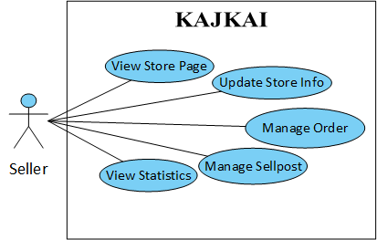

*Figure 3-4: Use case diagram of Seller actor*

* + - * 1. View Store page

*Use Case Specification*

|  |  |  |  |
| --- | --- | --- | --- |
| UC ID and Name: | **UC-28.0 View Store page** | | |
| Created by: | **MinhTD** | Date Created: | **05/06/2017** |
| Primary Actor: | **Seller** | Secondary Actors: | User, Guest |
| Trigger: | N/A | | |
| Description: | Allow Seller to view Store page | | |
| Preconditions: | **PRE-28.1.** Seller logins successfully.  **PRE-28.2.** Seller owns at least 1 store or create new store successfully | | |
| Post conditions: | **POST-28.1.** Store page is displayed | | |
| Normal Flow: | **28.0 View store page**   1. On Navigation Bar, Seller clicks on option icon next by avatar 2. System displays an option dropdown list 3. Select an existed store 4. System displays selected store includes store information and sellpost | | |
| Alternative Flows: | **28.0 Other ways to open a store**   1. On the help bar in the left panel, click needed store | | |
| Exceptions: | **28.0-E1 – Cannot communicate with server.**   1. KajKai displays error message. | | |
| Priority: | Low | | |
| Frequency of Use: | Medium | | |
| Business Rules: |  | | |
| Other Information: |  | | |
| Assumptions: |  | | |

* + - * 1. Update store info

*Use Case Specification*

|  |  |  |  |
| --- | --- | --- | --- |
| UC ID and Name: | **UC-29.0 Update store info** | | |
| Created by: | **MinhTD** | Date Created: | **08/06/2017** |
| Primary Actor: | Seller | Secondary Actors: |  |
| Trigger: | N/A | | |
| Description: | Allow Seller to update store information | | |
| Preconditions: | **PRE-29.1**. Seller logins successfully.  **PRE-29.2**. Seller owns at least 1 store or create new store successfully | | |
| Post conditions: | **POST-29.1**. Seller information is updated in database  **POST-29.2.** New updated information is displayed in store page | | |
| Normal Flow: | **29.0 Update store information**   1. Seller opens an existed store 2. System displays store page 3. Seller clicks setting page 4. System displays setting page 5. On each field, seller clicks edit button 6. System allows seller to edit this field 7. Seller changes information then clicks Save button 8. System updates store information 9. Seller clicks store page tab 10. New updated information is displayed | | |
| Alternative Flows: | N/A | | |
| Exceptions: | **29.0-E1 – Cannot communicate with server.**   1. KajKai displays error message. | | |
| Priority: | Low | | |
| Frequency of Use: | Medium | | |
| Business Rules: | **B11, B12, B13, B14, B15, B16, B17, B18, B19, B20, B25** | | |
| Other Information: |  | | |
| Assumptions: |  | | |

* + - * 1. Manage sellpost

*Use Case Specification*

|  |  |  |  |
| --- | --- | --- | --- |
| UC ID and Name: | **UC-30.0 Manage sellpost** | | |
| Created by: | **DaiPH** | Date Created: | **08/06/2017** |
| Primary Actor: | **Seller** | Secondary Actors: |  |
| Trigger: | N/A | | |
| Description: | Allow Seller to manage sellpost | | |
| Preconditions: | **PRE-30.1.** Seller logins successfully.  **PRE-30.2.** Seller owns at least 1 store | | |
| Post conditions: | **POST-30.1.** Sellpost is updated if Seller edits successfully  **POST-30.2.** Sellpost is removed if Seller deletes successfully  **POST-30.3.** Seller blocks User successfully | | |
| Normal Flow: | **30.0 Open sellpost**   1. Open an exited sellpost or create new sellpost successfully 2. System displays corresponding sellpost   **30.1 Edit sellpost**   1. Seller clicks option icon in sellpost’s top right 2. System displays options 3. Seller select Edit Sellpost 4. System displays a modal that allows seller to edit the sellpost 5. Seller edits the context then clicks Edit sellpost button 6. Editor modal is hided. New update data is saved in database and displays in the sellpost   **30.2 Delete sellpost**   1. Seller clicks option icon in sellpost’s top right 2. System displays options 3. Seller select Delete Sellpost 4. System displays confirmation box 5. Seller select Yes 6. This sellpost is removed from store page   **30.3 Block user**   1. Seller clicks option icon in sellpost’s comment 2. System displays options 3. Seller selects block user 4. System save blocked user in store’s blacklist. Blocked user is not allowed to comment in store | | |
| Alternative Flows: | **30.1 Edit sellpost**   1. In step 5, seller could click Close button to cancel editing sellpost. No data is updated   **30.2 Delete sellpost**   1. In step 5, seller could click Close button to cancel deleting sellpost. No data is deleted | | |
| Exceptions: | **30.0-E1 – Cannot communicate with server.**   1. KajKai displays error message. | | |
| Priority: | High | | |
| Frequency of Use: | Medium | | |
| Business Rules: |  | | |
| Other Information: |  | | |
| Assumptions: |  | | |

* + - * 1. Manage order

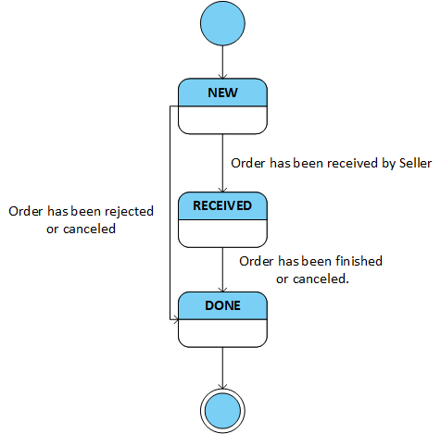

Figure 3-5: Order state machine diagram

*Use Case Specification*

|  |  |  |  |
| --- | --- | --- | --- |
| UC ID and Name: | **UC-31.0 Manage order** | | |
| Created by: | **MinhTD** | Date Created: | **08/06/2017** |
| Primary Actor: | **Seller** | Secondary Actors: |  |
| Trigger: | N/A | | |
| Description: | Allow Seller to manage order | | |
| Preconditions: | **PRE-31.1.** Seller logins successfully.  **PRE-31.2.** Seller owns at least 1 store | | |
| Post conditions: | **POST-31.1.** User receives notification when seller process an order | | |
| Normal Flow: | **31.0 View an order**   1. User makes an order in the sellpost 2. New order is appended in Seller’s Order Management panel   **31.1 Receive an order**   1. Seller clicks Receive button below an order 2. User receives notification inform that Seller has received an order   **31.2 Mark an order as Done**   1. Seller clicks Done button below an order 2. User receives notification informs that Seller has done on this order | | |
| Alternative Flows: | N/A | | |
| Exceptions: | **31.0-E1 – Cannot communicate with server.**   1. KajKai displays error message. | | |
| Priority: | High | | |
| Frequency of Use: | High | | |
| Business Rules: |  | | |
| Other Information: |  | | |
| Assumptions: |  | | |

* + - * 1. View statistics

*Use Case Specification*

|  |  |  |  |
| --- | --- | --- | --- |
| UC ID and Name: | **UC-32.0 View statistics** | | |
| Created by: | **DaiPH** | Date Created: | **29/05/2017** |
| Primary Actor: | **Seller** | Secondary Actors: |  |
| Trigger: | N/A | | |
| Description: | Allow Seller to view store statistics | | |
| Preconditions: | **PRE-32.1.** Seller logins successfully.  **PRE-32.2.** Seller owns at least one store | | |
| Post conditions: | **POST-32.1.** System displays store’s statistics | | |
| Normal Flow: | **32.0 View statistics**   1. Seller opens Store page 2. System displays store 3. Seller clicks Statistics tab 4. System displays store’s statistics tab | | |
| Alternative Flows: | N/A | | |
| Exceptions: | **32.0-E1 – Cannot communicate with server.**   1. KajKai displays error message. | | |
| Priority: | Low | | |
| Frequency of Use: | Low | | |
| Business Rules: |  | | |
| Other Information: |  | | |
| Assumptions: |  | | |

* + - 1. Admin

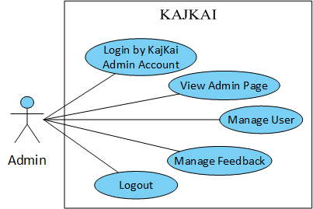

*Figure 3-6: Use case diagram of Admin actor*

* + - * 1. Login by KajKai admin account

*Use Case Specification*

|  |  |  |  |
| --- | --- | --- | --- |
| UC ID and Name: | **UC-33.0 Login by KajKai admin account** | | |
| Created by: | **LongLH** | Date Created: | **30/05/2017** |
| Primary Actor: | Admin | Secondary Actors: |  |
| Trigger: | N/A | | |
| Description: | Allows Admin to login into KajKai Administration. | | |
| Preconditions: | **PRE-33.1**. Actor is admin | | |
| Post conditions: | **POST-33.1**. Admin logins KajKai Administration successfully.  **POST-33.2**. System displays Dashboard page. | | |
| Normal Flow: | **33.0 Login by KajKai admin account**   1. Admin accesses Admin page 2. System displays login form 3. Admin types valid account and password then press login 4. System displays Dashboard page | | |
| Alternative Flows: | **33.0 Account and password is invalid in step 3**   1. System displays error message | | |
| Exceptions: | **33.0-E1 – Cannot communicate with server.**   1. KajKai displays error message. | | |
| Priority: | Medium | | |
| Frequency of Use: | Medium | | |
| Business Rules: | **B21, B22, B23** | | |
| Other Information: |  | | |
| Assumptions: |  | | |

* + - * 1. View Admin page

*Use Case Specification*

|  |  |  |  |
| --- | --- | --- | --- |
| UC ID and Name: | **UC-34.0 View Admin page** | | |
| Created by: | **LongLH** | Date Created: | **30/05/2017** |
| Primary Actor: | Admin | Secondary Actors: |  |
| Trigger: | N/A | | |
| Description: | Allow Admin to login into KajKai Administration | | |
| Preconditions: | **PRE-34.1**. Admin logins successfully | | |
| Post conditions: | **POST-34.1**. System displays Dashboard page.  **POST-34.2**. System displays User Management page. | | |
| Normal Flow: | **34.0 View Admin-Dashboard section**   1. Dashboard includes 3 tabs    * + New      + Unsolved      + All 2. Each tab displays feedbacks table with following information    * + No      + Reporter:        - Avatar        - Username (Hyperlink)      + Reporter:        - Avatar        - Username (Hyperlink)      + Feedback content      + Sellpost link      + Last updated time      + Feedback status: Unsolved | Solved      + Details button 3. Select a specific new feedback, click “Details” button 4. Feedback details modal is displayed with following information:    * + Header:        - Feedback + #id        - Feedback status: Solved | Unsolved      + Reporter:        - Avatar        - Username (Hyperlink)        - Status label: Activated | Deactivated        - Status toggle      + Defendant:        - Avatar        - Username (Hyperlink)        - Status label: Activated | Deactivated        - Status toggle      + Feedback content      + Sellpost url      + Last updated time      + Decision text area      + Save button      + Close button   **34.1 View Admin-User section**   1. Admin clicks User tab 2. User management page is displayed with following information    * + No      + User        - Avatar        - Username (Hyperlink)      + Stores        - Avatar        - Store name (Hyperlink)      + Email      + Status: Activated | Deactivated      + Details button 3. Select a specific user then click Details button 4. System displays user details modal with following information    * + Header        - Avatar        - Username (Hyperlink)      + Email      + Stores:        - Avatar        - Store name (Hyperlink)      + Status: Activated | Deactivated      + By: (Admin last action with reason)      + Reason text area that causes admin action      + Deactivated | Activated button      + Close button | | |
| Alternative Flows: | N/A | | |
| Exceptions: | **34.0-E1 – Cannot communicate with server.**   1. KajKai displays error message. | | |
| Priority: | Medium | | |
| Frequency of Use: | Medium | | |
| Business Rules: |  | | |
| Other Information: |  | | |
| Assumptions: |  | | |

* + - * 1. Manage user

*Use Case Specification*

|  |  |  |  |
| --- | --- | --- | --- |
| UC ID and Name: | **UC-35.0 Manage user** | | |
| Created by: | **LongLH** | Date Created: | **30/05/2017** |
| Primary Actor: | Admin | Secondary Actors: |  |
| Trigger: | N/A | | |
| Description: | Admin manage user including user’s information and status (access permission) | | |
| Preconditions: | **PRE-35.1**. Admin logins into KajKai administration successfully | | |
| Post conditions: | **POST-35.1**. System displays User Management  **POST-35.2**. User status is changed | | |
| Normal Flow: | **35.0 Manage user**  Admin clicks User management tab  User management tab is displayed  Admin select a specific user click “Details” button  System displays user details modal  Admin click on user’s status toggle  User’s status is changed  Admin fill reason that causes admin action  Admin click “Activate” | “Deactivated” depend on user current status  This user’s status is updated | | |
| Alternative Flows: | **35.0 Cancel updating user status**   1. In step 6, instead of changing user status, click “Close” 2. System hides user details modal. User status is not changed | | |
| Exceptions: | **35.0-E1 – Cannot communicate with server.**   1. KajKai displays error message. | | |
| Priority: | Medium | | |
| Frequency of Use: | Medium | | |
| Business Rules: | **B24** | | |
| Other Information: |  | | |
| Assumptions: |  | | |

* + - * 1. Manage feedback

*Use Case Specification*

|  |  |  |  |
| --- | --- | --- | --- |
| UC ID and Name: | **UC-36.0 Manage feedback** | | |
| Created by: | **LongLH** | Date Created: | **30/05/2017** |
| Primary Actor: | Admin | Secondary Actors: |  |
| Trigger: | N/A | | |
| Description: | Allow Admin to manage User’s feedbacks | | |
| Preconditions: | **PRE-36.1**. Admin logins into KajKai administration successfully | | |
| Post conditions: | **POST-36.1**. System displays Dashboard  **POST-36.2**. Feedback is solved and User status is changed | | |
| Normal Flow: | **36.0 Solve a feedback**  In dashboard page, click “New” tab. This tab is a feedback list that is unsolved  Select a specific feedback, click “Details” button  System displays feedback details modal  Change status of users is optional  Fill admin’s decision is mandatory  Click “Save” button  This feedback is turn to “Solved” then disappear from “New” tab | | |
| Alternative Flows: | **36.0 Cancel after editing feedback**   1. In step 6, click “Close” 2. System hided feedback details. No feedback status is changed | | |
| Exceptions: | **36.0-E1 – Cannot communicate with server.**   1. KajKai displays error message. | | |
| Priority: | Medium | | |
| Frequency of Use: | Medium | | |
| Business Rules: | **B24** | | |
| Other Information: |  | | |
| Assumptions: |  | | |

* + - * 1. Logout admin

*Use Case Specification*

|  |  |  |  |
| --- | --- | --- | --- |
| UC ID and Name: | **UC-37.0 Logout admin** | | |
| Created by: | **LongLH** | Date Created: | **30/05/2017** |
| Primary Actor: | Admin | Secondary Actors: |  |
| Trigger: | N/A | | |
| Description: | Allow Admin to logout | | |
| Preconditions: | **PRE-37.1**. Actor is admin  **PRE-37.2**. Admin logins successfully | | |
| Post conditions: | **POST-37.1**. Admin logins KajKai Administration successfully  **POST-37.2**. Admin logouts successfully | | |
| Normal Flow: | **37.0 Logout admin**   1. Admin clicks logout button 2. System displays login page | | |
| Alternative Flows: | N/A | | |
| Exceptions: | **37.0-E1 – Cannot communicate with server.**   1. KajKai displays error message. | | |
| Priority: | Low | | |
| Frequency of Use: | Low | | |
| Business Rules: |  | | |
| Other Information: |  | | |
| Assumptions: |  | | |

* 1. Non-functional Requirement
     1. Security
* Cookie-Based Authentication
* HTTPS protocol
* The security matrix is as the following table:

|  |  |  |  |  |
| --- | --- | --- | --- | --- |
| **Function** | **Guest** | **User** | **Seller** | **Admin** |
| Sign up | ✓ |  |  |  |
| Reset password | ✓ |  |  |  |
| Login by KajKai user account | ✓ |  |  |  |
| Login by Gmail | ✓ |  |  |  |
| Login by Facebook | ✓ |  |  |  |
| View Home page | ✓ | ✓ |  |  |
| View User page | ✓ | ✓ |  |  |
| Edit general info |  | ✓ |  |  |
| Change password |  | ✓ |  |  |
| Search user | ✓ | ✓ |  |  |
| Search store | ✓ | ✓ |  |  |
| Search sellpost | ✓ | ✓ |  |  |
| Chat |  | ✓ |  |  |
| Comment |  | ✓ |  |  |
| Reply comment |  | ✓ |  |  |
| Like and unlike comment, reply |  | ✓ |  |  |
| Like and unlike sellpost |  | ✓ |  |  |
| Manage interest |  | ✓ |  |  |
| Receive notification |  | ✓ |  |  |
| View notification list |  | ✓ |  |  |
| View notification detail |  | ✓ |  |  |
| Turn on and off notification |  | ✓ |  |  |
| Create store |  | ✓ |  |  |
| Follow and unfollow store |  | ✓ |  |  |
| Follow and unfollow sellpost |  | ✓ |  |  |
| Feedback |  | ✓ |  |  |
| Logout user |  | ✓ |  |  |
| View Store page | ✓ | ✓ | ✓ |  |
| Update Store Info |  |  | ✓ |  |
| Manage sellpost |  |  | ✓ |  |
| Manage order |  |  | ✓ |  |
| View statistics |  |  | ✓ |  |
| Login by KajKai admin account |  |  |  | ✓ |
| View Admin page |  |  |  | ✓ |
| Manage user |  |  |  | ✓ |
| Manage feedback |  |  |  | ✓ |
| Logout admin |  |  |  | ✓ |

*Table 3-4: Security matrix*

* + 1. Maintainability & Extensibility
* Apply microservices architecture for backend system.
* We wrote automation test including Unit Tests and Integration Tests by using Mocha and Chai.
* Follow the coding convention to help improve readability of source code and make the website more maintainable.
* Client-side web application uses Redux architecture. It complements React's compostable view components by utilizing a unidirectional data flow.
  + 1. Availability and Scalability
* Using Amazon Application Load Balancer for high availability.
  + 1. Performance
* Using Amazon Cloudfront for low latency web content delivery.
* Using HTTP/2, which uses a single, multiplexed connection to allow multiple requests to be sent on the same connection instead of establishing new connection for each request, increase speed of request-response.
* Web frontend uses React which uses several clever techniques to minimize the number of costly DOM operations required to update the UI.
* Web frontend is a Single Page Application with the goal of providing a more fluid user experience.
* Node.js brings event-driven programming to web servers, enables development of fast web servers in JavaScript.
  + 1. Usability
* The interface should be easy to use as much as possible.
* **Alternative attributes** **are provided for non-text elements**, such as images.
* **Links, buttons and checkboxes are easily clickable**.
* **Search box is wide** enough for users to see what they have typed.
* **Search is available on every page**, not just the Home page.
* **Links are easily recognizable.** They look clickable. Items that are not links do not look clickable, for example underlining text is avoided.
  1. Database document diagram





Figure 3-7: KajKai database document diagram

# : Software Design

3. 1. Purpose

This chapter is to give the developer team the overview and detailed design of what the system’s architecture is, and how they should be implemented. This chapter consists of:

* Architecture overview
* Component diagram
* Detailed design
* Detailed description of components
* Database design
  1. Architecture Overview
     1. System Architecture
        1. Diagram

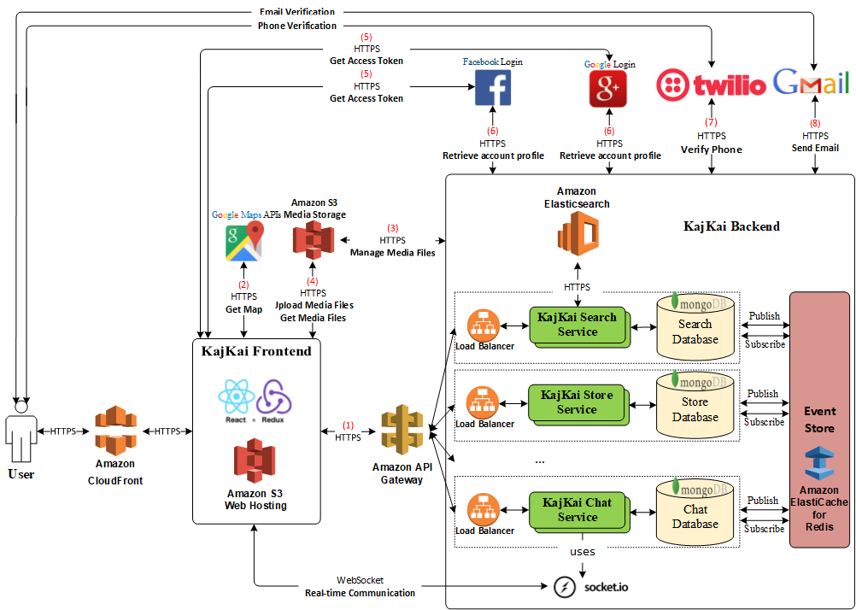

Figure ‑: KAJKAI System Architecture

Figure ‑1: KAJKAI System Architecture

* + - 1. Explanation

1. KajKai Frontend sends a request to KajKai Backend.

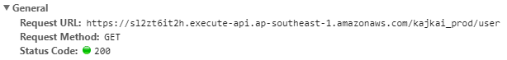

1. KajKai Frontend sends a request to Google Map API[1].

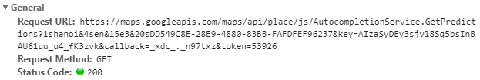

1. - KajKai Backend sends a request to Amazon S3 to sign a URL that authorize[2] KajKai Frontend to upload a media file directly to Amazon S3.

- KajKai Backend stores URL for each uploaded media file.

1. - KajKai Frontend uses signed URL by KajKai Backend to upload media file.

- KajKai Frontend gets a media file directly from Amazon S3 by a URL stored in KajKai Backend.

1. KajKai Frontend sends a request to Google[3]/Facebook[4] API to get access token.

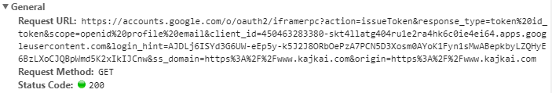

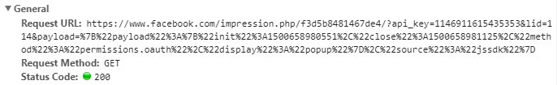

1. KajKai Backend sends a request to Google[5]/Facebook[6] API using access token to retrieve account profile.
2. - KajKai Backend generates a code and stores it in pair with User phone number.

- Next, KajKai Backend requests to Twilio API[7] to send a SMS message containing verification the code to a phone number and stores .

- Then Twilio sends the message the phone number.

- After that, User sends the code to KajKai Backend via KajKai Frontend.

- Finally, KajKai Backend verifies User phone by the stored code in database.

1. KajKai Backend uses gmail-send[8] library to send email to User using Gmail.
   * 1. System Architecture Explanation

The entire project will be deployed on Amazon. We aim at delivering a secured, responsive, and highly available system. In the following section, we will explain the function and mechanism of each unit in the system architecture design.

* + - 1. Amazon Route 53



Figure 4‑2: Amazon Route 53

**Amazon Route 53** is a highly available and scalable cloud Domain Name System web service. **We use it to register kajkai.com domain and create 3 sub-domains: www.kajkai.com, admin.kajkai.com, socket.kajkai.com.**

* + - 1. Amazon Cloudfront



Figure 4‑3: Amazon Cloudfront

**Amazon CloudFront** is a global content delivery network service that securely delivers data, videos, applications, and APIs to viewers with low latency and high transfer speeds. **We use it to provide addition layer of protection for KajKai, deliver content with the best possible performance and redirect HTTP traffic to HTTPS.**

* + - 1. React



Figure 4-4: React

**React** is an open-source JavaScript library for building user interfaces, allows developers to create large web applications that use data which can change over time, without reloading the page. **We use it to build entire website view instead of plain HTML/JavaScript.**

* + - 1. Redux



Figure 4‑5: Redux

**Redux** is a predictable state container for JavaScript apps. **Redux** evolves the ideas of **Flux** what is the application architecture that Facebook uses for building client-side web applications. It complements **React** view components by utilizing a unidirectional data flow. **We use Redux to take advantages of better separation of concerns, less time debugging.**

* + - 1. Amazon Simple Storage Service (Amazon S3)



Figure 4-6: Amazon S3

**Amazon S3** is object storage with a simple web service interface to store and retrieve any amount of data from anywhere on the web. **We use it to store media files and host static web content of KajKai Frontend.**

* + - 1. Amazon API Gateway



Figure 4‑7: Amazon API Gateway

**Amazon API Gateway** is a fully managed service that makes it easy for developers to create, publish, maintain, monitor, and secure APIs at any scale. **We use it as front door for distributed microservices.**

* + - 1. Amazon Elastic Compute Cloud (Amazon EC2)



Figure 4‑8: Amazon EC2

**Amazon EC2** is a web service that provides secure, resizable compute capacity in the cloud. **We use it deploy KajKai Backend.**

* + - 1. Amazon Application Load Balancer

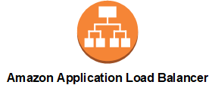

Figure 4‑9: Amazon Application Load Balancer

**Amazon Application Load Balancer** distributes incoming application traffic across multiple EC2 instances, it automatically scales as traffic to application changes over time. **We use it to increases the availability of KajKai Backend.**

* + - 1. MongoDB



Figure 4‑10: MongoDB

**MongoDB** is a free and open-source cross-platform document-oriented database program. **We use it to manage KajKai operational data.**

* + - 1. Amazon ElastiCache for Redis



Figure ‑11: Redis

**Redis** is an open source, in-memory data structure store, used as a database, cache and message broker.



Figure 4‑12: Amazon ElastiCache

**Amazon ElastiCache for Redis** is a Redis-compatible in-memory data structure service that can be used as a data store or cache. **We use it as an event store for communication between microservices.**

* + - 1. Amazon Elasticsearch



Figure 4‑13: Elasticsearch

**Elasticsearch** is a search engine that provides a distributed, multitenant-capable full-text search engine with an HTTP web interface and schema-free JSON documents.



Figure 4‑14: Amazon Elastisearch

**Amazon Elasticsearch Service** is a managed service that makes it easy to create a domain and deploy, operate, and scale Elasticsearch clusters. **We use it to implement full-text search feature.**

* + - 1. Node.js



Figure 4‑15: Node.js

**Node.js** is an open-source, cross-platform JavaScript run-time environment for executing JavaScript code server-side. **We use it to develop KajKai Backend microservices.**

* + - 1. Socket.IO



Figure 4‑16: Socket.IO

**Socket.IO** is a JavaScript library for real-time web applications. It enables real-time, bi-directional communication between web clients and servers. It has two parts: a client-side library that runs in the browser, and a server-side library for node.js**. We use it to implement chat, comment and notification features.**

* 1. Design of KAJKAI System
     1. Architecture Layers Design
        1. KAJKAI – API Layer Design

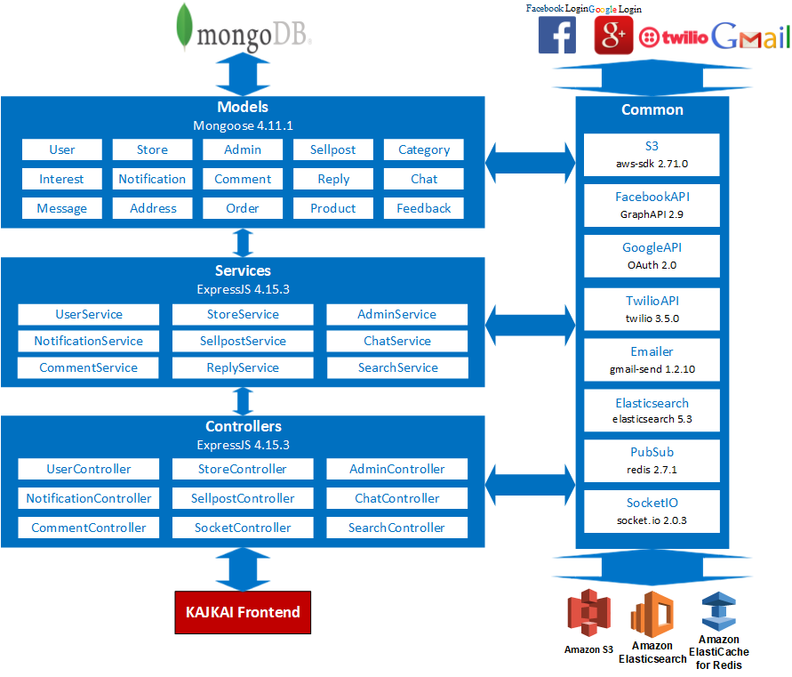

Figure 4‑17: KAJKAI – API Layer Design

|  |  |  |  |
| --- | --- | --- | --- |
| **No** | **Directory/File** | **Description** | **Convention** |
|  | index.js | Entry point for the application. Everything in the app gets triggered through this file. |  |
|  | server.js | Initializes http server for Express app in app.js file. |  |
|  | sub.js | Initializes redis channels in channels.js file |  |
|  | app.js | Initializes REST API routes in routes.js |  |
|  | channels.js | Contains redis channels the app subscribes. |  |
|  | routes.js | Contains route logic for REST API endpoints. |  |
|  | datasource.js | Initializes database connection. |  |
|  | config/ | Contains configuration files. |  |
|  | middlewares/ | Contains custom middlewares for Express app. |  |
|  | controllers/ | Contains files that handle logic for each group of request like UserController.js, StoreController.js. | **XXXController.js** |
|  | services/ | Contains files that directly interact with database like UserService.js, StoreService.js. | **XXXService.js** |
|  | models/ | Contains Mongoose models. |  |
|  | socketio/ | Contains event handling logic for socket.io |  |
|  | utils/ | Contains helper files. |  |
|  | package.json | Contains metadata about application: the list of dependencies, npm run script. |  |

* + - 1. KAJKAI – Frontend Design

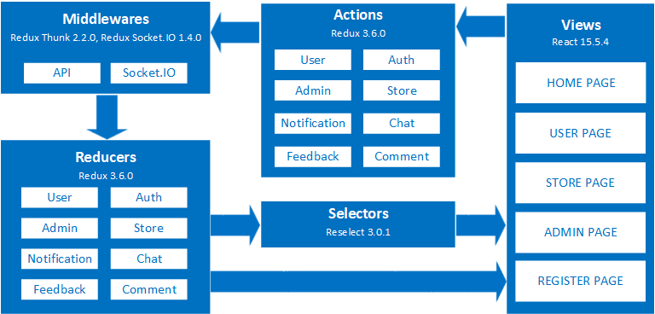

Figure 4‑18: KAJKAI – Frontend Design

|  |  |  |  |
| --- | --- | --- | --- |
| **No** | **Directory/File** | **Description** | **Convention** |
|  | index.html | HTML for Webpack to mount application. |  |
|  | index.js | Entry point for the application. Everything in the app gets triggered through this file. |  |
|  | dist/ | Contains bundle files from Webpack. |  |
|  | images/ | contains all images used for markup components. |  |
|  | config/ | Contains configuration files. |  |
|  | common/ | Contains common React component files. |  |
|  | actions/ | Contains Redux actions. |  |
|  | components/ | Contains React components. |  |
|  | containers/ | Contains Redux container components. |  |
|  | reducers/ | Contains Redux reducers. |  |
|  | package.json | Contains metadata about application: the list of dependencies, npm run script. |  |
|  | webpack.config.js | Webpack configuration file. |  |

* + 1. Database Design
       1. Explanation of database decision

As our system have following characteristic:

* Users comment frequently
* Sellposts are regularly created and updated
* Flexible data model
* System may need to scale
* Provide real-time experience so read and write must be fast

So we chose MongoDB because:

* MongoDB stores data in flexible, JSON-like documents, meaning fields can vary from document to document and data structure can be changed over time
* MongoDB is free and open-source
* MongoDB enables scaling by shards (partitions data by key ranges and distributes the data among two or more database instances)
* MongoDB allows stores sub-document inside document avoiding join multiple tables, therefore providing faster write and read time
  + - 1. Database Diagram





Figure 4‑19: KajKai database document diagram

* + - 1. MongoDB-Indexing

Indexes support the efficient execution of queries in MongoDB. Without indexes, MongoDB must perform a collection scan, i.e. scan every document in a collection, to select those documents that match the query statement. If an appropriate index exists for a query, MongoDB can use the index to limit the number of documents it must inspect.

Indexes are special data structures that store a small portion of the collection’s data set in an easy to traverse form. The index stores the value of a specific field or set of fields, ordered by the value of the field. The ordering of the index entries supports efficient equality matches and range-based query operations. In addition, MongoDB can return sorted results by using the ordering in the index.

By default, MongoDB creates a unique index on the _id field during the creation of a collection. The _id index prevents clients from inserting two documents with the same value for the _id field. Additionally, we use some indexes to support faster query time.

|  |  |  |
| --- | --- | --- |
| **Collection** | **Indexes** | **Index Type** |
| **Interests** | location | 2dsphere index |
| **Feedbacks** | sellpostId | Single field index |
| **Sellposts** | storeId | Single field index |
| **Stores** | Owner | Single field index |
| **Comments** | sellpostId | Single field index |
| **Replies** | commentId | Single field index |

Table 4.1 KajKai’s database indexes

* + - 1. Data Dictionary

|  |  |  |  |  |  |  |  |  |
| --- | --- | --- | --- | --- | --- | --- | --- | --- |
| **Collection** | **Field** | | | | | | **Type** | **Description** |
| Users | _id | | | | | | ObjectId | MongoDB ObjectId, Unique for each document |
| username | | | | | | String | User’s Name |
| password | | | | | | String | User’s password |
| email | | | | | | String | User’s Email |
| verified | | | | | | Boolean | Status if user verified by email |
| phone | | | | | | String | User phone number |
| socialNetworkType | | | | | | String | Type of social network user use to sign up |
| socialNetworkId | | | | | | String | Id of social network |
| avatarUrl | | | | | | String | Image url of user avatar |
| coverUrl | | | | | | String | Image url of user cover |
| sex | | | | | | String | Sex of user |
| yearOfBirth | | | | | | Number | Year of birth of user |
| passwordLastUpdatedAt | | | | | | Date | Last time user update password |
| userNameLastUpdatedAt | | | | | | Date | Last time user update username |
| yearOfBirthLastUpdatedAt | | | | | | Date | Last time user update year of birth |
| phoneLastUpdatedAt | | | | | | Date | Last time user update phone |
| Banned | | | | | | Boolean | Status if user is banned |
| banReason | | | | | | String | Reason if user is bannned |
| Longitude | | | | | | Double | User chosen position’s longitude |
| Latitude | | | | | | Double | User chosen position’s latitude |
| Notification |  | | | | | BsonArray | List of sellpost or store user get notification from |
| storeId | | | | | String | Id of store |
| sellpostId | | | | | String | Id of sellpost |
| Block |  | | | | | BsonArray | List of user’s blocked user |
| UserId | | | | | String | userId |
| ImageList |  | | | | | BsonArray | List of user’s image |
| url | | | | | String | Image url |
| timeAdded | | | | | Date | Time image added |
| FollowingSellpost |  | | | | | BsonDocument | List sellpost id user interested in |
| sellpostId | | | | | String | Id of sellpost |
| Stores | _id | | | | | | ObjectId | Id of store |
| storeName | | | | | | String | Name of store |
| Phone | | | | | | String | Store’s phone number |
| category | | | | | | String | Name of category |
| categoryId | | | | | | String | Id of category |
| subCategoryId | | | | | | String | Id of subCategory |
| owner | | | | | | String | userId of owner |
| avatarUrl | | | | | | String | url of store avatar |
| coverUrl | | | | | | String | url of store cover |
| address | | | | | | String | Store’s address |
| Longitude | | | | | | Double | Store position’s longitude |
| Latitude | | | | | | Double | Store position’s latitude |
| lastUpdateStoreName | | | | | | Date | Last time store update name |
| lastUpdateAvatarUrl | | | | | | Date | Late time store update avatar |
| lastUpdateCoverUrl | | | | | | Date | Last time store update cover |
| createAt | | | | | | Date | Time when store’s created |
|  | followers |  | | | | | BsonArray | List of user follow this store |
|  | userId | | | | | String | Id of user |
| Sellposts | _id | | | | | | ObjectId | Id of sellpost |
| storeId | | | | | | String | Id of store which has this sellpost |
| Category | | | | | | String | Category of product sell in this post |
| Title | | | | | | String | Title of sellpost |
| Description | | | | | | String | Description of sellpost |
| Time | | | | | | Date | Last time update sellpost |
| Status | | | | | | String | Status of sellpost |
| shipDescription | | | | | | String | Description of of this sellpost shipping condittion |
| likers |  | | | | | BsonArray | List of user like this sellpost |
| userId | | | | | String | Id of user |
|  | followers |  | | | | | BsonArray | List of user follow sellpost |
|  | userId | | | | | String | Id of user |
|  | SellpostDetail |  | | | | | BsonArray | List of sellpost detail |
|  | content | | | | | String | Content describe this sellpost detail |
|  | line | | | | | Integer | Number of lines in this sellpost detail |
|  | title | | | | | String | Tittle of this sellpost detail |
|  | type | | | | | String | Type of this sellpost detail |
|  | imageUrls | | | | | String | List of image in this sellpost detail |
|  | products | | | | | BsonArray | List of products |
|  |  | | | _id | | ObjectId | productId |
|  | Description | | String | Product description |
|  | ImageUrl | | String | Url of product image |
|  | Name | | String | Product name |
|  | Price | | Double | Product Price |
|  | List | | StringArray | List of additional information if any |
| Comments | posterId | | | | | | String | userId of user post this comment |
| Content | | | | | | String | Content of comment |
| time | | | | | | Date | Time comments created |
| SellpostId | | | | | | String | Id of sellpost this comment belong to |
| Order | | |  | | | BsonArray | List of product ordered |
| productid | | | String | Id of product |
| quantity | | | Interger | Number of product ordered |
| likers | | |  | | | BsonArray | List of user like this comment |
| userId | | | String | Id of user |
| Replies | posterId | | | | | | String | userId of user post this comment |
| Content | | | | | | String | Content of reply |
| Time | | | | | | Date | Time of reply created |
| commentId | | | | | | String | id of comment this reply to |
| postId | | | | | | String | Id of sellpostId comment belong to |
| likers | | |  | | | BsonArray | List of user like this comment |
| userId | | | String | Id of user |
| MessageGroups | _id | | | | | | ObjectId | Id of group message |
| members | |  | | | | BsonArray | List of member of message group |
| userId | | | | String |
| message | |  | | | | BsonArray | message |
| senderId | | | | String | userId of user send message |
| Time | | | | Date | Time created message |
| content | | |  | BsonArray | All message in group |
| text | String | Text content |
| url | String | url of image |
| type | String | url or text type |
| Notifications | userId | | | | | | String | Id of user whose notification for |
| notificationList | |  | | | | BsonArray | List of notification |
| type | | | | String | Type of notification |
| commentId | | | | String | Id comment if any in notification |
| replyId | | | | String | Id reply if any in notification |
| sellpostId | | | | String | Id sellpost if any in notification |
| actorId | | | | String | Id of user cause this notification |
| Content | | | | String | Content of notifcation |
| Name | | | | String | Name of user cause this notification |
| avatarUrl | | | | String | url avatar of user cause this notification |
| Time | | | | Date | Time notification created |
| storeName | | | | String | Name of store cause this notification |
| storeId | | | | String | Id of store cause this notification |
| urlName | | | | String | Shortcut url to store |
| storeAvatarUrl | | | | String | Avatar url of store |
| Number of like | | | | String | Number of like in comment, reply or sellpost in this notification |
| likers | | | | ArrayString | User likes in comment, reply or sellpost in this notification |
| numberOfReply | | | | Number | Number of reply |
| Feedbacks | reporter | | | | | | String | Id of user who is reported |
| reportee | | | | | | String | Id of user who being reported |
| Content | | | | | | String | Content for report |
| sellpostId | | | | | | String | Id of sellpost where conflict happens |
| Status | | | | | | Boolean | Status of feedback is handled or not |
| reason | | | | | | String | Reason for this report |
| Time | | | | | | Date | Time when report is created |
| Admins | _id | | | | | | ObjectId | Id of admin |
| adminName | | | | | | String | Name of admin |
| Password | | | | | | String | Admin password |
| Categories | _id | | | | | | ObjectId | Id of this category |
| Name | | | | | | String | Category name |
| Subcategory | |  | | | | BsonArray | List of subcategory |
| _id | | | | ObjectId | Subcategory id |
| Name | | | | String | Name of subCategory |
| Interests | userId | | | | | | String | Id of user have this interest |
| categoryId | | | | | | String | Id of category user interested in |
| location | |  | | | | BsonObject | Location user interest in |
| Longitude | | | | Double | Longitude of postion |
| Latitude | | | | Double | Latitude of position |

Table 4.2 KajKai’s data dictionary

* + 1. Common Design
       1. Microservices architecture
          1. What is microservices?

**Microservices** is a [software architecture style](https://en.wikipedia.org/wiki/Architectural_pattern) in which complex [applications](https://en.wikipedia.org/wiki/Software_application) are composed of small, independent [processes](https://en.wikipedia.org/wiki/Process_(computing)) communicating with each other using [language-agnostic](https://en.wikipedia.org/wiki/Language-independent_specification) [APIs](https://en.wikipedia.org/wiki/Application_programming_interface). These [services](https://en.wikipedia.org/wiki/Service_(systems_architecture)) are small, highly [decoupled](https://en.wikipedia.org/wiki/Coupling_(computer_programming)) and focus on doing a small task, facilitating a modular approach to [system](https://en.wikipedia.org/wiki/System)-building.

* + - * 1. Philosophy
* Philosophy of Microservices architecture essentially equals the [Unix philosophy](https://en.wikipedia.org/wiki/Unix_philosophy) of "Do one thing and do it well". It is described as follows
* The services are small - fine-grained to perform a single function.
* The organization culture should embrace automation of deployment and testing. This eases the burden on management and operations.
* The culture and design principles should embrace failure and faults, similar to [anti-fragile systems](https://en.wikipedia.org/wiki/Antifragility).
* Each service is elastic, resilient, compostable, minimal, and complete.
  + - * 1. Microservices in KAJKAI

In KAJKAI, we implement Microservices as follows:

* Use Amazon EC2 for KajKai Backend deployment
* Deploy KajKai User, KajKai Store, KajKai Admin, KajKai Chat, KajKai Search, KajKai Socket, KajKai Comment, KajKai Notification as single services.
* How the system handles user interaction from KajKai Frontend:

1. components: contains Javascript files that renders GUI

User interacts with KajKai Frontend from here using browsers, creates events.

1. containers: contains Javascript files that handle the events by dispatching actions
2. actions: contains Javascript files that defines actions from users

There are two types of action:

- synchronous action: handled by KajKai Frontend

- asynchronous action: requests to KajKai Backend, when responses are received, synchronous actions will be dispatched to update KajKai Frontend state.

1. reducers: contains Javascript files that handle actions

Each reducer is a pure Javascript function that takes synchronous actions and current state of KajKai Frontend as parameters and produces new state of KajKai Frontend.

1. app.js: initialize route logic defined in routes.js

Each KajKai microservice contains one app.js file.

1. routes.js: defines route logic for REST API endpoints as figure below

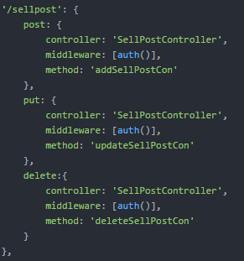

Figure 4.20 Route logic in each KajKai microsevices

Each request from KajKai Frontend will be firstly handled by Amazon API Gateway, then it is routed to corresponding KajKai microservice.

1. controllers: contains Javascript files that handle requests from KajKai Frontend asynchronous actions

Controllers are called by app.js.

1. services: contains Javascript files that solves logic for each request

Services are called by controller.

1. database: stores data for each KajKai microservice and is accessed by services

* Apply CQRS pattern to split application into microservices. The command-side handles create, update, and delete requests and publish events to Event Store when data changes. The query-side handles queries data that are kept up to date by subscribing to the stream of events published from the command-side.

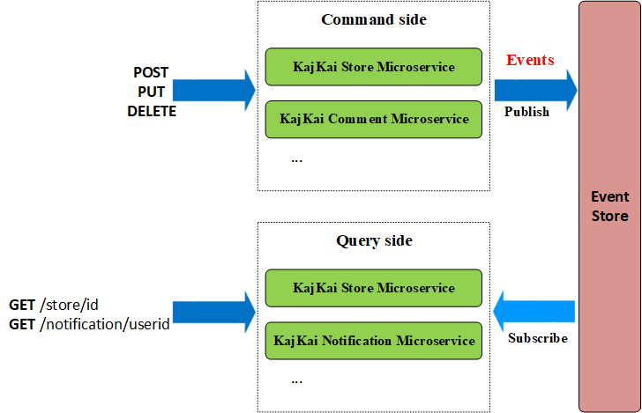

Figure 4.21 CQRS pattern illustration in KajKai microsevices

* Use Amazon ElastiCache for Redis as Event Store for communicating between services. It is illustrated as figure below with the scenario: a request starts at KajKai Store Microservice and similarly when a request starts at KajKai User Microservice or any other microservice.

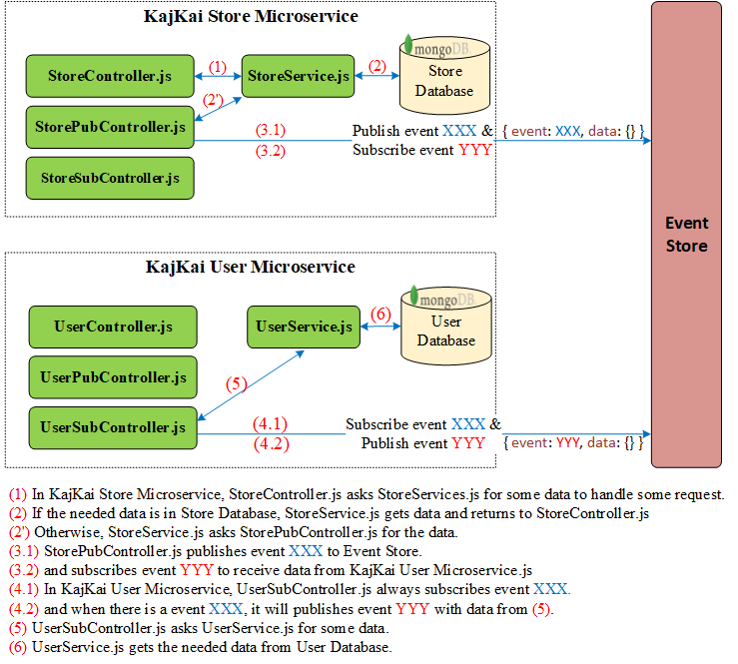

Figure 4.22 Interaction between two KajKai microsevices

* Use third-party services:
  + Google API, Facebook API for login by Google, Facebook account
  + Gmail for sending email by using gmail-send library
  + Twilio for phone verification
  + Amazon S3 for KajKai Frontend hosting and storing media files
    - 1. Authorization with middleware style

There are 4 types of public REST APIs (user can access without access token):

* POST /login – to login with username and password
* GET /search – allow guest to surf Home page
* GET /user – allow everyone to view basic info of a user
* GET /store – allow everyone to view basic info of a store

We will make all other routes pass through **auth** middleware to check authorization before they reach corresponding controllers.

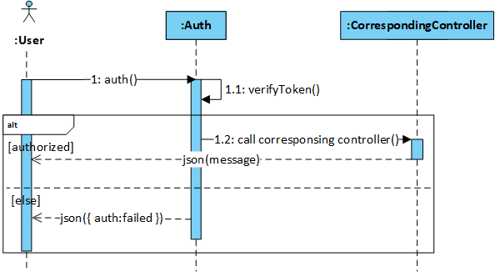

Figure 4‑23: Application auth middleware sequence diagram

* + - 1. Phone verification

Whenever user needs to verify phone to update phone or create new store, we generate a phone code for that pair of user and phone. By default, there is a Boolean property named **verified** with false value every time the code is generated. If user verifies phone successfully, we will update **verified** to true.

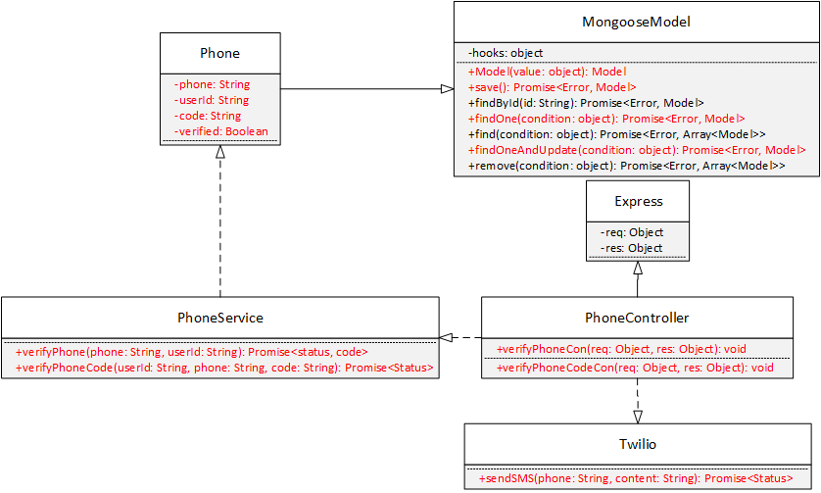

Figure 4‑24: Phone verification class diagram

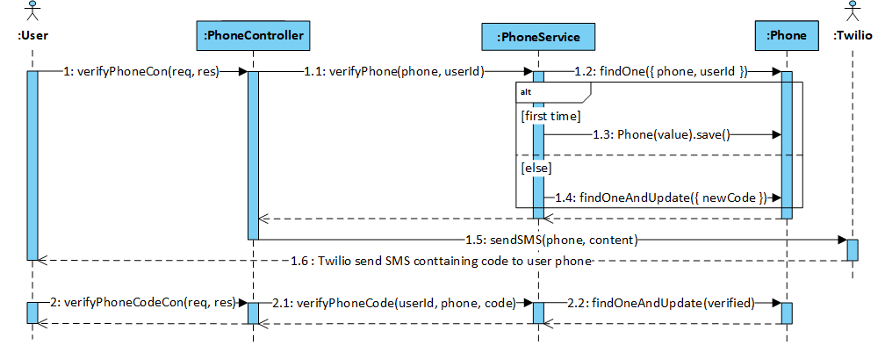

Figure 4‑25: Phone verification sequence diagram

* + - 1. Building elasticsearch database

We use elasticsearch to support users search by full-text search instead of using our database, MongoDB. In order to do that, we build a copy of a fraction of our database in elasticsearch database.

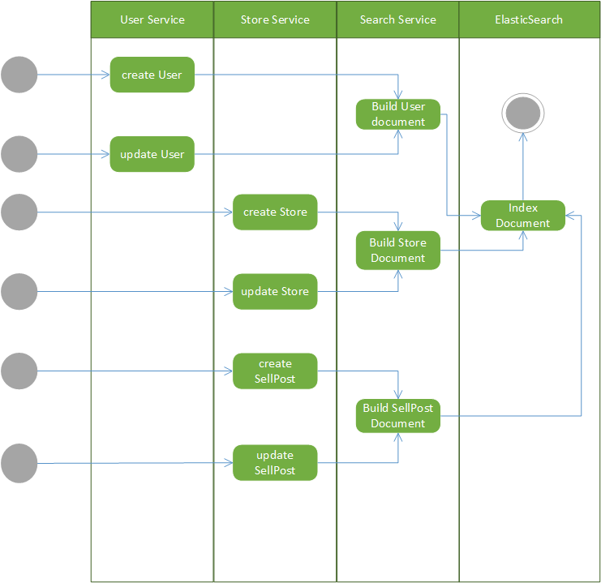

Figure 4‑26: Building elastic search database activity diagram

**Pseudocode for Building Document:**

* + - 1. Choose info that needed for search and display search result from objects received from other services
         1. User:

userId

username

avatarUrl

* + - * 1. Store

storeId

storeName

avatarUrl

* + - * 1. Sellpost:

sellpostId

storeId

sellpostTitle

sellpostCategory

categoryId

subCategoryId

productNameList

location

latitude

longitude

* + - 1. Generate lowercase and non-token counterpart with each search fields:
         1. User

nonTokenUserName

* + - * 1. Store

nonTokenStoreName

* + - * 1. SellPost

nonTokenTitle

nonTokenCategory

nonTokenProductNameList

* + - 1. Searching with elasticsearch

Using elasticsearch, we can exploit advantage of full-text search helping users search for users, stores, sellposts. Furthermore, we can also filter out sellposts search by category, sub-category or even by location.

We use following features from elasticsearch in order to search and filtering users, stores and sellposts

|  |  |  |  |  |
| --- | --- | --- | --- | --- |
| Bool query | | | | |
| Use: A query that matches documents matching combinations of other queries | | | | |
| Attributes | Value | | | Explanation |
| should | An array of subqueries such as match, multi-match, term and geo.  Contain two match queries by token and non-token for user search, store search. | | | Should appear at least 1 in matching document if there are no must or filter, at least none otherwise.  Contain two multi match queries by token and non-token for user search, store search. |
| must | An array of subqueries such as match, multi-match, term and geo. | | | The clause (query) must appear in matching documents and will contribute to the score |
| filter | An array of subqueries such as match, multi-match, term and geo distant. | | | The clause (query) must appear in matching documents. However unlike must the score of the query will be ignored.  May contain term queries and geo distant queries in search sellpost to filter category, subcategory or location |
| minimum_should_match | 1 | | | The minimum number of should queries matching document must have |
| Match | | | | |
| Use: A query that analyze keyword, and construct a search for each word and combine result for each word. | | | | |
| Attributes | Value | | | Explanation |
| field_name {query, fuzziness } | Object contains two attribute query and fuzziness | | | field_name is the name of the searching field in documents |
| field_name.query | String contains search keyword | | | Search keyword |
| field_name.fuzziness | 1 | | | Generates all possible matching terms that are within the 1 edit distance, this help us can find correct shops even user mistyped the keyword. For example: “abc” and “acb”.  Here we use one because allow user mistype at most one distant from search word and also limit number of generated matching term optimize elasticsearch |
| Multi-Match | | | | |
| Use: Same as match but can use for multiple fields instead of one fields | | | | |
| Term | | | | |
| Use: Find documents which contain the exact term specified in the field specified | | | | |
| Attributes | | Value | Explanation | |
| term: {search_field: keyword} | | Object contain search field and search keyword | Use when user want to search sellpost with a specific category given. | |
| Geo distant | | | | |
| Use: Finds document with geo-points within the specified distance of a central point. | | | | |
| Attributes | | Value | Explanation | |
| distance | | 30km | Distant from central point | |
| location | | Object contain longitude and latitude | Central point | |

* + - 1. Real-time features with Socket.IO

**Real-time applications**

**Socket.IO** is a JavaScript library for real-time web applications. It enables real-time, bi-directional communication between web clients and servers.

**Socket.IO** has two parts: a client-side library that runs in the browser, and a server-side library for Node.js. Both components have a nearly identical API.

**Socket.IO** primarily uses the WebSocket protocol with polling as a fallback option, while providing the same interface.

**Security**

Application security is very important, each user should be able to join to their private channel if and only if they provide valid access token. Any user should not be able to join to other user’s channel.

* + - * 1. Socket.IO on KAJKAI Frontend

We use **socket.io-client** library on [NPM](https://www.npmjs.com/package/socket.io-client) to implement it on KAJKAI Frontend.

* Initialization



* Receive Socket.IO event from server as actions in Redux using socketIoMiddleware from **redux-socket.io** on [NPM](https://www.npmjs.com/package/redux-socket.io)

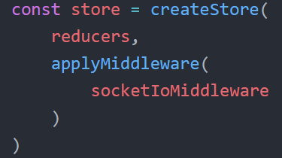

* + - * 1. Socket.IO on KAJKAI Backend

We use **socket.io** library on [NPM](https://www.npmjs.com/package/socket.io) to implement it on KAJKAI Backend.

* Initialization

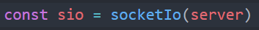

* Socket.IO authentication

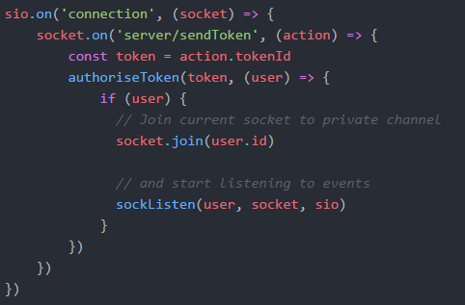

* + - 1. Using MongoDB with Mongoose

**Mongoose** is an library on [NPM](https://www.npmjs.com/package/mongoose) for Mongo, written in Node.js. The document of Mongoose is very clear and well updated. Every model in our project will be wrapped inside Mongoose Model. Thus, every model by default will have a unique _**id.**

* + - 1. Class diagram

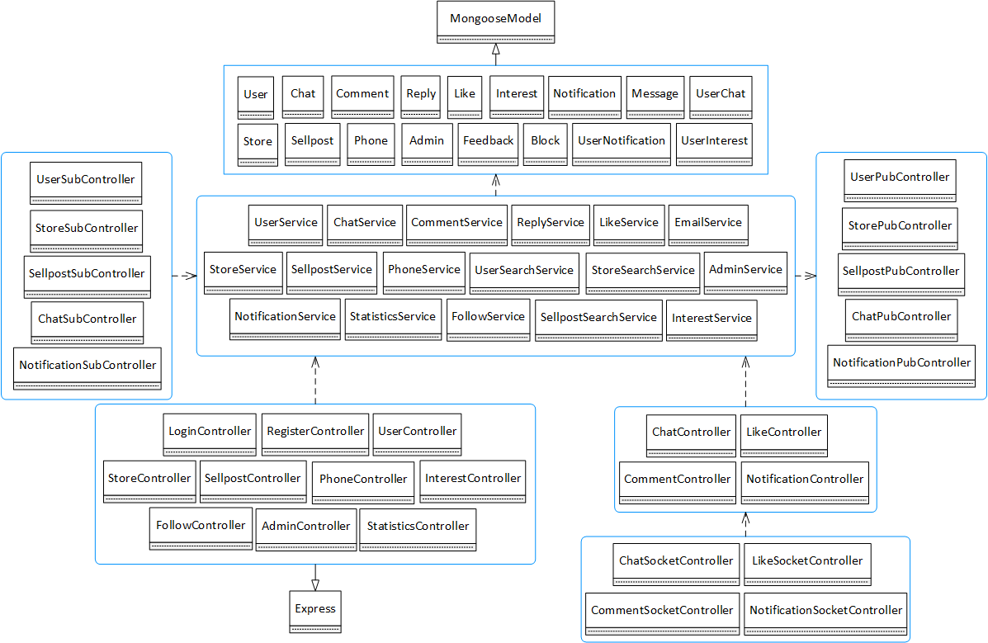

Figure ‑27: KAJKAI class diagram

* + 1. Detail Design
       1. Guest signs up

##### **Screen Design**

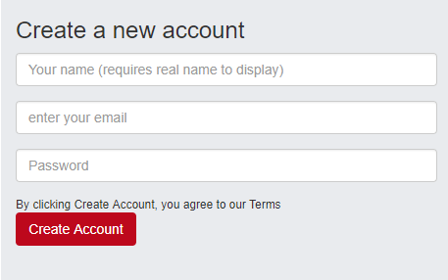

Figure 4‑28: Guest signs up screen design

##### **Class Diagram**

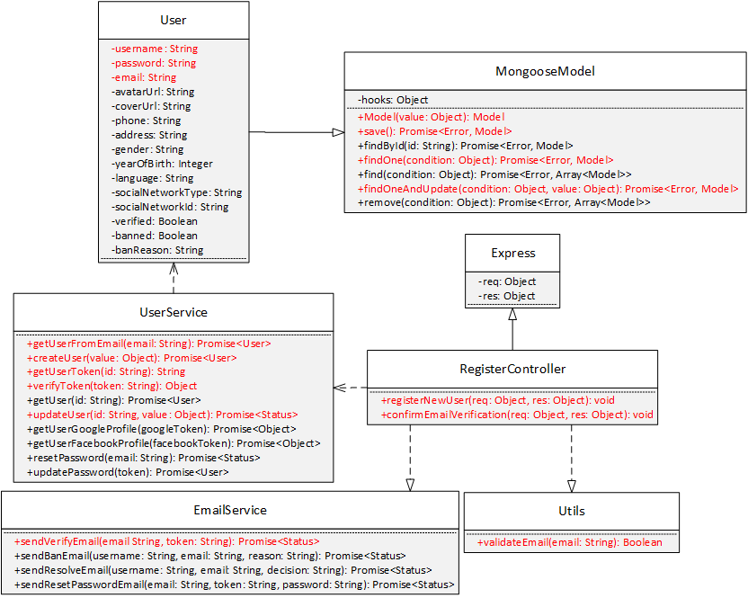

Figure 4‑29: Guest signs up class diagram

##### **Class Specification**

***User***

|  |  |  |  |
| --- | --- | --- | --- |
| **User** | | | |
| Physical address | Backend /models/User.js | | |
| Base class | MongooseModel | | |
| Attributes | | | |
| No | Name | Type | Description |
| 1 | username | String |  |
| 2 | password | String |  |
| 3 | email | String |  |
| Operation | | | |
|  |  |  |  |

***UserService***

|  |  |  |  |
| --- | --- | --- | --- |
| **UserService** | | | |
| Physical address | Backend /services/UserService.js | | |
| Base class |  | | |
| Attributes | | | |
| No | Name | Type | Description |
| Operation | | | |
| getUserFromEmail |  |  |  |
| Return Type | Promise<User> |  |  |
| Parameters | Name | Type | Description |
|  | email | String |  |
| createUser |  |  |  |
| Return Type | Promise<User> |  |  |
| Parameters | Name | Type | Description |
|  | value | Object |  |
| getUserToken |  |  |  |
| Return Type | String |  |  |
| Parameters | Name | Type | Description |
|  | id | String |  |
| verifyToken |  |  |  |
| Return Type | Object |  |  |
| Parameters | Name | Type | Description |
|  | token | String |  |
| updateUser |  |  |  |
| Return Type | Promise<Status> |  |  |
| Parameters | Name | Type | Description |
|  | id | String |  |
|  | value | Object |  |

***EmailService***

|  |  |  |  |
| --- | --- | --- | --- |
| **EmailService** | | | |
| Physical address | Backend /services/EmailService.js | | |
| Base class |  | | |
| Attributes | | | |
| No | Name | Type | Description |
| Operation | | | |
| sendVerifyEmail |  |  |  |
| Return Type | Promise<Status> |  |  |
| Parameters | Name | Type | Description |
|  | email | String |  |
|  | token | String |  |

***Utils***

|  |  |  |  |
| --- | --- | --- | --- |
| **Utils** | | | |
| Physical address | Backend /utils/index.js | | |
| Base class |  | | |
| Attributes | | | |
| No | Name | Type | Description |
| Operation | | | |
| validateEmail |  |  |  |
| Return Type | Boolean |  |  |
| Parameters | Name | Type | Description |
|  | email | String |  |

***RegisterController***

|  |  |  |  |
| --- | --- | --- | --- |
| **RegisterController** | | | |
| Physical address | Backend /controllers/RegisterController.js | | |
| Base class | Express | | |
| Attributes | | | |
| No | Name | Type | Description |
| Operation | | | |
| registerNewUser |  |  |  |
| Return Type | void |  |  |
| Parameters | Name | Type | Description |
|  | req | object |  |
|  | res | object |  |
| confirmEmailVerification |  |  |  |
| Return Type | void |  |  |
| Parameters | Name | Type | Description |
|  | req | object |  |
|  | res | object |  |

##### **Sequence Diagram**

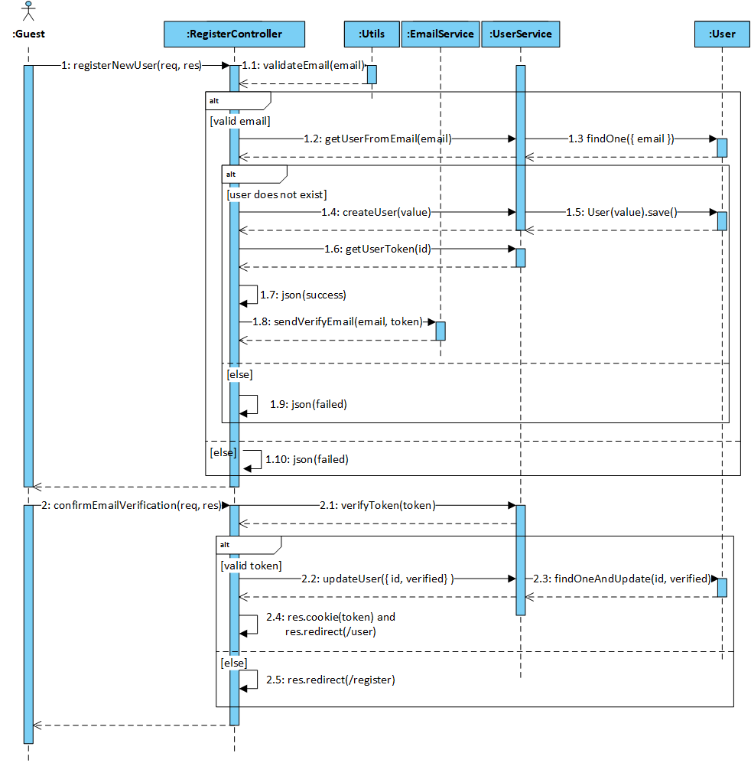

Figure 4‑30: Guest signs up sequence diagram

* + - 1. Guest resets password

##### **Screen Design**

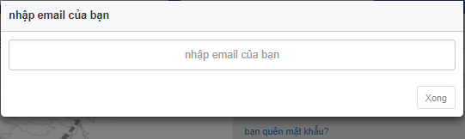

Figure 4‑31: Guest resets password screen design

##### **Class Diagram**

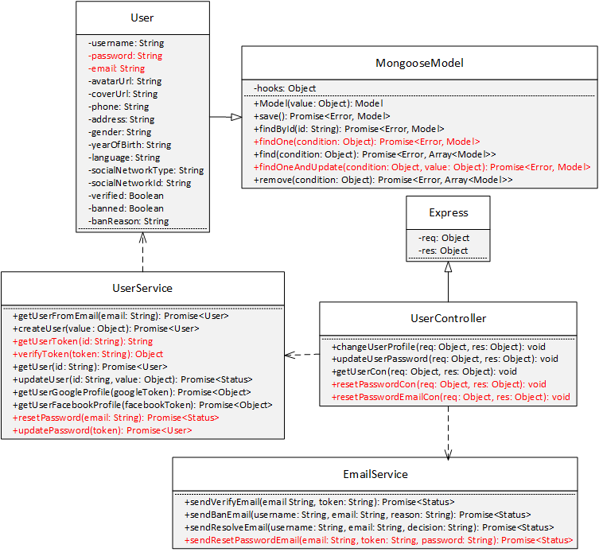

Figure 4‑32: Guest resets password class diagram

##### **Class Specification**

***User***

|  |  |  |  |
| --- | --- | --- | --- |
| **User** | | | |
| Physical address | Backend /models/User.js | | |
| Base class | MongooseModel | | |
| Attributes | | | |
| No | Name | Type | Description |
| 1 | email | String |  |
| 2 | password | String |  |
| Operation | | | |

***UserService***

|  |  |  |  |
| --- | --- | --- | --- |
| **UserService** | | | |
| Physical address | Backend /services/UserService.js | | |
| Base class |  | | |
| Attributes | | | |
| No | Name | Type | Description |
| Operation | | | |
| resetPassword |  |  |  |
| Return Type | Promise <Status> |  |  |
| Parameters | Name | Type | Description |
|  | email | string |  |
| updatePassword |  |  |  |
| Return Type | Promise<User> |  |  |
| Parameters | Name | Type | Description |
|  | token | String |  |

***EmailService***

|  |  |  |  |
| --- | --- | --- | --- |
| **EmailService** | | | |
| Physical address | Backend /services/EmailService.js | | |
| Base class |  | | |
| Attributes | | | |
| No | Name | Type | Description |
| Operation | | | |
| sendResetPasswordEmail |  |  |  |
| Return Type | Promise <Status> |  |  |
| Parameters | Name | Type | Description |
|  | email | String |  |
|  | token | String |  |
|  | password | String |  |

***UserController***

|  |  |  |  |
| --- | --- | --- | --- |
| **UserController** | | | |
| Physical address | Backend/controllers/UserController.js | | |
| Base class | Express | | |
| Attributes | | | |
| No | Name | Type | Description |
| Operation | | | |
| resetPasswordCon |  |  |  |
| Return Type | void |  |  |
| Parameters | Name | Type | Description |
|  | req | object |  |
|  | res | object |  |
| resetPasswordEmailCon |  |  |  |
| Return Type | void |  |  |
| Parameters | Name | Type | Description |
|  | req | object |  |
|  | res | object |  |

##### **Sequence Diagram**

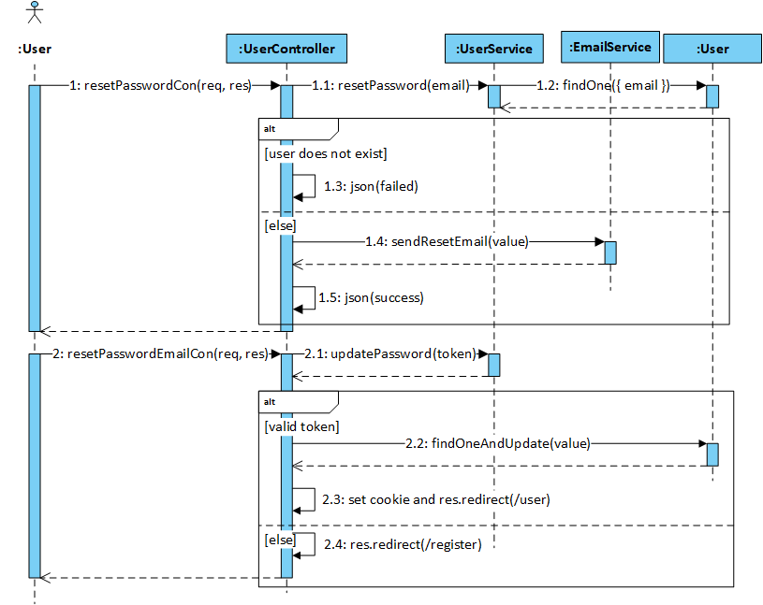

Figure 4‑33: Guest resets password sequence diagram

* + - 1. Guest logins by KajKai user account

##### **Screen Design**

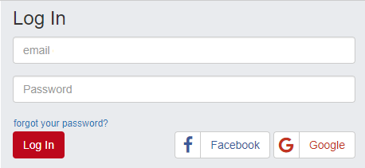

Figure 4‑34: Guest logins by KajKai user account screen design

##### **Class Diagram**

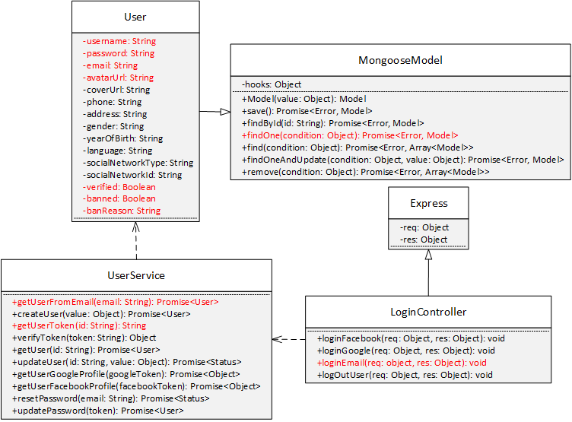

Figure 4‑35: Guest logins by KajKai user account class diagram.

##### **Class Specification**

***User***

|  |  |  |  |
| --- | --- | --- | --- |
| **User** | | | |
| Physical address | Backend /models/User.js | | |
| Base class | MongooseModel | | |
| Attributes | | | |
| No | Name | Type | Description |
| 1 | email | String |  |
| 2 | password | String |  |
| 3 | verified | Boolean |  |
| Operation | | | |
|  |  |  |  |

***UserService***

|  |  |  |  |
| --- | --- | --- | --- |
| **UserService** | | | |
| Physical address | Backend /services/UserService.js | | |
| Base class |  | | |
| Attributes | | | |
| No | Name | Type | Description |
| Operation | | | |
| getUserFromEmail |  |  |  |
| Return Type | Promise <User> |  |  |
| Parameters | Name | Type | Description |
|  | email | string |  |
| getUserToken |  |  |  |
| Return Type | String |  |  |
| Parameters | Name | Type | Description |
|  | id | String |  |

***LoginController***

|  |  |  |  |
| --- | --- | --- | --- |
| **LoginController** | | | |
| Physical address | Backend/controllers/LoginController.js | | |
| Base class | Express | | |
| Attributes | | | |
| No | Name | Type | Description |
| Operation | | | |
| loginEmail |  |  |  |
| Return Type | void |  |  |
| Parameters | Name | Type | Description |
|  | req | object |  |
|  | res | object |  |

##### **Sequence Diagram**

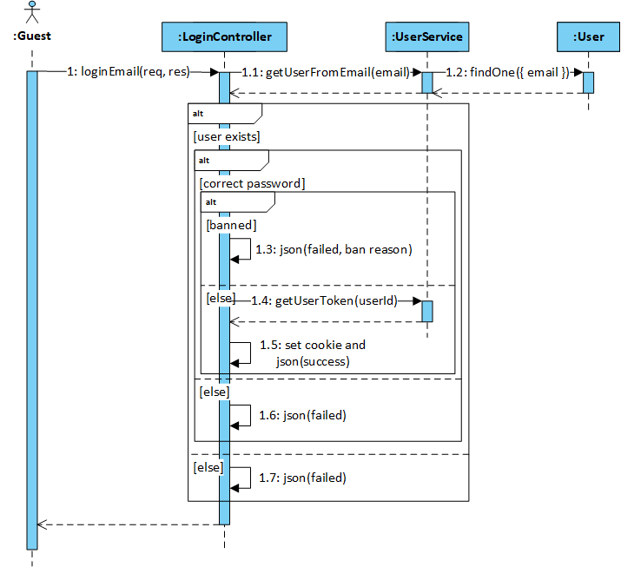

Figure 4‑36: Guest logins by KajKai user account sequence diagram

* + - 1. Guest logins by Gmail

##### **Screen Design**



Figure 4‑37: Guest logins by Gmail screen design

##### **Class Diagram**

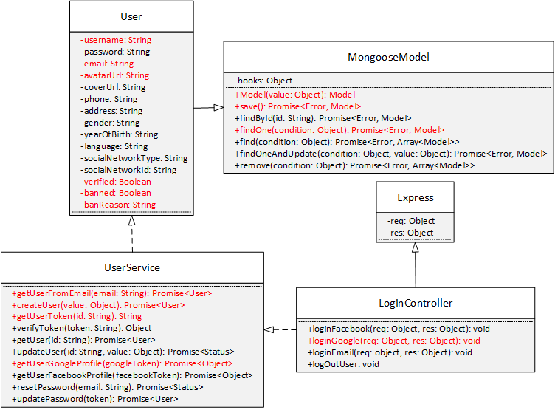

Figure 4‑38: Guest logins by Gmail class diagram

##### **Class Specification**

***User***

|  |  |  |  |
| --- | --- | --- | --- |
| **User** | | | |
| Physical address | Backend /models/User.js | | |
| Base class | MongooseModel | | |
| Attributes | | | |
| No | Name | Type | Description |
| 1 | email | String |  |
| 2 | username | String |  |
| 3 | avatarUrl | String |  |
| 4 | verified | Boolean |  |
| 5 | banned | Boolean |  |
| 6 | banReason | String |  |
| Operation | | | |

***LoginController***

|  |  |  |  |
| --- | --- | --- | --- |
| **LoginController** | | | |
| Physical address | Backend /controllers/LoginController.js | | |
| Base class | Express | | |
| Attributes | | | |
| No | Name | Type | Description |
| Operation | | | |
| loginGmail |  |  |  |
| Return Type | void |  |  |
| Parameters | Name | Type | Description |
|  | req | object |  |
|  | res | object |  |

***UserService***

|  |  |  |  |
| --- | --- | --- | --- |
| **UserService** | | | |
| Physical address | Backend /services/UserService.js | | |
| Base class |  | | |
| Attributes | | | |
| No | Name | Type | Description |
| Operation | | | |
| getUserFromEmail |  |  |  |
| Return Type | Promise <User> |  |  |
| Parameters | Name | Type | Description |
|  | email | string |  |
| createUser |  |  |  |
| Return Type | Promise<User> |  |  |
| Parameters | Name | Type | Description |
|  | value | Object |  |
| getUserToken |  |  |  |
| Return Type | String |  |  |
| Parameters | Name | Type | Description |
|  | id | String |  |
| getUserGoogleProfile |  |  |  |
| Return Type | Promise<Object> |  |  |
| Parameter | Name | Type | Decription |
|  | googleToken | String |  |

##### **Sequence Diagram**

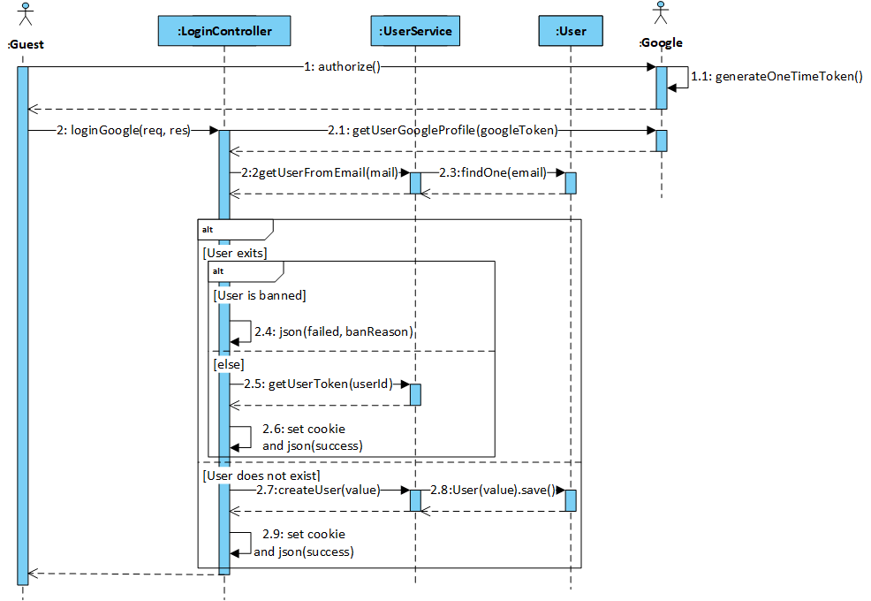

Figure 4‑39: Guest logins by Gmail sequence diagram

* + - 1. Guest logins by Facebook

##### **Screen Design**



Figure 4‑40: Guest logins by Facebook screen design

##### **Class Diagram**

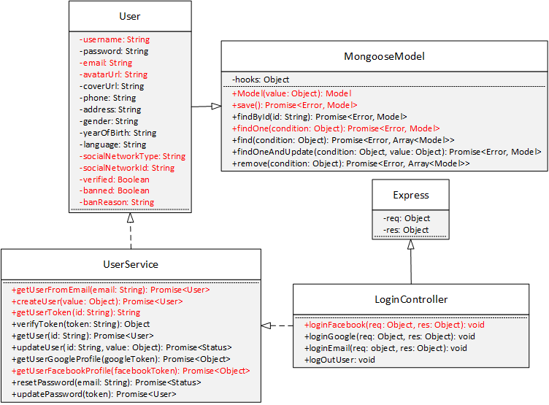

Figure 4‑41: Guest logins by Facebook class diagram

##### **Class Specification**

***User***

|  |  |  |  |
| --- | --- | --- | --- |
| **User** | | | |
| Physical address | Backend /models/User.js | | |
| Base class | MongooseModel | | |
| Attributes | | | |
| No | Name | Type | Description |
| 1 | email | String |  |
| 2 | username | String |  |
| 3 | avatarUrl | String |  |
| 4 | verified | Boolean |  |
| 5 | banned | Boolean |  |
| 6 | banReason | String |  |
| Operation | | | |
|  |  |  |  |

***LoginController***

|  |  |  |  |
| --- | --- | --- | --- |
| **LoginController** | | | |
| Physical address | Backend /controllers/LoginController.js | | |
| Base class | Express | | |
| Attributes | | | |
| No | Name | Type | Description |
| Operation | | | |
| loginFacebook |  |  |  |
| Return Type | void |  |  |
| Parameters | Name | Type | Description |
|  | req | object |  |
|  | res | object |  |

***UserService***

|  |  |  |  |
| --- | --- | --- | --- |
| **UserService** | | | |
| Physical address | Backend /services/UserService.js | | |
| Base class |  | | |
| Attributes | | | |
| No | Name | Type | Description |
| Operation | | | |
| getUserFromFacebookId |  |  |  |
| Return Type | Promise <User> |  |  |
| Parameters | Name | Type | Description |
|  | id | string |  |
| createUser |  |  |  |
| Return Type | Promise<User> |  |  |
| Parameters | Name | Type | Description |
|  | value | Object |  |
| getUserToken |  |  |  |
| Return Type | String |  |  |
| Parameters | Name | Type | Description |
|  | id | String |  |
| getUserFacebookProfile |  |  |  |
| Return Type | Promise<Object> |  |  |
| Parameter | Name | Type | Decription |
|  | facebookId | String |  |

##### **Sequence Diagram**

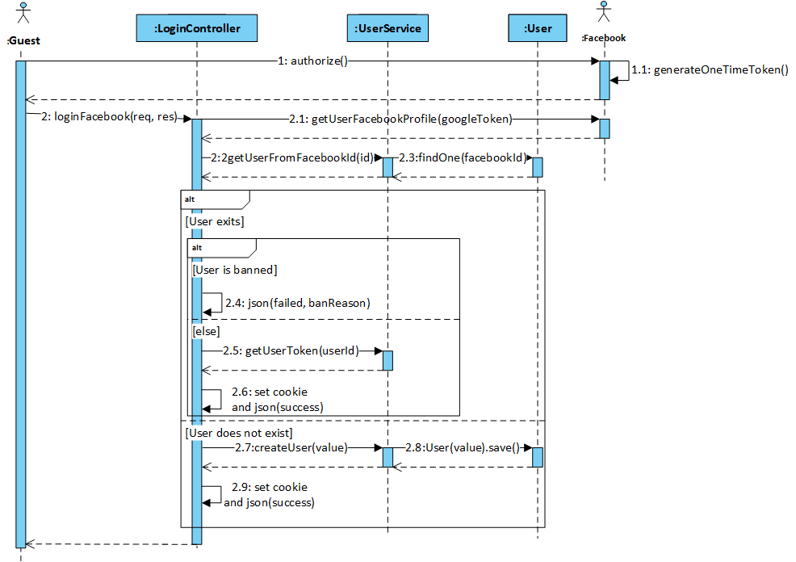

Figure 4‑42: Guest logins by Facebook sequence diagram

* + - 1. User views Home page

Home page is designed to allow user to view the searched result, so refer to 4.3.4.10, 4.3.4.11 4.3.4.12 for more details about search.

##### **Screen Design**

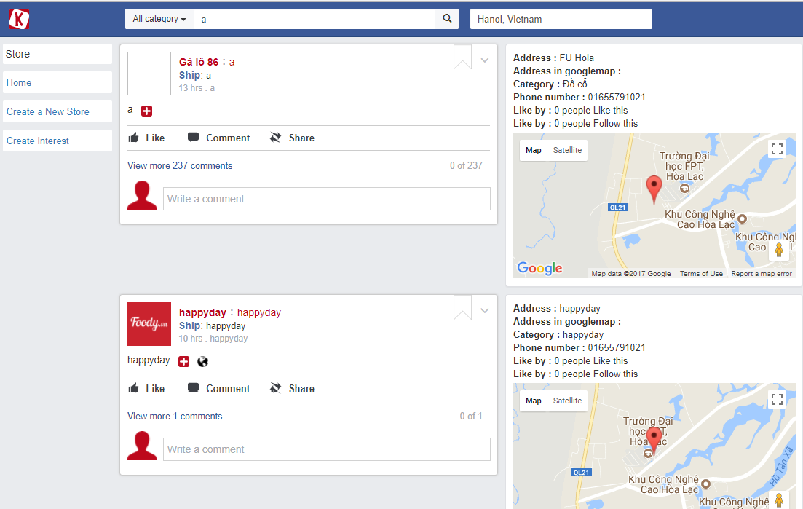

Figure ‑43: User views Home page screen design

* + - 1. User views User page

##### **Screen Design**

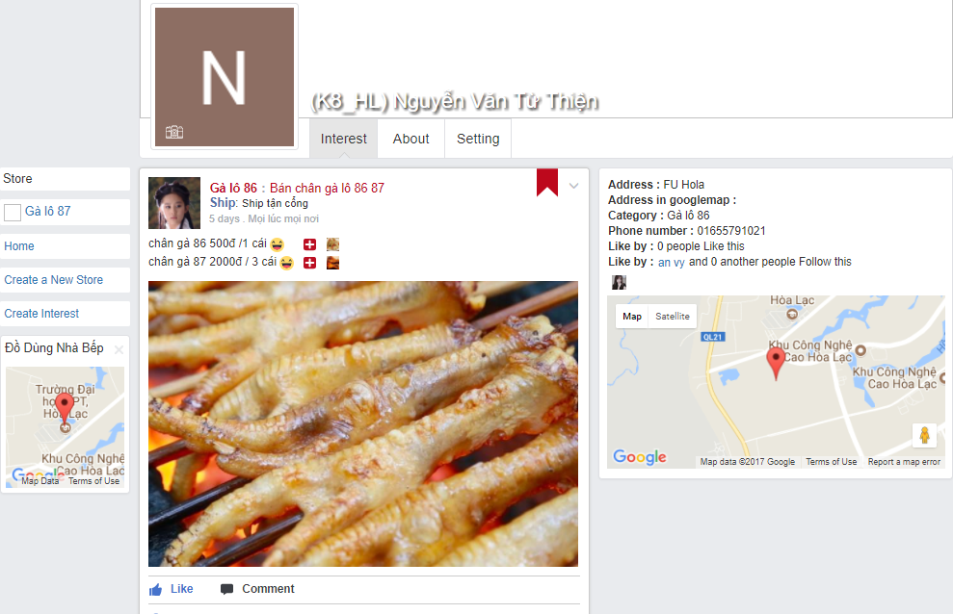

Figure 4‑44: User views User page screen design

##### **Class Diagram**

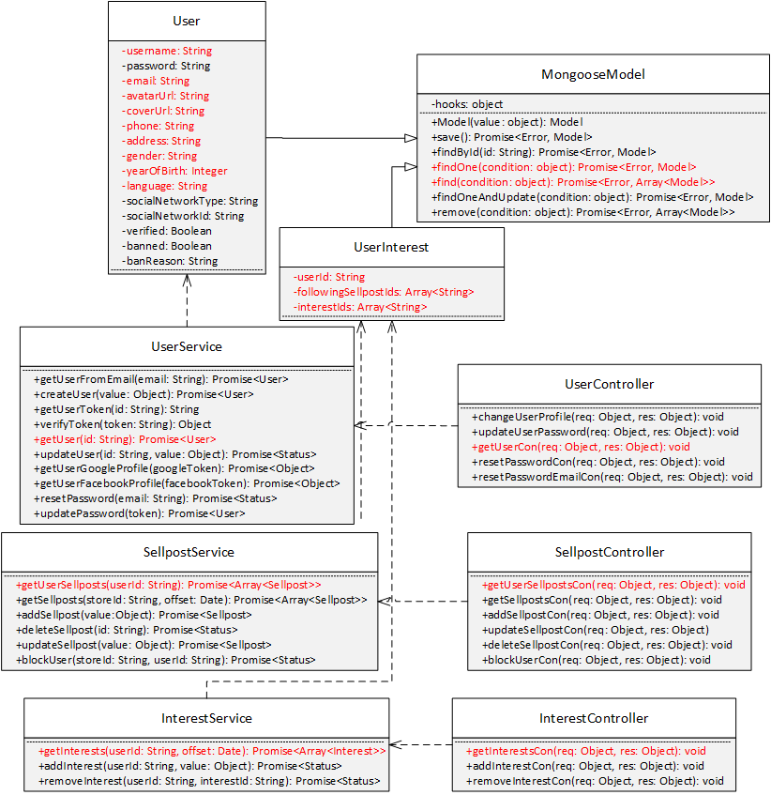

Figure 4‑45: User views User page class diagram

##### **Class Specification**

***User***

|  |  |  |  |
| --- | --- | --- | --- |
| **User** | | | |
| Physical address | Backend /models/User.js | | |
| Base class | MongooseModel | | |
| Attributes | | | |
| No | Name | Type | Description |
| 1 | username | String |  |
| 2 | email | String |  |
| 3 | avartarUrl | String |  |
| 4 | coverUrl | String |  |
| 5 | phone | String |  |
| 6 | address | String |  |
| 7 | gender | String |  |
| 8 | yearOfBirth | Integer |  |
| 9 | language | String |  |
| Operation | | | |
|  |  |  |  |

***UserInterest***

|  |  |  |  |
| --- | --- | --- | --- |
| **UserInterest** | | | |
| Physical address | Backend /models/UserInterest.js | | |
| Base class | MongooseModel | | |
| Attributes | | | |
| No | Name | Type | Description |
| 1 | userId | String |  |
| 2 | followingSellpostIds | Array<String> |  |
| 3 | InterestIds | Array<String> |  |
| Operation | | | |
|  |  |  |  |

***UserService***

|  |  |  |  |
| --- | --- | --- | --- |
| **UserService** | | | |
| Physical address | Backend /services/UserService.js | | |
| Base class |  | | |
| Attributes | | | |
| No | Name | Type | Description |
| Operation | | | |
| getUser |  |  |  |
| Return Type | Promise<User> |  |  |
| Parameters | Name | Type | Description |
|  | id | String |  |

***SellpostService***

|  |  |  |  |
| --- | --- | --- | --- |
| **SellpostService** | | | |
| Physical address | Backend /services/SellpostService.js | | |
| Base class |  | | |
| Attributes | | | |
| No | Name | Type | Description |
| Operation | | | |
| getUserSellposts |  |  |  |
| Return Type | Promise<Array<Sellpost>> |  |  |
| Parameters | Name | Type | Description |
|  | userId | String |  |

***InterestService***

|  |  |  |  |
| --- | --- | --- | --- |
| **InterestService** | | | |
| Physical address | Backend /services/InterestService.js | | |
| Base class |  | | |
| Attributes | | | |
| No | Name | Type | Description |
| Operation | | | |
| getInterests |  |  |  |
| Return Type | Promise<Array<Interest>> |  |  |
| Parameters | Name | Type | Description |
|  | userId | String |  |
|  | offset | Date |  |

***UserController***

|  |  |  |  |
| --- | --- | --- | --- |
| **RegisterController** | | | |
| Physical address | Backend /controllers/RegisterController.js | | |
| Base class | Express | | |
| Attributes | | | |
| No | Name | Type | Description |
| Operation | | | |
| changeUserProfile |  |  |  |
| Return Type | void |  |  |
| Parameters | Name | Type | Description |
|  | req | object |  |
|  | res | object |  |

##### **Sequence Diagram**

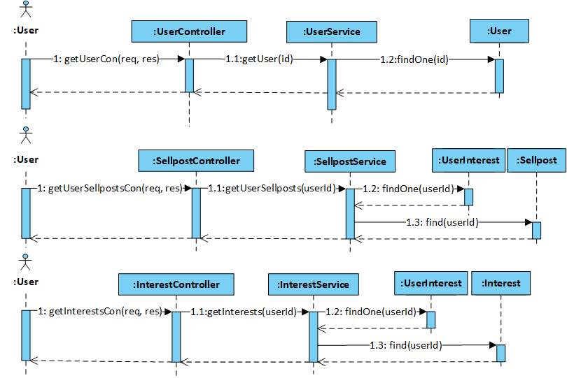

Figure 4‑26: User views User page sequence diagram

* + - 1. User edits general info

##### **Screen Design**

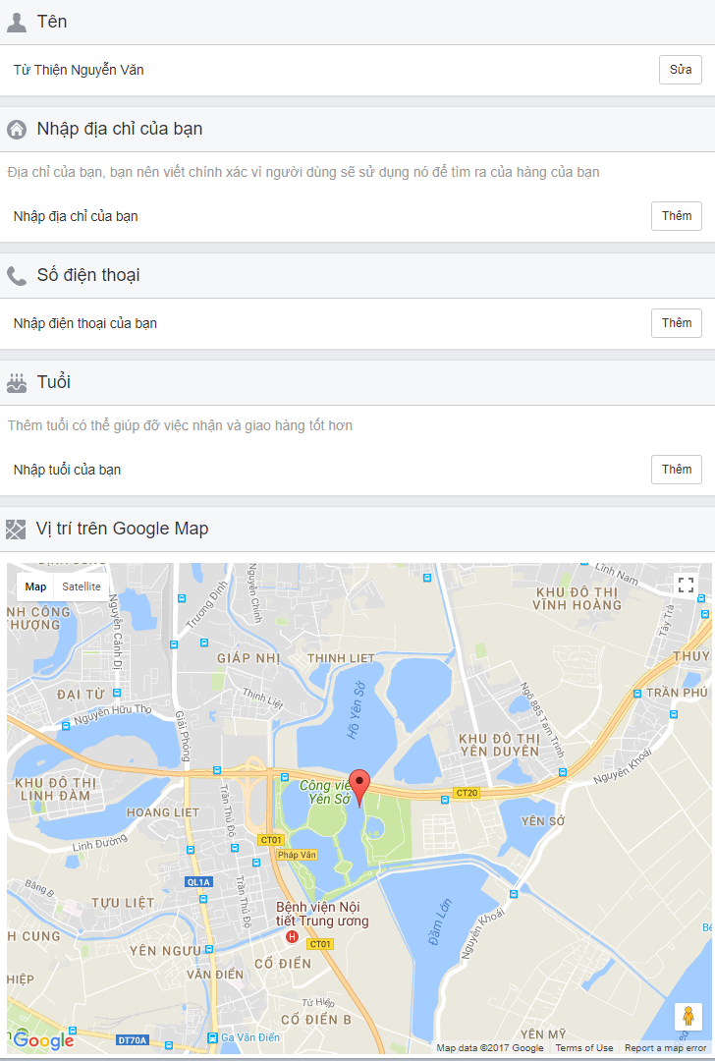

Figure 4‑47: User edits general info screen design

##### **Class Diagram**

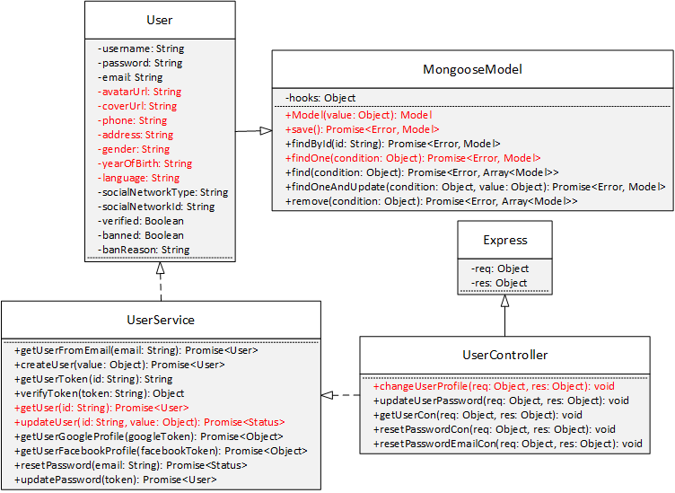

Figure 4‑48: User edits general info class diagram

##### **Class Specification**

***User***

|  |  |  |  |
| --- | --- | --- | --- |
| **User** | | | |
| Physical address | Backend /models/User.js | | |
| Base class | MongooseModel | | |
| Attributes | | | |
| No | Name | Type | Description |
| 1 | avartarUrl | String |  |
| 2 | coverUrl | String |  |
| 3 | phone | String |  |
| 4 | address | String |  |
| 5 | gender | String |  |
| 6 | yearOfBirth | Number |  |
| 7 | language | String |  |
| Operation | | | |

***UserService***

|  |  |  |  |
| --- | --- | --- | --- |
| **UserService** | | | |
| Physical address | Backend /services/UserService.js | | |
| Base class |  | | |
| Attributes | | | |
| No | Name | Type | Description |
| Operation | | | |
| getUser |  |  |  |
| Return Type | Promise<User> |  |  |
| Parameters | Name | Type | Description |
|  | id | String |  |
| updateUser |  |  |  |
| Return Type | Promise<User> |  |  |
| Parameters | Name | Type | Description |
|  | id | String |  |
|  | value | Object |  |

***UserController***

|  |  |  |  |
| --- | --- | --- | --- |
| **RegisterController** | | | |
| Physical address | Backend /controllers/RegisterController.js | | |
| Base class | Express | | |
| Attributes | | | |
| No | Name | Type | Description |
| Operation | | | |
| changeUserProfile |  |  |  |
| Return Type | void |  |  |
| Parameters | Name | Type | Description |
|  | req | object |  |
|  | res | object |  |

##### **Sequence Diagram**

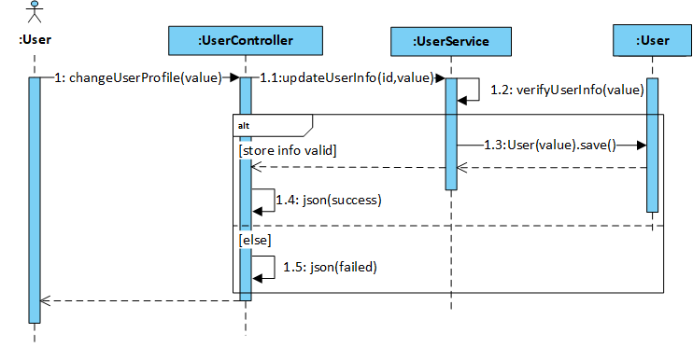

Figure 4‑49: User edits general info sequence diagram

* + - 1. User changes password

##### **Screen Design**

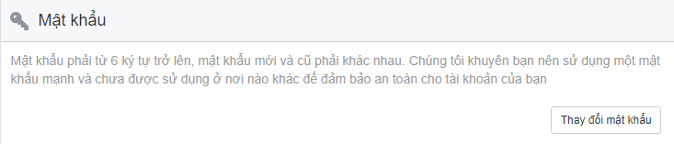

Figure 4‑50: User changes password screen design

##### **Class Diagram**

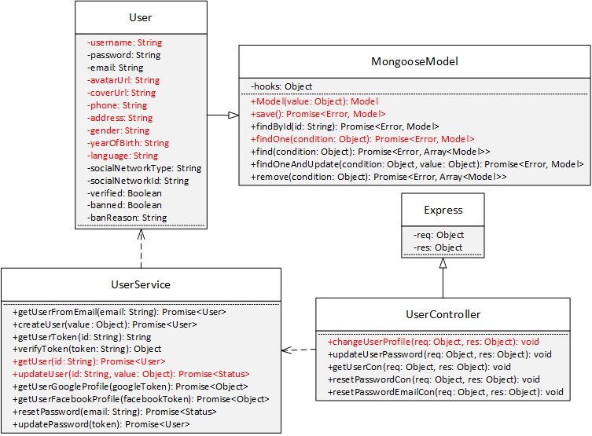

Figure 4‑51: User changes password class diagram

##### **Class Specification**

***User***

|  |  |  |  |
| --- | --- | --- | --- |
| **User** | | | |
| Physical address | Backend /models/User.js | | |
| Base class | MongooseModel | | |
| Attributes | | | |
| No | Name | Type | Description |
| 1 | password | String |  |
| Operation | | | |
|  |  |  |  |

***UserService***

|  |  |  |  |
| --- | --- | --- | --- |
| **UserService** | | | |
| Physical address | Backend /services/UserService.js | | |
| Base class |  | | |
| Attributes | | | |
| No | Name | Type | Description |
| Operation | | | |
| getUser |  |  |  |
| Return Type | Promise<User> |  |  |
| Parameters | Name | Type | Description |
|  | id | String |  |
| updateUser |  |  |  |
| Return Type | Promise<User> |  |  |
| Parameters | Name | Type | Description |
|  | id | String |  |
|  | value | Object |  |

***UserController***

|  |  |  |  |
| --- | --- | --- | --- |
| **UserController** | | | |
| Physical address | Backend /controllers/UserController.js | | |
| Base class | Express | | |
| Attributes | | | |
| No | Name | Type | Description |
| Operation | | | |
| updateUserPassword |  |  |  |
| Return Type | void |  |  |
| Parameters | Name | Type | Description |
|  | req | object |  |
|  | res | object |  |

##### **Sequence Diagram**

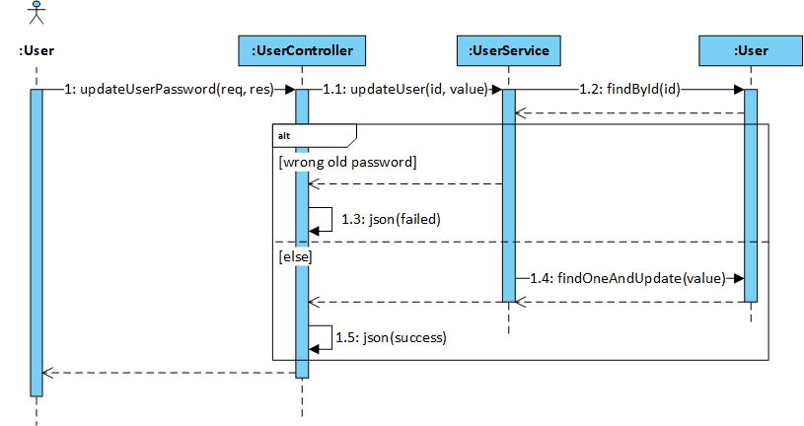

Figure ‑52: User changes password sequence diagram

* + - 1. User searches user

##### **Screen Design**

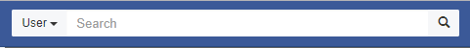

Figure ‑53: User search user screen design

##### **Class Diagram**

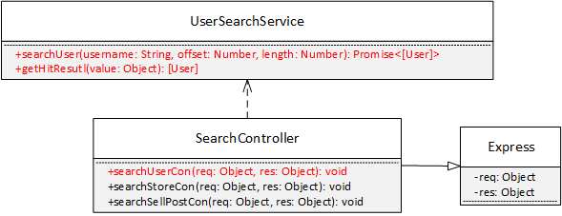

Figure 4‑54: User search user class diagram

##### **Class Specification**

***UserSearchService***

|  |  |  |  |
| --- | --- | --- | --- |
| **User** | | | |
| Physical address | Backend /services/UserSearchService.js | | |
| Base class |  | | |
| Attributes | | | |
| No | Name | Type | Description |
| Operation | | | |
| searchUser |  |  |  |
| Return Type | Promise<[User]> |  |  |
| Parameters | Name | Type | Description |
|  | username | String |  |
|  | offset | Number |  |
|  | length | Number |  |
| getHitResults |  |  |  |
| Return Type | [User] |  |  |
| Parameters | Name | Type | Description |
|  | value | Object |  |

***SearchController***

|  |  |  |  |
| --- | --- | --- | --- |
| **SearchController** | | | |
| Physical address | Backend /controllers/SearchController.js | | |
| Base class | Express | | |
| Attributes | | | |
| No | Name | Type | Description |
| Operation | | | |
| searchUserCon |  |  |  |
| Return Type | void |  |  |
| Parameters | Name | Type | Description |
|  | req | object |  |
|  | res | object |  |

##### **Sequence Diagram**

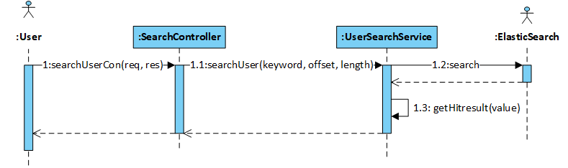

Figure 4‑55: User search user sequence diagram

* + - 1. User searches store

##### **Screen Design**



Figure 4‑56: User search store screen design

##### **Class Diagram**

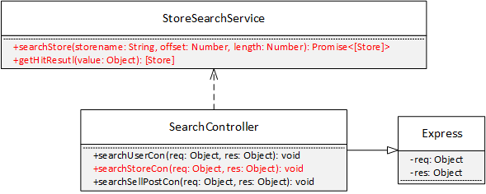

Figure 4‑57: User search store class diagram

##### **Class Specification**

***StoreSearchService***

|  |  |  |  |
| --- | --- | --- | --- |
| **Store** | | | |
| Physical address | Backend /services/StoreSearchService.js | | |
| Base class |  | | |
| Attributes | | | |
| No | Name | Type | Description |
| Operation | | | |
| searchUser |  |  |  |
| Return Type | Promise<[Store]> |  |  |
| Parameters | Name | Type | Description |
|  | storename | String |  |
|  | offset | Number |  |
|  | length | Number |  |
| getHitResults |  |  |  |
| Return Type | [Store] |  |  |
| Parameters | Name | Type | Description |
|  | value | Object |  |

***SearchController***

|  |  |  |  |
| --- | --- | --- | --- |
| **SearchController** | | | |
| Physical address | Backend /controllers/SearchController.js | | |
| Base class | Express | | |
| Attributes | | | |
| No | Name | Type | Description |
| Operation | | | |
| searchStoreCon |  |  |  |
| Return Type | void |  |  |
| Parameters | Name | Type | Description |
|  | req | object |  |
|  | res | object |  |

##### **Sequence Diagram**

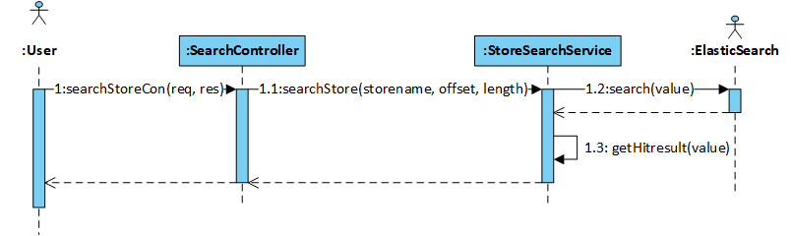

Figure 4‑58: User search store sequence diagram

* + - 1. User searches sellpost

##### **Screen Design**



Figure 4‑59: User search sellpost screen design

##### **Class Diagram**

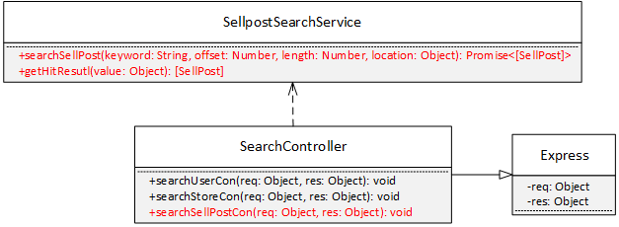

Figure 4‑60: User search sellpost class diagram

##### **Class Specification**

***SellPostSearchService***

|  |  |  |  |
| --- | --- | --- | --- |
| **Store** | | | |
| Physical address | Backend /services/StoreSearchService.js | | |
| Base class | Express | | |
| Attributes | | | |
| No | Name | Type | Description |
| Operation | | | |
| searchUser |  |  |  |
| Return Type | Promise<[SellPost]> |  |  |
| Parameters | Name | Type | Description |
|  | keyword | String |  |
|  | offset | Number |  |
|  | length | Number |  |
|  | location | Object |  |
| getHitResults |  |  |  |
| Return Type | [SellPost] |  |  |
| Parameters | Name | Type | Description |
|  | value | Object |  |

***SearchController***

|  |  |  |  |
| --- | --- | --- | --- |
| **SearchController** | | | |
| Physical address | Backend /controllers/SearchController.js | | |
| Base class | Express | | |
| Attributes | | | |
| No | Name | Type | Description |
| Operation | | | |
| searchSellPostCon |  |  |  |
| Return Type | void |  |  |
| Parameters | Name | Type | Description |
|  | req | object |  |
|  | res | object |  |

##### **Sequence Diagram**

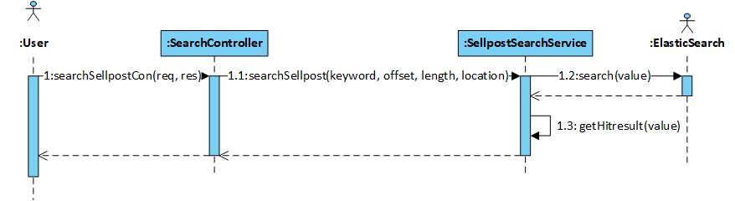

Figure 4‑61: User search sellpost sequence diagram

* + - 1. User chats

##### **Screen Design**

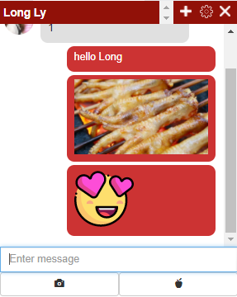

Figure 4-62: User chats sccreen design

##### **Class Diagram**

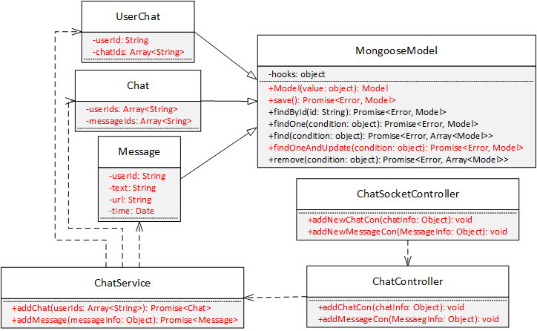

Figure 4‑63: User chats class diagram

##### **Class Specification**

***Message***

|  |  |  |  |
| --- | --- | --- | --- |
| **Message** | | | |
| Physical address | Backend /models/Message.js | | |
| Base class |  | | |
| Attributes | | | |
| No | Name | Type | Description |
| 1 | userId | String |  |
| 2 | text | String |  |
| 3 | url | String |  |
| 4 | time | Date |  |
| Operation | | | |

***Chat***

|  |  |  |  |
| --- | --- | --- | --- |
| **Chat** | | | |
| Physical address | Backend /models/Chat.js | | |
| Base class |  | | |
| Attributes | | | |
| No | Name | Type | Description |
| 1 | userIds | Array<String> |  |
| 2 | messageIds | Array<String> |  |
| Operation | | | |

***UserChat***

|  |  |  |  |
| --- | --- | --- | --- |
| **UserChat** | | | |
| Physical address | Backend /models/UserChat.js | | |
| Base class |  | | |
| Attributes | | | |
| No | Name | Type | Description |
| 1 | userId | String |  |
| 2 | chatIds | Array<String> |  |
| Operation | | | |

***ChatService***

|  |  |  |  |
| --- | --- | --- | --- |
| **ChatService** | | | |
| Physical address | Backend /services/ChatService.js | | |
| Base class |  | | |
| Attributes | | | |
| No | Name | Type | Description |
| Operation | | | |
| addChat |  |  |  |
| Return Type | Promise<Chat> |  |  |
| Parameters | Name | Type | Description |
|  | userIds | Array<String> |  |
| addMessage |  |  |  |
| Return Type | Promise<Message> |  |  |
| Parameters | Name | Type | Description |
|  | messageInfo | Object |  |

***ChatController***

|  |  |  |  |
| --- | --- | --- | --- |
| **ChatController** | | | |
| Physical address | Backend /controllers/ChatController.js | | |
| Base class | Express | | |
| Attributes | | | |
| No | Name | Type | Description |
| Operation | | | |
| addChatCon |  |  |  |
| Return Type | void |  |  |
| Parameters | Name | Type | Description |
|  | chatInfo | Object |  |
| addMessageCon |  |  |  |
| Return Type | void |  |  |
| Parameters | Name | Type | Description |
|  | messageInfo | Object |  |

***ChatSocketController***

|  |  |  |  |
| --- | --- | --- | --- |
| **ChatSocketController** | | | |
| Physical address | Backend /controllers/ChatSocketControllers.js | | |
| Base class |  | | |
| Attributes | | | |
| No | Name | Type | Description |
| Operation | | | |
| addNewChatCon |  |  |  |
| Return Type | void |  |  |
| Parameters | Name | Type | Description |
|  | chatInfo | Object |  |
| addNewMessageCon |  |  |  |
| Return Type | void |  |  |
| Parameters | Name | Type | Description |
|  | messageInfo | Object |  |

##### **Sequence Diagram**

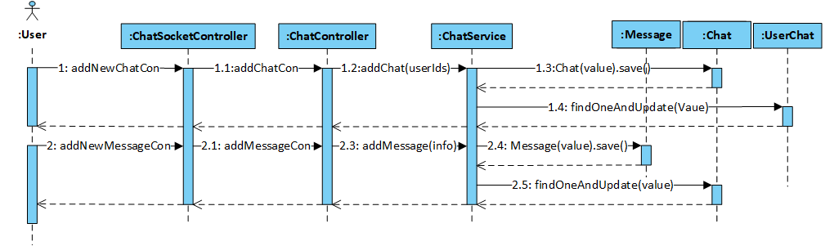

Figure 4‑64: User chats sequence diagram

* + - 1. User comments

##### **Screen Design**

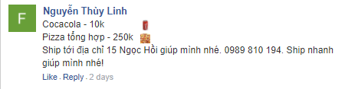

Figure 4‑65: User comments screen design

##### **Class Diagram**

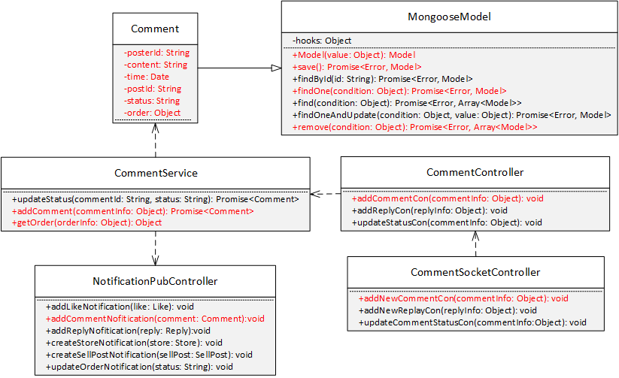

Figure 4‑66: User comments class diagram

**Class Specification**

***Comment***

|  |  |  |  |
| --- | --- | --- | --- |
| **Comment** | | | |
| Physical address | Backend /models/Comment.js | | |
| Base class |  | | |
| Attributes | | | |
| No | Name | Type | Description |
| 1 | posterId | String |  |
| 2 | content | String |  |
| 3 | time | Number |  |
| 4 | postId | String |  |
| 5 | order | Object |  |
| 6 | status | String |  |
| Operation | | | |

***CommentService***

|  |  |  |  |
| --- | --- | --- | --- |
| **CommentService** | | | |
| Physical address | Backend /services/CommentService.js | | |
| Base class |  | | |
| Attributes | | | |
| No | Name | Type | Description |
| Operation | | | |
| addComment |  |  |  |
| Return Type | Promise<Comment> |  |  |
| Parameters | Name | Type | Description |
|  | commentInfo | Object |  |

***CommentController***

|  |  |  |  |
| --- | --- | --- | --- |
| **CommentController** | | | |
| Physical address | Backend /controllers/CommentController.js | | |
| Base class | Express | | |
| Attributes | | | |
| No | Name | Type | Description |
| Operation | | | |
| addCommentCon |  |  |  |
| Return Type | void |  |  |
| Parameters | Name | Type | Description |
|  | commentInfo | Object |  |

***CommentSocketController***

|  |  |  |  |
| --- | --- | --- | --- |
| **CommentSocketController** | | | |
| Physical address | Backend /controllers/CommentSocketControllers.js | | |
| Base class |  | | |
| Attributes | | | |
| No | Name | Type | Description |
| Operation | | | |
| addNewCommentCon |  |  |  |
| Return Type | void |  |  |
| Parameters | Name | Type | Description |
|  | commentInfo | Object |  |

***NotificationPubController***

|  |  |  |  |
| --- | --- | --- | --- |
| **NotificationPubController** | | | |
| Physical address | Backend /controllers/NotificationPubController.js | | |
| Base class |  | | |
| Attributes | | | |
| No | Name | Type | Description |
| Operation | | | |
| addCommentNotification |  |  |  |
| Return Type | void |  |  |
| Parameters | Name | Type | Description |
|  | comment | Like |  |

##### **Sequence Diagram**

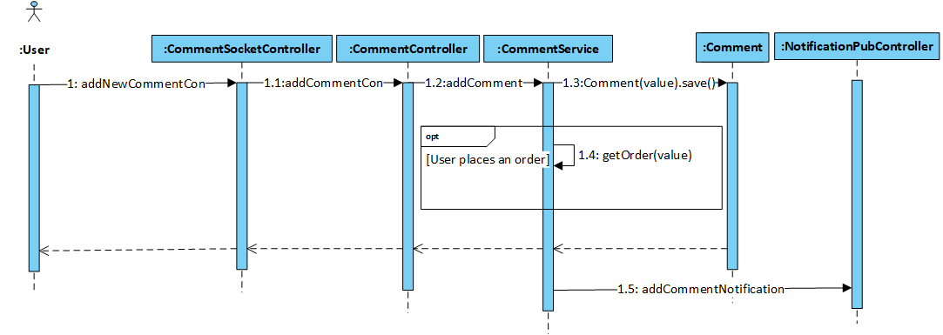

Figure 4‑67: User comment sequence diagram

* + - 1. User replies comment

##### **Screen Design**

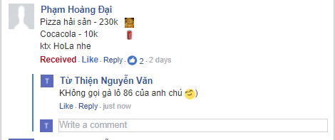

Figure 4‑68: User replies comment screen design

##### **Class Diagram**

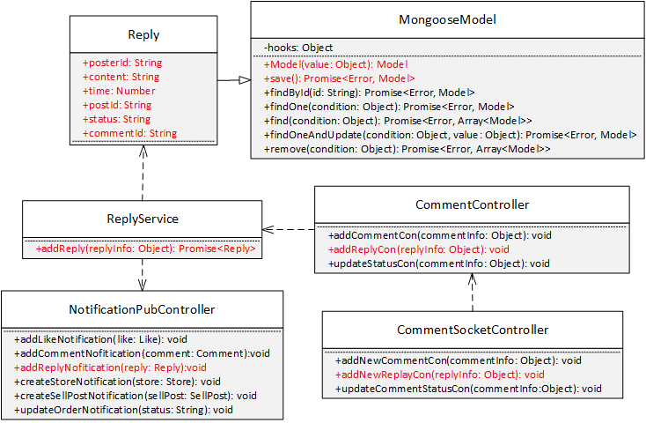

Figure 4‑69: User replies comment class diagram

##### **Class Specification**

***Reply***

|  |  |  |  |
| --- | --- | --- | --- |
| **Reply** | | | |
| Physical address | Backend /models/Reply.js | | |
| Base class |  | | |
| Attributes | | | |
| No | Name | Type | Description |
| 1 | posterId | String |  |
| 2 | content | String |  |
| 3 | time | Number |  |
| 4 | postId | String |  |
| 5 | commentId | String |  |
| 6 | status | String |  |
| Operation | | | |

***ReplyService***

|  |  |  |  |
| --- | --- | --- | --- |
| **ReplyService** | | | |
| Physical address | Backend /services/ReplyService.js | | |
| Base class |  | | |
| Attributes | | | |
| No | Name | Type | Description |
| Operation | | | |
| addReply |  |  |  |
| Return Type | Promise<Comment> |  |  |
| Parameters | Name | Type | Description |
|  | replyInfo | Object |  |

***CommentController***

|  |  |  |  |
| --- | --- | --- | --- |
| **CommentController** | | | |
| Physical address | Backend /controllers/CommentController.js | | |
| Base class |  | | |
| Attributes | | | |
| No | Name | Type | Description |
| Operation | | | |
| addReplyCon |  |  |  |
| Return Type | void |  |  |
| Parameters | Name | Type | Description |
|  | replyInfo | Object |  |

***CommentSocketController***

|  |  |  |  |
| --- | --- | --- | --- |
| **CommentSocketController** | | | |
| Physical address | Backend /controllers/CommentSocketControllers.js | | |
| Base class |  | | |
| Attributes | | | |
| No | Name | Type | Description |
| Operation | | | |
| addNewReplyCon |  |  |  |
| Return Type | void |  |  |
| Parameters | Name | Type | Description |
|  | replyInfo | Object |  |

***NotificationPubController***

|  |  |  |  |
| --- | --- | --- | --- |
| **NotificationPubController** | | | |
| Physical address | Backend /controllers/NotificationPubController.js | | |
| Base class |  | | |
| Attributes | | | |
| No | Name | Type | Description |
| Operation | | | |
| addReplyNotification |  |  |  |
| Return Type | void |  |  |
| Parameters | Name | Type | Description |
|  | reply | Reply |  |

##### **Sequence Diagram**

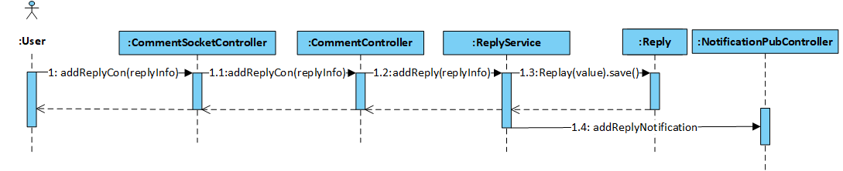

Figure 4‑70: User replies comment sequence diagram

* + - 1. User likes and unlikes comment, reply

##### **Screen Design**

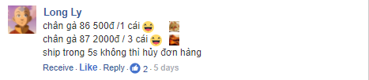

Figure 4‑71: User likes and unlikes comment, reply screen design

##### **Class Diagram**

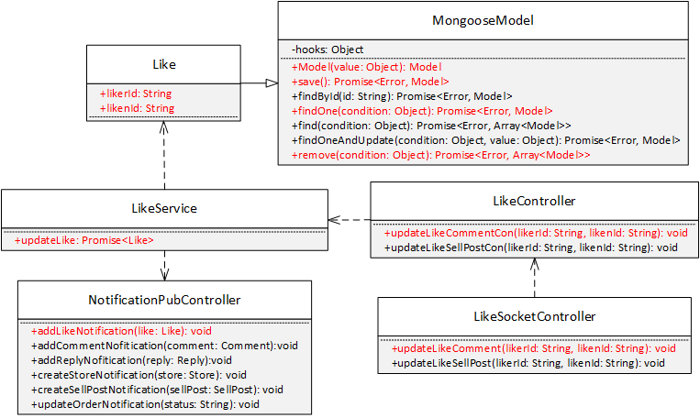

Figure 4‑72: User likes and unlikes comment, reply screen class diagram

##### **Class Specification**

***Like***

|  |  |  |  |
| --- | --- | --- | --- |
| **Like** | | | |
| Physical address | Backend /models/Like.js | | |
| Base class |  | | |
| Attributes | | | |
| No | Name | Type | Description |
| 1 | likerId | String |  |
| 2 | likenId | String |  |
| Operation | | | |

***LikeService***

|  |  |  |  |
| --- | --- | --- | --- |
| **LikeService** | | | |
| Physical address | Backend /services/LikeServices.js | | |
| Base class |  | | |
| Attributes | | | |
| No | Name | Type | Description |
| Operation | | | |
| updateLike |  |  |  |
| Return Type | Promise<Like> |  |  |
| Parameters | Name | Type | Description |
|  | likerId | String |  |
|  | likenId | String |  |

***LikeController***

|  |  |  |  |
| --- | --- | --- | --- |
| **LikeController** | | | |
| Physical address | Backend /controllers/LikeControllers.js | | |
| Base class |  | | |
| Attributes | | | |
| No | Name | Type | Description |
| Operation | | | |
| updateLikeCommentCon |  |  |  |
| Return Type | void |  |  |
| Parameters | Name | Type | Description |
|  | likerId | String |  |
|  | likenId | String |  |

***LikeSocketController***

|  |  |  |  |
| --- | --- | --- | --- |
| **LikeSocketController** | | | |
| Physical address | Backend /controllers/LikeControllers.js | | |
| Base class |  | | |
| Attributes | | | |
| No | Name | Type | Description |
| Operation | | | |
| updateLikeComment |  |  |  |
| Return Type | void |  |  |
| Parameters | Name | Type | Description |
|  | likerId | String |  |
|  | likenId | String |  |

***NotificationPubController***

|  |  |  |  |
| --- | --- | --- | --- |
| **NotificationPubController** | | | |
| Physical address | Backend /controllers/NotificationPubController.js | | |
| Base class |  | | |
| Attributes | | | |
| No | Name | Type | Description |
| Operation | | | |
| addLikeNotification |  |  |  |
| Return Type | void |  |  |
| Parameters | Name | Type | Description |
|  | like | Like |  |

##### **Sequence Diagram**

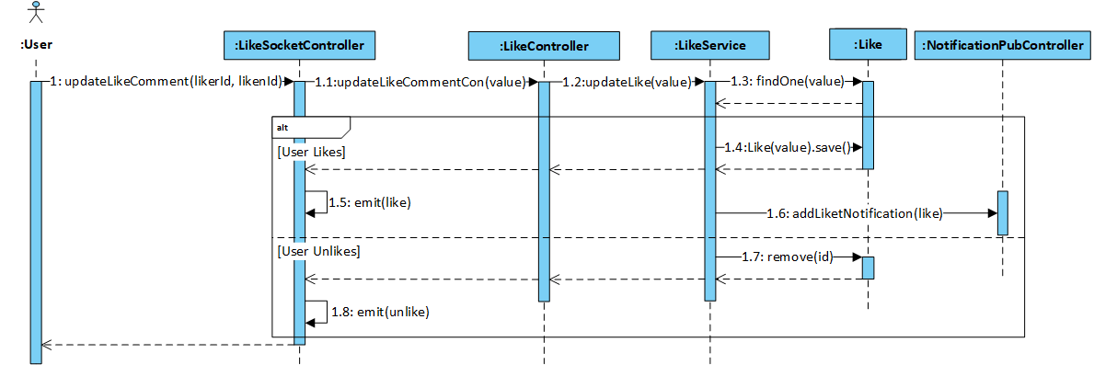

Figure 4‑73: User likes and unlikes comment, reply sequence diagram

* + - 1. User likes and unlikes sellpost

##### **Screen Design**

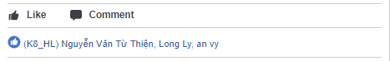

Figure 4‑74: User likes and unlikes sellpost screen design

##### **Class Diagram**

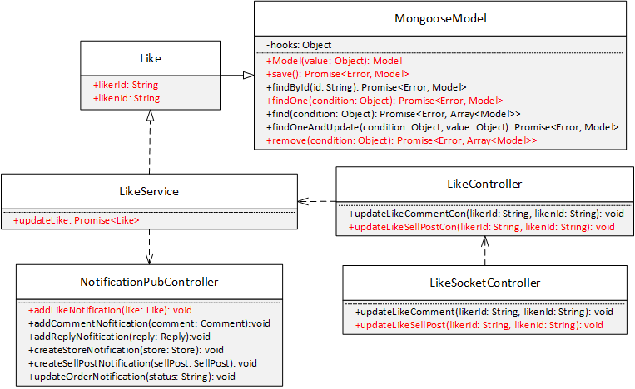

Figure 4‑75: likes and unlikes sellpost class diagram

##### **Class Specification**

***Like***

|  |  |  |  |
| --- | --- | --- | --- |
| **Like** | | | |
| Physical address | Backend /models/Like.js | | |
| Base class |  | | |
| Attributes | | | |
| No | Name | Type | Description |
| 1 | likerId | String |  |
| 2 | likenId | String |  |
| Operation | | | |

***LikeService***

|  |  |  |  |
| --- | --- | --- | --- |
| **LikeService** | | | |
| Physical address | Backend /services/LikeServices.js | | |
| Base class |  | | |
| Attributes | | | |
| No | Name | Type | Description |
| Operation | | | |
| updateLike |  |  |  |
| Return Type | Promise<Like> |  |  |
| Parameters | Name | Type | Description |
|  | likerId | String |  |
|  | likenId | String |  |

***LikeController***

|  |  |  |  |
| --- | --- | --- | --- |
| **LikeController** | | | |
| Physical address | Backend /controllers/LikeControllers.js | | |
| Base class |  | | |
| Attributes | | | |
| No | Name | Type | Description |
| Operation | | | |
| updateLikeSocketCon |  |  |  |
| Return Type | void |  |  |
| Parameters | Name | Type | Description |
|  | likerId | String |  |
|  | likenId | String |  |

***LikeSocketController***

|  |  |  |  |
| --- | --- | --- | --- |
| **LikeSocketController** | | | |
| Physical address | Backend /controllers/LikeControllers.js | | |
| Base class |  | | |
| Attributes | | | |
| No | Name | Type | Description |
| Operation | | | |
| updateLikeSellPost |  |  |  |
| Return Type | void |  |  |
| Parameters | Name | Type | Description |
|  | likerId | String |  |
|  | likenId | String |  |

***NotificationPubController***

|  |  |  |  |
| --- | --- | --- | --- |
| **NotificationPubController** | | | |
| Physical address | Backend /controllers/NotificationPubController.js | | |
| Base class |  | | |
| Attributes | | | |
| No | Name | Type | Description |
| Operation | | | |
| addLikeNotification |  |  |  |
| Return Type | void |  |  |
| Parameters | Name | Type | Description |
|  | like | Like |  |

##### **Sequence Diagram**

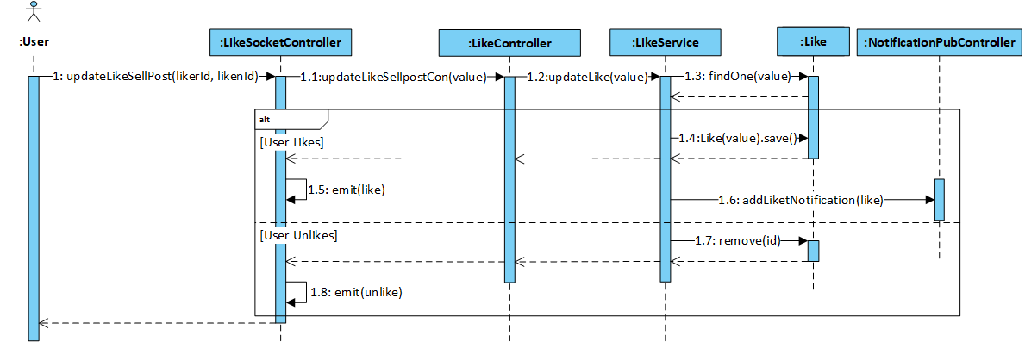

Figure 4‑76: User likes and unlikes sellpost sequence diagram

* + - 1. User manages interest

##### **Screen Design**

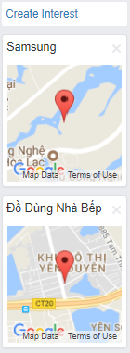

Figure 4‑77: User manages interest screen design

##### **Class Diagram**

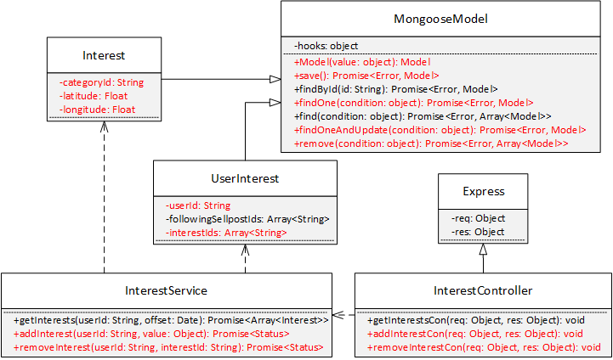

Figure 4‑78: User manages interest class diagram

##### **Class Specification**

***Interest***

|  |  |  |  |  |
| --- | --- | --- | --- | --- |
| **Interest** | | | | |
| Physical address | Backend /models/Interest.js | | | |
| Base class | Mongoose Model | | | |
| Attributes | | | | |
| No | Name | | Type | Description |
| 1 | categoryId | | String |  |
| 2 | latitude | | Float |  |
| 3 | longitude | | Float |  |
| Operation | | | | |
|  | |  | | |

***UserInterest***

|  |  |  |  |  |
| --- | --- | --- | --- | --- |
| **UserInterest** | | | | |
| Physical address | Backend /models/UserInterest.js | | | |
| Base class | Mongoose Model | | | |
| Attributes | | | | |
| No | Name | | Type | Description |
| 1 | userId | | String |  |
| 2 | interestIds | | Array<String> |  |
| Operation | | | | |
|  | |  | | |

***InterestService***

|  |  |  |  |
| --- | --- | --- | --- |
| **InterestService** | | | |
| Physical address | Backend /services/InterestService.js | | |
| Base class |  | | |
| Attributes | | | |
| No | Name | Type | Description |
| Operation | | | |
| addInterest |  |  |  |
| Return Type | Promise<Status> |  |  |
| Parameters | Name | Type | Description |
|  | userId | String |  |
|  | value | Object |  |
| removeInterest |  |  |  |
| Return Type | Promise<Status> |  |  |
| Parameters | Name | Type | Description |
|  | userId | String |  |
|  | interestId | String |  |

***InterestController***

|  |  |  |  |
| --- | --- | --- | --- |
| **InterestController** | | | |
| Physical address | Backend /controllers/InterestController.js | | |
| Base class | Express | | |
| Attributes | | | |
| No | Name | Type | Description |
| Operation | | | |
| addInterest Con |  |  |  |
| Return Type | void |  |  |
| Parameters | Name | Type | Description |
|  | req | Object |  |
|  | res | Object |  |
| removeInterest Con |  |  |  |
| Return Type | void |  |  |
| Parameters | Name | Type | Description |
|  | req | Object |  |
|  | res | Object |  |

##### **Sequence Diagram**

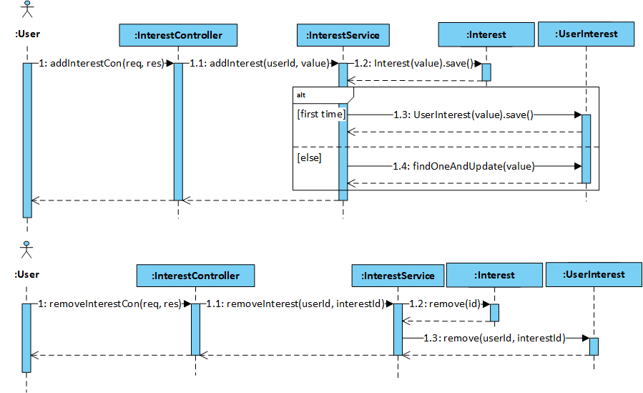

Figure 4‑79: User manages interest sequence diagram

* + - 1. User receives notification

##### **Screen Design**

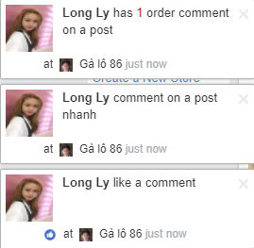

Figure 4‑80: User receives notification screen design

##### **Class Diagram**

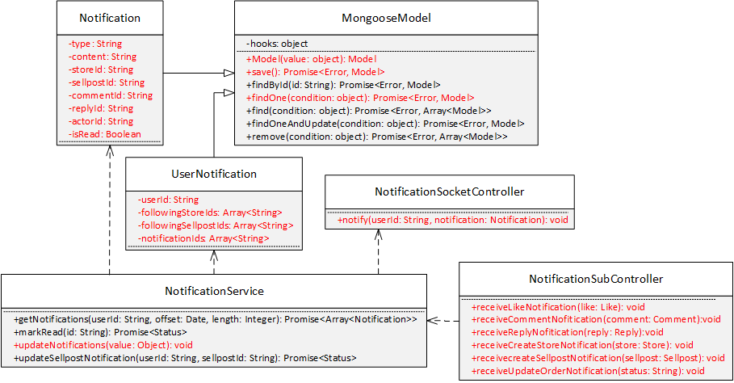

Figure 4‑81: User receives notification class diagram

##### **Class Specification**

***Notification***

|  |  |  |  |  |
| --- | --- | --- | --- | --- |
| **Notification** | | | | |
| Physical address | Backend /models/Notification.js | | | |
| Base class | Mongoose Model | | | |
| Attributes | | | | |
| No | Name | | Type | Description |
| 1 | type | | String |  |
| 2 | content | | String |  |
| 3 | storeId | | String |  |
| 4 | sellpostId | | String |  |
| 5 | commentId | | String |  |
| 6 | replyId | | String |  |
| 7 | actorId | | String |  |
| 8 | isRead | | Boolean |  |
| Operation | | | | |
|  | |  | | |

***UserNotification***

|  |  |  |  |  |
| --- | --- | --- | --- | --- |
| **UserNotification** | | | | |
| Physical address | Backend /models/UserNotification.js | | | |
| Base class | Mongoose Model | | | |
| Attributes | | | | |
| No | Name | | Type | Description |
| 1 | userId | | String |  |
| 2 | followingStoreIds | | Array<String> |  |
| 3 | followingSellpostIds | | Array<String> |  |
| 4 | notificationIds | | Array<String> |  |
| Operation | | | | |
|  | |  | | |

***NotificationService***

|  |  |  |  |
| --- | --- | --- | --- |
| **NotificationService** | | | |
| Physical address | Backend /services/NotificationService.js | | |
| Base class |  | | |
| Attributes | | | |
| No | Name | Type | Description |
| Operation | | | |
| updateNotifications |  |  |  |
| Return Type | void |  |  |
| Parameters | Name | Type | Description |
|  | value | Object |  |

***NotificationSocketController***

|  |  |  |  |
| --- | --- | --- | --- |
| **NotificationSocketController** | | | |
| Physical address | Backend /controllers/NotificationSocketController.js | | |
| Base class |  | | |
| Attributes | | | |
| No | Name | Type | Description |
| Operation | | | |
| notify |  |  |  |
| Return Type | void |  |  |
| Parameters | Name | Type | Description |
|  | userId | String |  |
|  | notification | Notification |  |

***NotificationSubController***

|  |  |  |  |
| --- | --- | --- | --- |
| **NotificationSubController** | | | |
| Physical address | Backend /controllers/NotificationSubController.js | | |
| Base class |  | | |
| Attributes | | | |
| No | Name | Type | Description |
| Operation | | | |
| receiveLikeNotification |  |  |  |
| Return Type | void |  |  |
| Parameters | Name | Type | Description |
|  | like | Like |  |
| receiveCommentNofitication |  |  |  |
| Return Type | void |  |  |
| Parameters | Name | Type | Description |
|  | comment | Comment |  |
| receiveReplyNofitication |  |  |  |
| Return Type | void |  |  |
| Parameters | Name | Type | Description |
|  | reply | Reply |  |
| receiveCreateStoreNotification |  |  |  |
| Return Type | void |  |  |
| Parameters | Name | Type | Description |
|  | store | Store |  |
| receiveCreateStoreNotification |  |  |  |
| Return Type | void |  |  |
| Parameters | Name | Type | Description |
|  | sellpost | Sellpost |  |
| receiveUpdateOrderNotification |  |  |  |
| Return Type | void |  |  |
| Parameters | Name | Type | Description |
|  | status | String |  |

##### **Sequence Diagram**

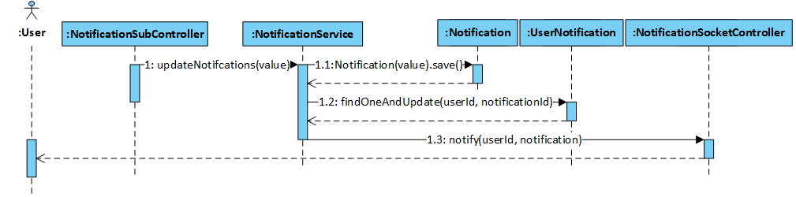

Figure 4‑82: User receives notification sequence diagram

* + - 1. User views notification list

##### **Screen Design**

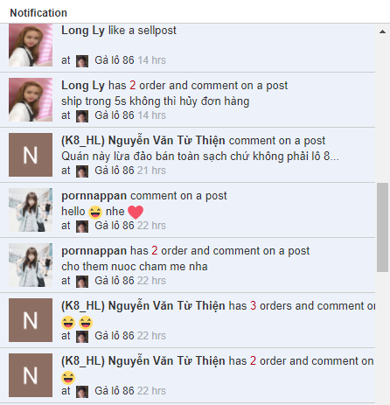

Figure 4‑83: User views notification list screen design

##### **Class Diagram**

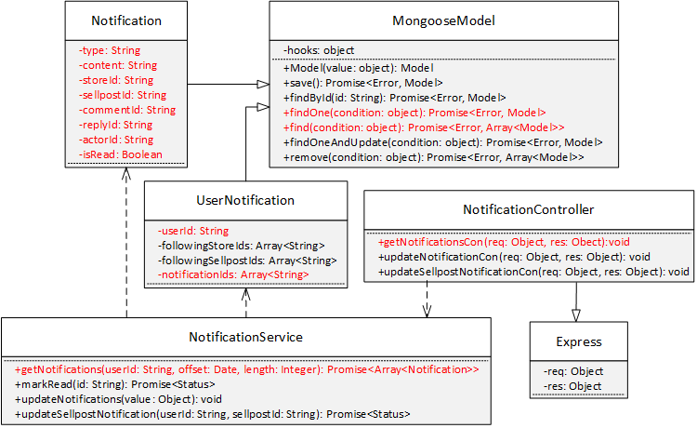

Figure 4‑84: User views notification list class diagram

##### **Class Specification**

***Notification***

|  |  |  |  |  |
| --- | --- | --- | --- | --- |
| **Notification** | | | | |
| Physical address | Backend /models/Notification.js | | | |
| Base class | Mongoose Model | | | |
| Attributes | | | | |
| No | Name | | Type | Description |
| 1 | type | | String |  |
| 2 | content | | String |  |
| 3 | storeId | | String |  |
| 4 | sellpostId | | String |  |
| 5 | commentId | | String |  |
| 6 | replyId | | String |  |
| 7 | actorId | | String |  |
| 8 | isRead | | Boolean |  |
| Operation | | | | |
|  | |  | | |

***UserNotification***

|  |  |  |  |  |
| --- | --- | --- | --- | --- |
| **UserNotification** | | | | |
| Physical address | Backend /models/UserNotification.js | | | |
| Base class | Mongoose Model | | | |
| Attributes | | | | |
| No | Name | | Type | Description |
| 1 | userId | | String |  |
| 2 | notificationIds | | Array<String> |  |
| Operation | | | | |
|  | |  | | |

***NotificationService***

|  |  |  |  |
| --- | --- | --- | --- |
| **NotificationService** | | | |
| Physical address | Backend /services/NotificationService.js | | |
| Base class |  | | |
| Attributes | | | |
| No | Name | Type | Description |
| Operation | | | |
| getNotifications |  |  |  |
| Return Type | Promise<Array<Notification>> |  |  |
| Parameters | Name | Type | Description |
|  | userId | String |  |
|  | offset | Date |  |
|  | length | Integer |  |

***NotificationController***

|  |  |  |  |
| --- | --- | --- | --- |
| **NotificationController** | | | |
| Physical address | Backend /controllers/NotificationController.js | | |
| Base class | Express | | |
| Attributes | | | |
| No | Name | Type | Description |
| Operation | | | |
| getNotificationsCon |  |  |  |
| Return Type | void |  |  |
| Parameters | Name | Type | Description |
|  | req | Object |  |
|  | res | Object |  |

##### **Sequence Diagram**

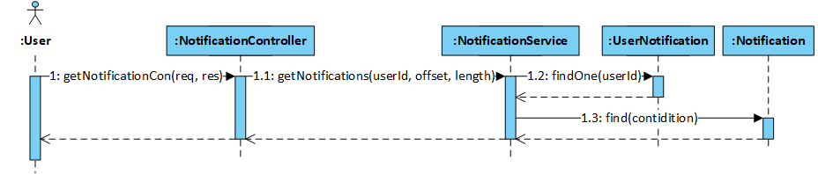

Figure 4‑85: User views notification list sequence diagram

* + - 1. User views notification detail

##### **Screen Design**

- If notification is a createStoreNotification, then screen design is Store page screen in 4.3.4.27

- Otherwise, system redirects to individual sellpost screen:

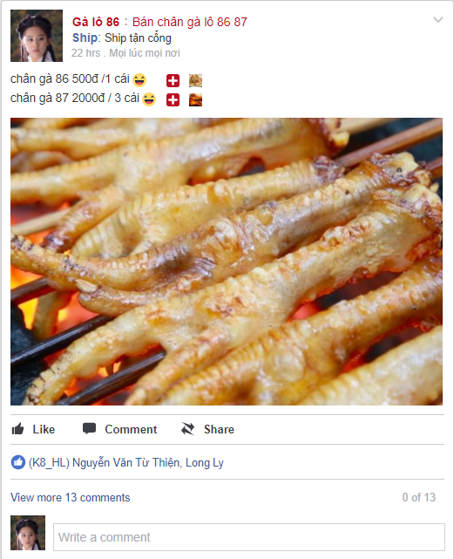

Figure 4- 86: User view notification detail screen design

##### **Class Diagram**

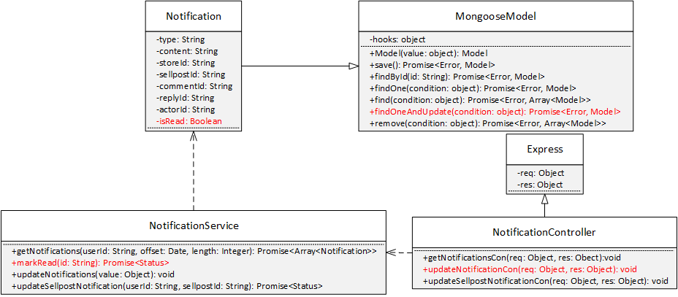

Figure 4‑87: User views notification detail class diagram

##### **Class Specification**

***Notification***

|  |  |  |  |  |
| --- | --- | --- | --- | --- |
| **Notification** | | | | |
| Physical address | Backend /models/Notification.js | | | |
| Base class | Mongoose Model | | | |
| Attributes | | | | |
| No | Name | | Type | Description |
| 1 | isRead | | Boolean |  |
| Operation | | | | |
|  | |  | | |

***NotificationService***

|  |  |  |  |
| --- | --- | --- | --- |
| **NotificationService** | | | |
| Physical address | Backend /services/NotificationService.js | | |
| Base class |  | | |
| Attributes | | | |
| No | Name | Type | Description |
| Operation | | | |
| markRead |  |  |  |
| Return Type | Promise<Status> |  |  |
| Parameters | Name | Type | Description |
|  | id | String |  |

***NotificationController***

|  |  |  |  |
| --- | --- | --- | --- |
| **NotificationController** | | | |
| Physical address | Backend /controllers/NotificationController.js | | |
| Base class | Express | | |
| Attributes | | | |
| No | Name | Type | Description |
| Operation | | | |
| updateNotificationCon |  |  |  |
| Return Type | void |  |  |
| Parameters | Name | Type | Description |
|  | req | Object |  |
|  | res | Object |  |

##### **Implementation**

When user clicks on a specific notification, KAJKAI Frontend will redirect user to a page related to the notification. In addition, at the same time, KAJKAI Frontend will send a request to KAJKAI Backend to mark the clicked notification as read.

##### **Sequence Diagram**

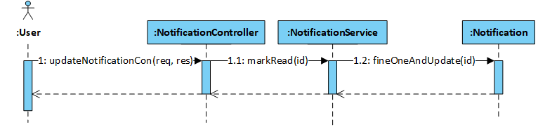

Figure 4‑88: User views notification detail sequence diagram

* + - 1. User turns on and off notification

##### **Screen Design**

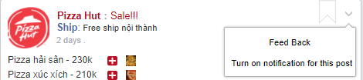

Figure 4- 89: User turns on and off notification screen design

##### **Class Diagram**

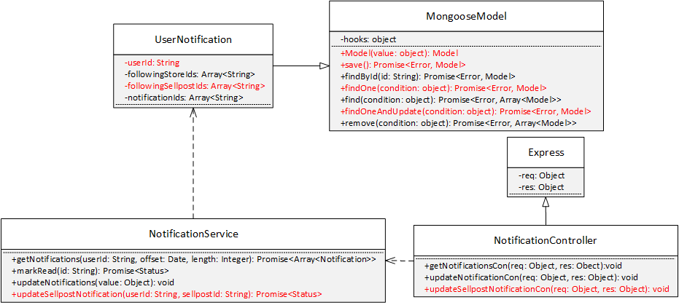

Figure 4‑90: User turns on and off notification class diagram

##### **Class Specification**

***UserNotification***

|  |  |  |  |  |
| --- | --- | --- | --- | --- |
| **UserNotification** | | | | |
| Physical address | Backend /models/UserNotification.js | | | |
| Base class | Mongoose Model | | | |
| Attributes | | | | |
| No | Name | | Type | Description |
| 1 | userId | | String |  |
| 2 | followingSellpostIds | | Array<String> |  |
| Operation | | | | |
|  | |  | | |

***NotificationService***

|  |  |  |  |
| --- | --- | --- | --- |
| **NotificationService** | | | |
| Physical address | Backend /services/NotificationService.js | | |
| Base class |  | | |
| Attributes | | | |
| No | Name | Type | Description |
| Operation | | | |
| updateSellpostNotification |  |  |  |
| Return Type | Promise<Status> |  |  |
| Parameters | Name | Type | Description |
|  | userId | String |  |
|  | sellpostId | String |  |

***NotificationController***

|  |  |  |  |
| --- | --- | --- | --- |
| **NotificationController** | | | |
| Physical address | Backend /controllers/NotificationController.js | | |
| Base class | Express | | |
| Attributes | | | |
| No | Name | Type | Description |
| Operation | | | |
| updateSellpostNotificationCon |  |  |  |
| Return Type | void |  |  |
| Parameters | Name | Type | Description |
|  | req | Object |  |
|  | res | Object |  |

##### **Sequence Diagram**

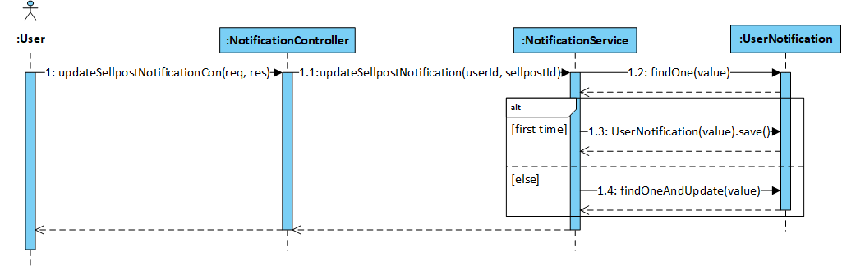

Figure ‑91: User turns on and off notification sequence diagram

* + - 1. User creates store

##### **Screen Design**

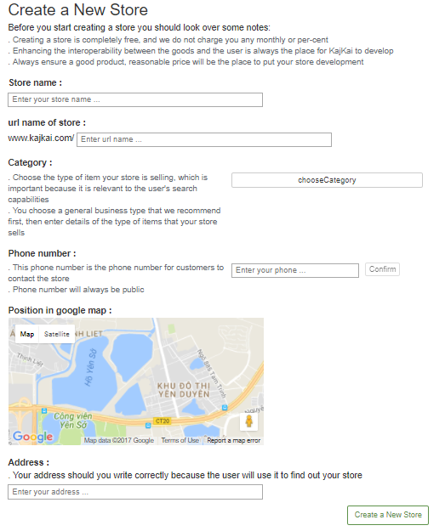

Figure 4‑92: User creates store screen design

##### **Class Diagram**

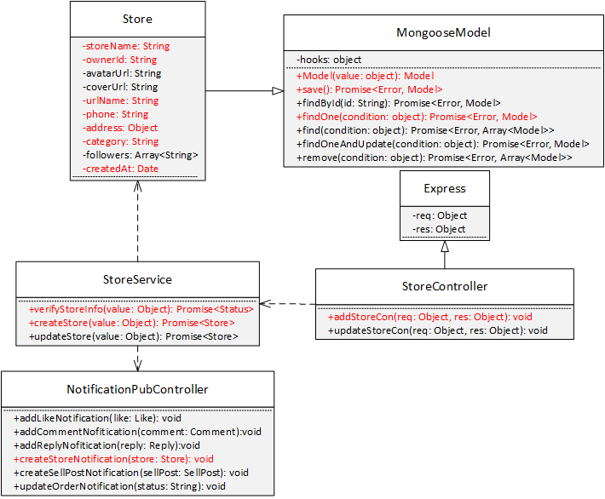

Figure 4‑93: User creates store class diagram

##### **Class Specification**

***Store***

|  |  |  |  |
| --- | --- | --- | --- |
| **Store** | | | |
| Physical address | Backend /models/Store.js | | |
| Base class | Mongoose Model | | |
| Attributes | | | |
| No | Name | Type | Description |
| 1 | storeName | String |  |
| 2 | ownerId | String |  |
| 3 | urlName | String |  |
| 4 | phone | String |  |
| 5 | category | String |  |
| 6 | address | Object |  |
| 7 | createdAt | String |  |
| Operation | | | |
|  |  | | |

**StoreService**

|  |  |  |  |
| --- | --- | --- | --- |
| **StoreService** | | | |
| Physical address | Backend /services/StoreService.js | | |
| Base class |  | | |
| Attributes | | | |
| No | Name | Type | Description |
| Operation | | | |
| verifyStoreInfo |  |  |  |
| Return Type | Promise<Status> |  |  |
| Parameters | Name | Type | Description |
|  | value | Object |  |
| createStore |  |  |  |
| Return Type | Promise<Store> |  |  |
| Parameters | Name | Type | Description |
|  | value | Object |  |

***StoreController***

|  |  |  |  |
| --- | --- | --- | --- |
| **StoreController** | | | |
| Physical address | Backend /controllers/StoreController.js | | |
| Base class | Express | | |
| Attributes | | | |
| No | Name | Type | Description |
| Operation | | | |
| addStoreCon |  |  |  |
| Return Type | void |  |  |
| Parameters | Name | Type | Description |
|  | req | object |  |
|  | res | object |  |

***NotificationPubController***

|  |  |  |  |
| --- | --- | --- | --- |
| **NotificationPubController** | | | |
| Physical address | Backend /controllers/NotificationPubController.js | | |
| Base class |  | | |
| Attributes | | | |
| No | Name | Type | Description |
| Operation | | | |
| createStoreNotification |  |  |  |
| Return Type | void |  |  |
| Parameters | Name | Type | Description |
|  | store | Store |  |

##### **Sequence Diagram**

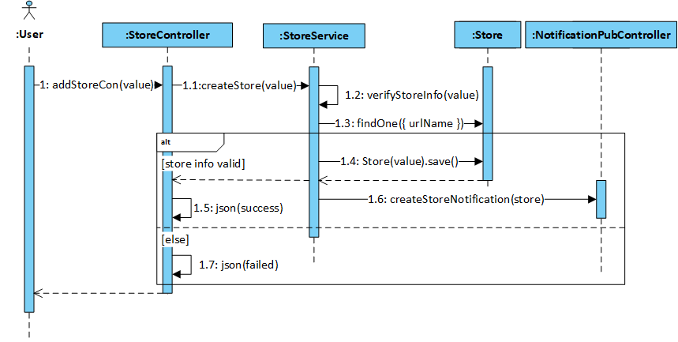

Figure 4‑94: User creates store sequence diagram

* + - 1. User follows and unfollows store

##### **Screen Design**

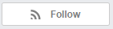

Figure 4‑95: User follows and unfollows store screen design

##### **Class Diagram**

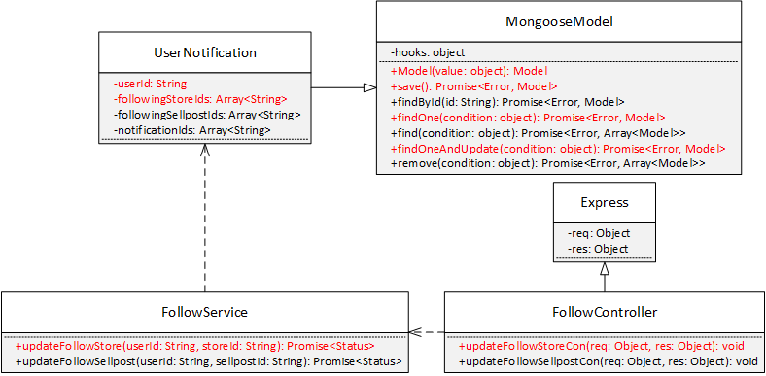

Figure 4‑96: User follows and unfollows store class diagram

##### **Class Specification**

***UserNotification***

|  |  |  |  |
| --- | --- | --- | --- |
| **UserNotification** | | | |
| Physical address | Backend /models/UserNotification.js | | |
| Base class | Mongoose Model | | |
| Attributes | | | |
| No | Name | Type | Description |
| 1 | userId | String |  |
| 2 | followingStoreIds | Array<String> |  |
| Operation | | | |
|  |  | | |

***FollowService***

|  |  |  |  |
| --- | --- | --- | --- |
| **FollowService** | | | |
| Physical address | Backend /services/FollowService.js | | |
| Base class |  | | |
| Attributes | | | |
| No | Name | Type | Description |
| Operation | | | |
| updateFollowStore |  |  |  |
| Return Type | Promise<Status> |  |  |
| Parameters | Name | Type | Description |
|  | userId | String |  |
|  | storeId | String |  |

***FollowController***

|  |  |  |  |
| --- | --- | --- | --- |
| **FollowController** | | | |
| Physical address | Backend /controllers/FollowController.js | | |
| Base class | Express | | |
| Attributes | | | |
| No | Name | Type | Description |
| Operation | | | |
| updateFollowStoreCon |  |  |  |
| Return Type | void |  |  |
| Parameters | Name | Type | Description |
|  | req | object |  |
|  | res | object |  |

##### **Sequence Diagram**

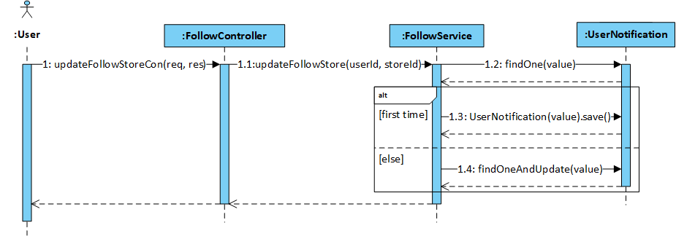

Figure 4‑97: User follows and unfollows store sequence diagram

* + - 1. User follows and unfollows sellpost

##### **Screen Design**



Figure 4‑98: User follows and unfollows sellpost screen design

##### **Class Diagram**

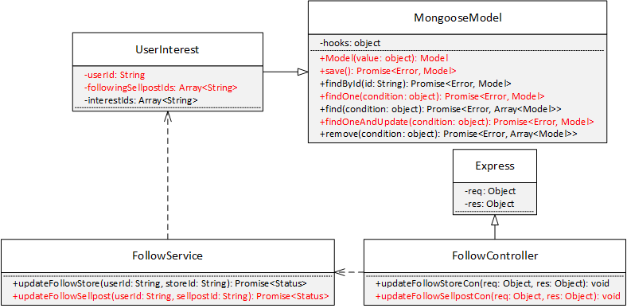

Figure 4‑99: User follows and unfollows sellpost class diagram

##### **Class Specification**

***UserNotification***

|  |  |  |  |
| --- | --- | --- | --- |
| **UserNotification** | | | |
| Physical address | Backend /models/UserNotification.js | | |
| Base class | Mongoose Model | | |
| Attributes | | | |
| No | Name | Type | Description |
| 1 | userId | String |  |
| 2 | followingSellpostIds | Array<String> |  |
| Operation | | | |
|  |  | | |

***FollowService***

|  |  |  |  |
| --- | --- | --- | --- |
| **FollowService** | | | |
| Physical address | Backend /services/FollowService.js | | |
| Base class |  | | |
| Attributes | | | |
| No | Name | Type | Description |
| Operation | | | |
| updateFollowStore |  |  |  |
| Return Type | Promise<Status> |  |  |
| Parameters | Name | Type | Description |
|  | userId | String |  |
|  | sellpostId | String |  |

***FollowController***

|  |  |  |  |
| --- | --- | --- | --- |
| **FollowController** | | | |
| Physical address | Backend /controllers/FollowController.js | | |
| Base class | Express | | |
| Attributes | | | |
| No | Name | Type | Description |
| Operation | | | |
| updateFollowSellpostCon |  |  |  |
| Return Type | void |  |  |
| Parameters | Name | Type | Description |
|  | req | object |  |
|  | res | object |  |

##### **Sequence Diagram**

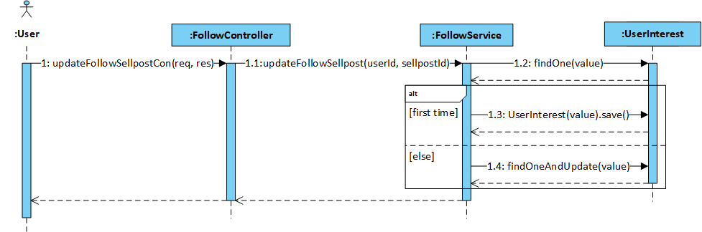

Figure 4‑100: User filters shops by ship places sequence diagram

* + - 1. User feedbacks

##### **Screen Design**

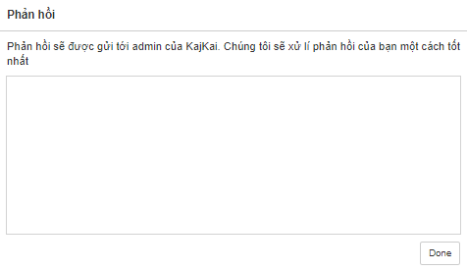

Figure 4‑101: User feedbacks screen design

##### **Class Diagram**

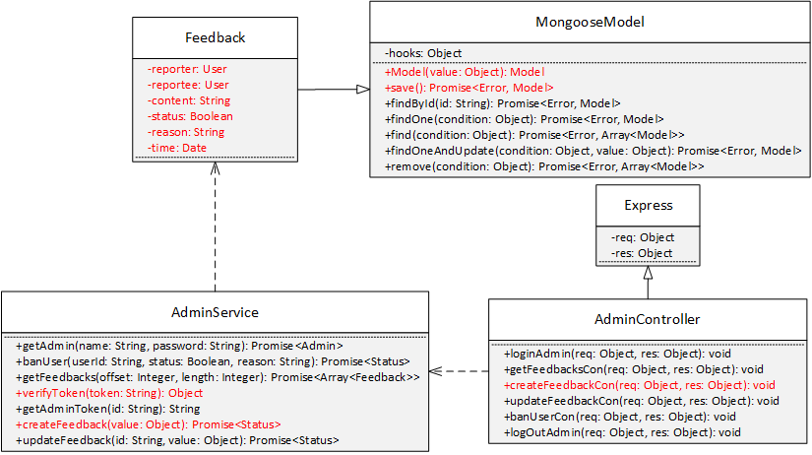

Figure 4‑102: User feedbacks class diagram

##### **Class Specification**

***Feedback***

|  |  |  |  |
| --- | --- | --- | --- |
| **Feedback** | | | |
| Physical address | Backend /models/Feedback.js | | |
| Base class | Mongoose Model | | |
| Attributes | | | |
| No | Name | Type | Description |
| 1 | reporterId | String |  |
| 2 | reporteeId | String |  |
| 3 | content | String |  |
| 4 | status | String |  |
| 5 | reason | String |  |
| 6 | time | Date |  |
| Operation | | | |
|  |  | | |

***AdminService***

|  |  |  |  |
| --- | --- | --- | --- |
| **AdminService** | | | |
| Physical address | Backend /services/AdminService.js | | |
| Base class |  | | |
| Attributes | | | |
| No | Name | Type | Description |
| Operation | | | |
| verifyToken |  |  |  |
| Return Type | Object |  |  |
| Parameters | Name | Type | Description |
|  | token | String |  |
| createFeedback |  |  |  |
| Return Type | Promise<Status> |  |  |
| Parameters | Name | Type | Description |
|  | value | Object |  |

***AdminController***

|  |  |  |  |
| --- | --- | --- | --- |
| **AdminController** | | | |
| Physical address | Backend /controllers/AdminController.js | | |
| Base class | Express | | |
| Attributes | | | |
| No | Name | Type | Description |
| Operation | | | |
| createFeedbackCon |  |  |  |
| Return Type | void |  |  |
| Parameters | Name | Type | Description |
|  | req | object |  |
|  | res | object |  |

##### **Sequence Diagram**

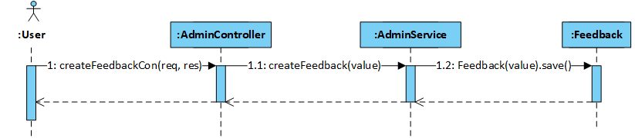

Figure 4‑103: User feedbacks sequence diagram

* + - 1. User logouts user

##### **Screen Design**

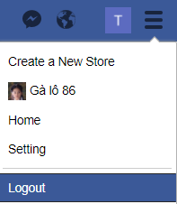

Figure 4‑104: User logouts user screen design

##### **Class Diagram**

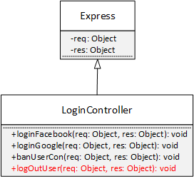

Figure 4‑105: User logouts user class diagram

##### **Class Specification**

***AdminController***

|  |  |  |  |
| --- | --- | --- | --- |
| **LoginController** | | | |
| Physical address | Backend /controllers/LoginController.js | | |
| Base class | Express | | |
| Attributes | | | |
| No | Name | Type | Description |
| Operation | | | |
| logOutUser |  |  |  |
| Return Type | void |  |  |
| Parameters | Name | Type | Description |
|  | req | object |  |
|  | res | object |  |

##### **Sequence Diagram**

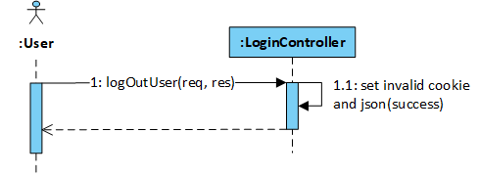

Figure 4‑106: User logouts user sequence diagram

* + - 1. Seller views Store page

##### **Screen Design**

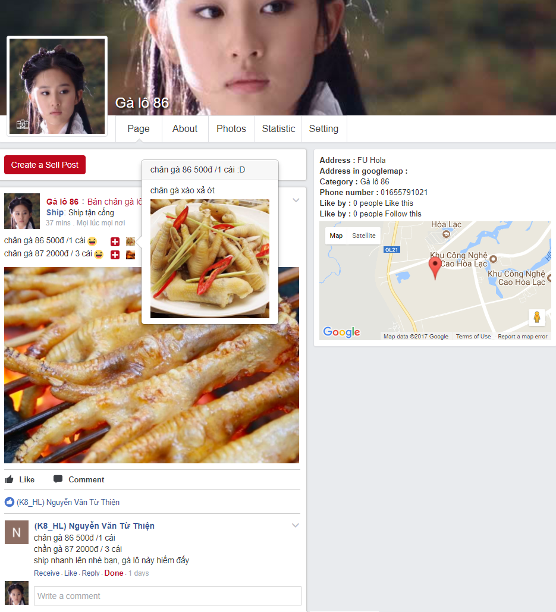

Figure 4‑107: Seller views Store page screen design

##### **Class Diagram**

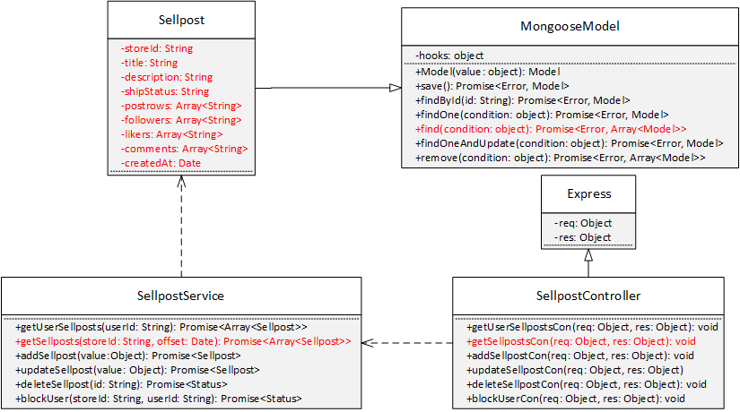

Figure 4‑108: Seller views Store page class diagram

##### **Class Specification**

***Sellpost***

|  |  |  |  |
| --- | --- | --- | --- |
| **Sellpost** | | | |
| Physical address | Backend /models/Sellpost.js | | |
| Base class | Mongoose Model | | |
| Attributes | | | |
| No | Name | Type | Description |
| 1 | storeId | String |  |
| 2 | title | String |  |
| 3 | description | String |  |
| 4 | shipStatus | String |  |
| 5 | postrows | Array<String> |  |
| 6 | followers | Array<String> |  |
| 7 | likers | Array<String> |  |
| 8 | comments | Array<String> |  |
| 9 | createdAt | Date |  |
| Operation | | | |
|  |  | | |

***SellpostService***

|  |  |  |  |
| --- | --- | --- | --- |
| **SellpostService** | | | |
| Physical address | Backend /services/SellpostService.js | | |
| Base class |  | | |
| Attributes | | | |
| No | Name | Type | Description |
| Operation | | | |
| getSellposts |  |  |  |
| Return Type | Promise<Array<Sellpost>> |  |  |
| Parameters | Name | Type | Description |
|  | storeId | String |  |
|  | offset | Date |  |

***SellpostController***

|  |  |  |  |
| --- | --- | --- | --- |
| **SellpostController** | | | |
| Physical address | Backend /controllers/SellpostController.js | | |
| Base class | Express | | |
| Attributes | | | |
| No | Name | Type | Description |
| Operation | | | |
| getSellpostsCon |  |  |  |
| Return Type | void |  |  |
| Parameters | Name | Type | Description |
|  | req | object |  |
|  | res | object |  |

##### **Sequence Diagram**

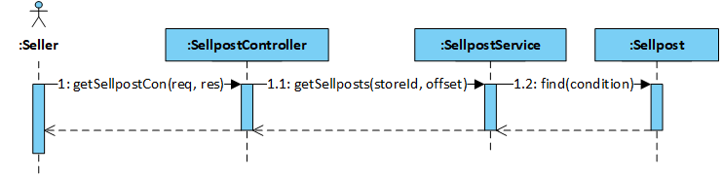

Figure 4‑109: Seller views Store page sequence diagram

* + - 1. Seller updates store info

##### **Screen Design**

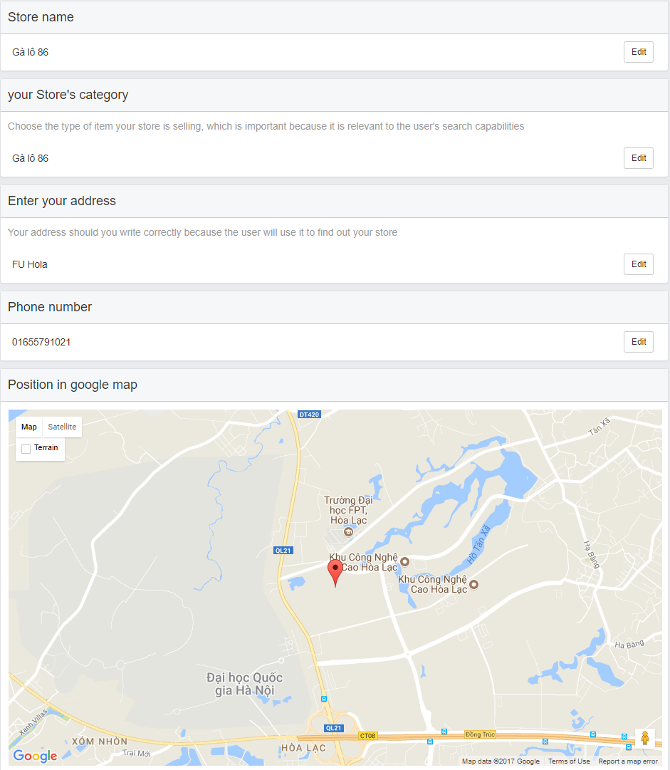

Figure 4‑110: Seller updates store info screen design

##### **Class Diagram**

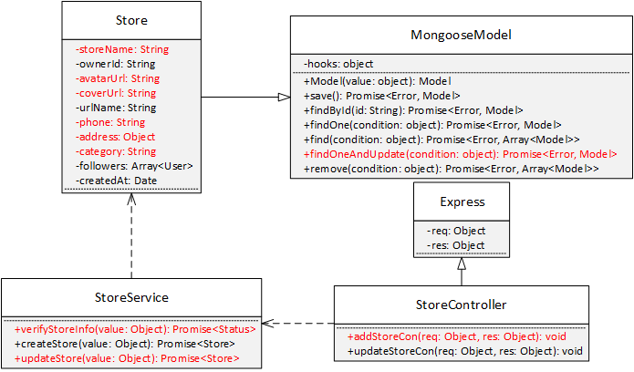

Figure 4‑111: Seller updates store info class diagram

##### **Class Specification**

***Store***

|  |  |  |  |
| --- | --- | --- | --- |
| **Store** | | | |
| Physical address | Backend /models/Store.js | | |
| Base class | Mongoose Model | | |
| Attributes | | | |
| No | Name | Type | Description |
| 1 | storeName | String |  |
| 2 | phone | String |  |
| 3 | category | String |  |
| 4 | address | Object |  |
| Operation | | | |
|  |  | | |

**StoreService**

|  |  |  |  |
| --- | --- | --- | --- |
| **StoreService** | | | |
| Physical address | Backend /services/StoreService.js | | |
| Base class |  | | |
| Attributes | | | |
| No | Name | Type | Description |
| Operation | | | |
| verifyStoreInfo |  |  |  |
| Return Type | Promise<Status> |  |  |
| Parameters | Name | Type | Description |
|  | value | Object |  |
| updateStore |  |  |  |
| Return Type | Promise<Store> |  |  |
| Parameters | Name | Type | Description |
|  | value | Object |  |

***StoreController***

|  |  |  |  |
| --- | --- | --- | --- |
| **StoreController** | | | |
| Physical address | Backend /controllers/StoreController.js | | |
| Base class | Express | | |
| Attributes | | | |
| No | Name | Type | Description |
| Operation | | | |
| updateStoreCon |  |  |  |
| Return Type | void |  |  |
| Parameters | Name | Type | Description |
|  | req | object |  |
|  | res | object |  |

##### **Sequence Diagram**

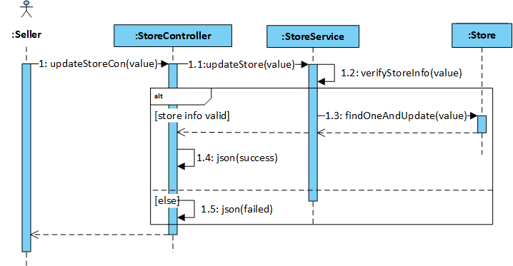

Figure ‑112: Seller updates store info sequence diagram

* + - 1. Seller manages sellpost

##### **Screen Design**

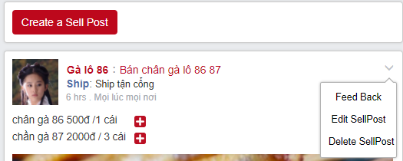

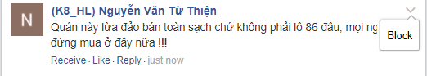

Figure 4‑113: Seller manages sellpost screen design

##### **Class diagram**

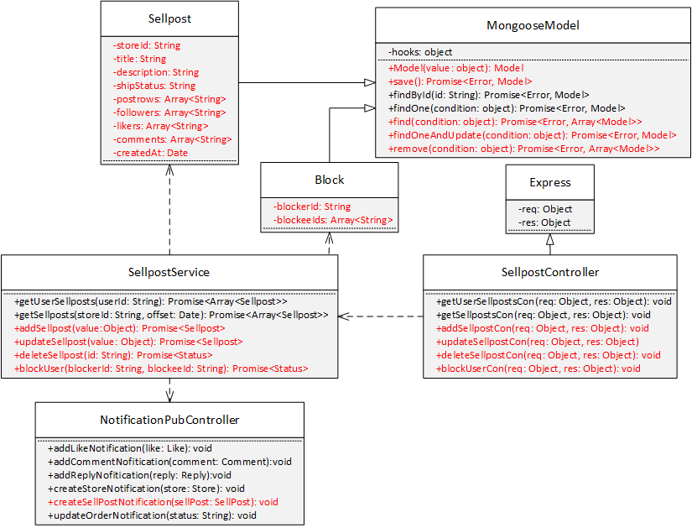

Figure 4‑114: Seller manages sellpost class diagram

##### **Class Specification**

***Sellpost***

|  |  |  |  |
| --- | --- | --- | --- |
| **Sellpost** | | | |
| Physical address | Backend /models/Sellpost.js | | |
| Base class | Mongoose Model | | |
| Attributes | | | |
| No | Name | Type | Description |
| 1 | storeId | String |  |
| 2 | title | String |  |
| 3 | description | String |  |
| 4 | shipStatus | String |  |
| 5 | postrows | Array<String> |  |
| 6 | followers | Array<String> |  |
| 7 | likers | Array<String> |  |
| 8 | comments | Array<String> |  |
| 9 | createdAt | Date |  |
| Operation | | | |
|  |  | | |

***Block***

|  |  |  |  |
| --- | --- | --- | --- |
| **Block** | | | |
| Physical address | Backend /models/Block.js | | |
| Base class | Mongoose Model | | |
| Attributes | | | |
| No | Name | Type | Description |
| 1 | blockerId | String |  |
| 2 | blockeeIds | Array<String> |  |
| Operation | | | |
|  |  | | |

***SellpostService***

|  |  |  |  |
| --- | --- | --- | --- |
| **SellpostService** | | | |
| Physical address | Backend /services/SellpostService.js | | |
| Base class |  | | |
| Attributes | | | |
| No | Name | Type | Description |
| Operation | | | |
| addSellpost |  |  |  |
| Return Type | Promise<Sellpost> |  |  |
| Parameters | Name | Type | Description |
|  | value | Object |  |
| updateSellpost |  |  |  |
| Return Type | Promise<Sellpost> |  |  |
| Parameters | Name | Type | Description |
|  | value | Object |  |
| deleteSellpost |  |  |  |
| Return Type | Promise<Status> |  |  |
| Parameters | Name | Type | Description |
|  | value | Object |  |
| blockUser |  |  |  |
| Return Type | Promise<Status> |  |  |
| Parameters | Name | Type | Description |
|  | blockerId | String |  |
|  | blockeeId | String |  |

***SellpostController***

|  |  |  |  |
| --- | --- | --- | --- |
| **SellpostController** | | | |
| Physical address | Backend /controllers/SellpostController.js | | |
| Base class | Express | | |
| Attributes | | | |
| No | Name | Type | Description |
| Operation | | | |
| addSellpostCon |  |  |  |
| Return Type | void |  |  |
| Parameters | Name | Type | Description |
|  | req | object |  |
|  | res | object |  |
| updateSellpostCon |  |  |  |
| Return Type | void |  |  |
| Parameters | Name | Type | Description |
|  | req | object |  |
|  | res | object |  |
| deleteSellpostCon |  |  |  |
| Return Type | void |  |  |
| Parameters | Name | Type | Description |
|  | req | object |  |
|  | res | object |  |
| blockUserCon |  |  |  |
| Return Type | void |  |  |
| Parameters | Name | Type | Description |
|  | req | object |  |
|  | res | object |  |

***NotificationPubController***

|  |  |  |  |
| --- | --- | --- | --- |
| **NotificationPubController** | | | |
| Physical address | Backend /controllers/NotificationPubController.js | | |
| Base class |  | | |
| Attributes | | | |
| No | Name | Type | Description |
| Operation | | | |
| createSellpostNotification |  |  |  |
| Return Type | void |  |  |
| Parameters | Name | Type | Description |
|  | sellpost | Sellpost |  |

##### **Implementation**

When a sellpost is created in a store, SellpostService will call createSellpostNotification function in NotificationPubController to publish the event, so that NotificationSubController in 4.3.4.19 can update notification list for the users who are following the store.

blockUser(blockerId, blockeeId) will check if blockee has been blocked by blocker or not, then add or remove blockeeId in the blockeeIds list corresponding to the blockeeId.

##### **Sequence Diagram**

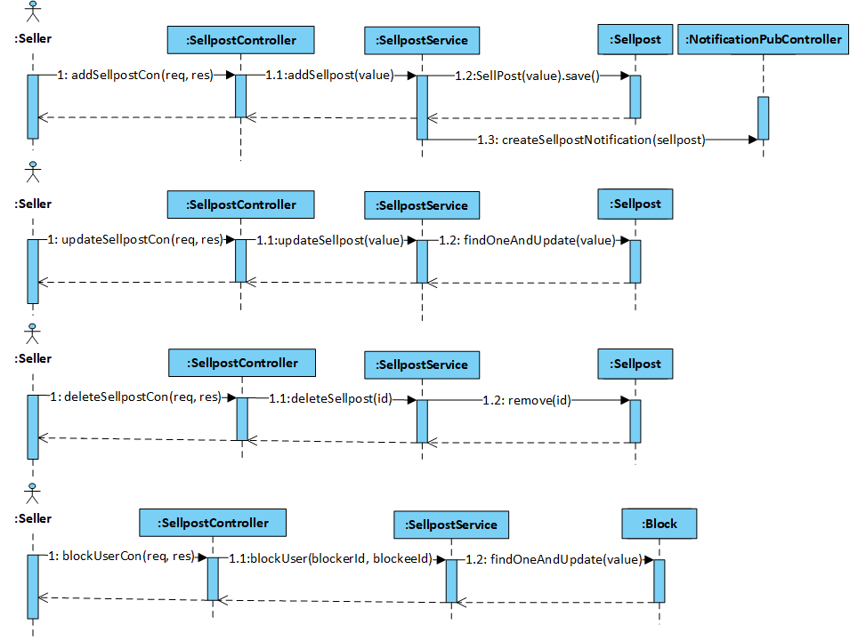

Figure 4‑115: Seller manages sellpost sequence diagram

* + - 1. Seller manages order

##### **Screen Design**

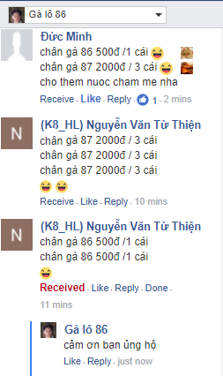

Figure 4‑116: Seller manage order screen design

##### **Class Diagram**

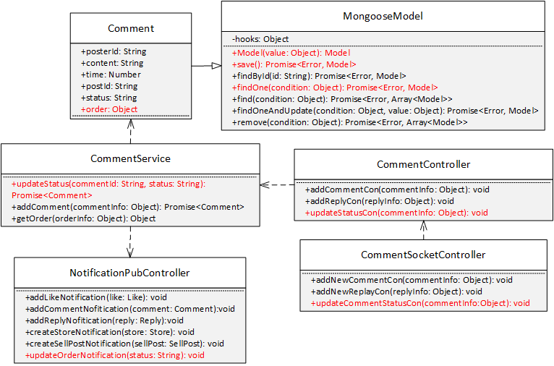

Figure 4‑117: Seller manage order class diagram

##### **Class Specification**

***Comment***

|  |  |  |  |
| --- | --- | --- | --- |
| **Comment** | | | |
| Physical address | Backend /models/Comment.js | | |
| Base class |  | | |
| Attributes | | | |
| No | Name | Type | Description |
| 1 | status | String |  |
| Operation | | | |

***CommentService***

|  |  |  |  |
| --- | --- | --- | --- |
| **CommentService** | | | |
| Physical address | Backend /services/CommentService.js | | |
| Base class |  | | |
| Attributes | | | |
| No | Name | Type | Description |
| Operation | | | |
| updateStatus |  |  |  |
| Return Type | Promise<Comment> |  |  |
| Parameters | Name | Type | Description |
|  | commentId | String |  |
|  | status | String |  |

***CommentController***

|  |  |  |  |
| --- | --- | --- | --- |
| **CommentController** | | | |
| Physical address | Backend /controllers/CommentController.js | | |
| Base class |  | | |
| Attributes | | | |
| No | Name | Type | Description |
| Operation | | | |
| updateStatusCon |  |  |  |
| Return Type | void |  |  |
| Parameters | Name | Type | Description |
|  | commentInfo | Object |  |

***CommentSocketController***

|  |  |  |  |
| --- | --- | --- | --- |
| **CommentSocketController** | | | |
| Physical address | Backend /controllers/CommentSocketControllers.js | | |
| Base class |  | | |
| Attributes | | | |
| No | Name | Type | Description |
| Operation | | | |
| updateCommentStatusCon |  |  |  |
| Return Type | void |  |  |
| Parameters | Name | Type | Description |
|  | commentInfo | Object |  |

***NotificationPubController***

|  |  |  |  |
| --- | --- | --- | --- |
| **NotificationPubController** | | | |
| Physical address | Backend /controllers/NotificationPubController.js | | |
| Base class |  | | |
| Attributes | | | |
| No | Name | Type | Description |
| Operation | | | |
| updateOrderNotification |  |  |  |
| Return Type | void |  |  |
| Parameters | Name | Type | Description |
|  | comment | Comment |  |

##### **Sequence Diagram**

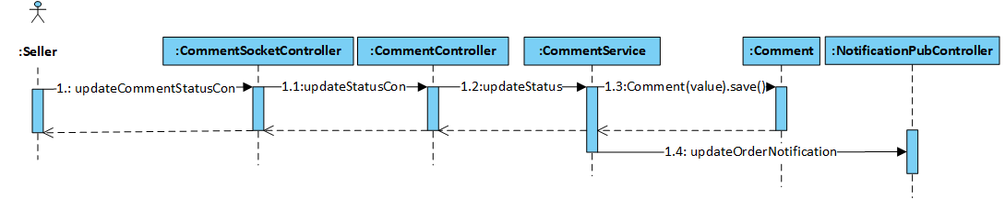

Figure 4‑118: Seller manage order sequence diagram

* + - 1. Seller views statistics

##### **Screen Design**

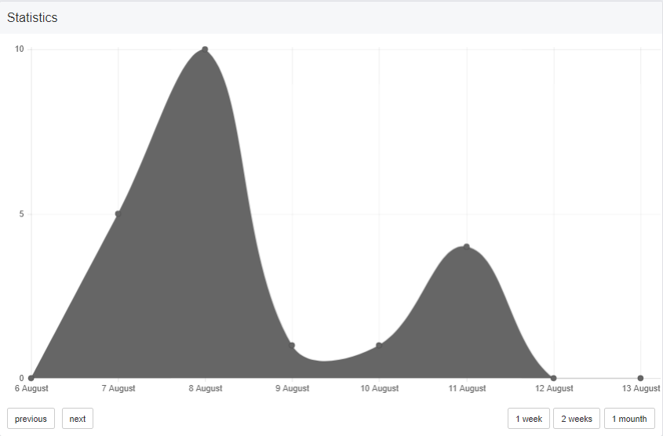

Figure 4‑119: Seller views statistics screen design

##### **Class Diagram**

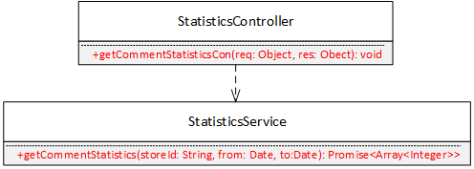

Figure 4‑120: Seller views statistics class diagram

##### **Class Specification**

***StatisticsService***

|  |  |  |  |
| --- | --- | --- | --- |
| **StatisticsService** | | | |
| Physical address | Backend /services/StatisticsService.js | | |
| Base class |  | | |
| Attributes | | | |
| No | Name | Type | Description |
| Operation | | | |
| getCommentStatistics |  |  |  |
| Return Type | Promise<Array<Integer>> |  |  |
| Parameters | Name | Type | Description |
|  | storeId | String |  |
|  | from | Date |  |
|  | to | Date |  |

***StatisticsController***

|  |  |  |  |
| --- | --- | --- | --- |
| **StatisticsController** | | | |
| Physical address | Backend /controllers/StatisticsController.js | | |
| Base class | Express | | |
| Attributes | | | |
| No | Name | Type | Description |
| Operation | | | |
| getCommentStatisticsCon |  |  |  |
| Return Type | void |  |  |
| Parameters | Name | Type | Description |
|  | req | object |  |
|  | res | object |  |

##### **Sequence Diagram**

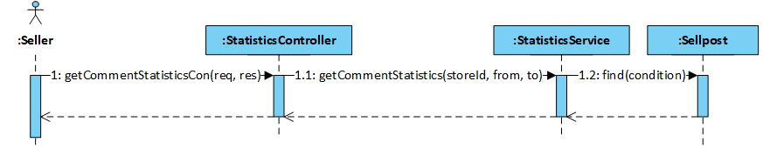

Figure 4‑121: Seller views statistics sequence diagram

* + - 1. Admin logins by KajKai admin account

##### **Screen Design**

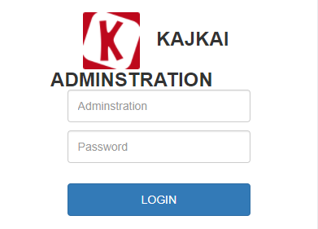

Figure 4‑122: Admin logins by KajKai admin account screen design

##### **Class Diagram**

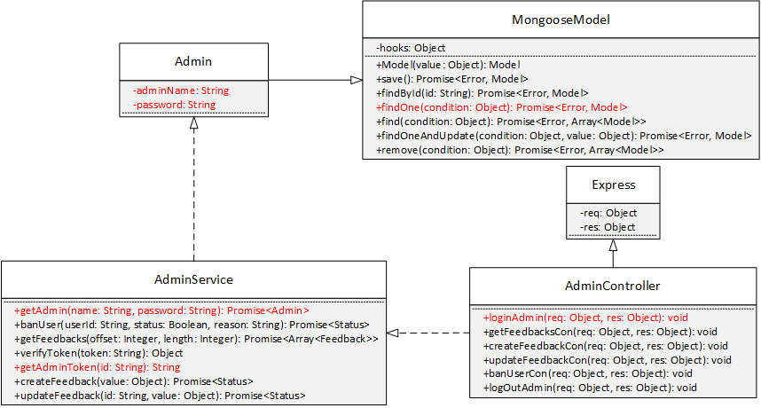

Figure 4‑123: Admin logins by KajKai admin account class diagram

##### **Class Specification**

***Admin***

|  |  |  |  |
| --- | --- | --- | --- |
| **Admin** | | | |
| Physical address | Backend /models/Admin.js | | |
| Base class | Mongoose Model | | |
| Attributes | | | |
| No | Name | Type | Description |
| 1 | adminName | String |  |
| 2 | password | String |  |
| Operation | | | |

***AdminService***

|  |  |  |  |
| --- | --- | --- | --- |
| **AdminService** | | | |
| Physical address | Backend /services/AdminService.js | | |
| Base class |  | | |
| Attributes | | | |
| No | Name | Type | Description |
| Operation | | | |
| getAdminToken |  |  |  |
| Return Type | Strnig |  |  |
| Parameters | Name | Type | Description |
|  | id | String |  |
| getAdmin |  |  |  |
| Return Type | Promise<Admin> |  |  |
| Parameters | Name | Type | Description |
|  | name | String |  |
|  | password | String |  |

***AdminController***

|  |  |  |  |
| --- | --- | --- | --- |
| **AdminController** | | | |
| Physical address | Backend /controllers/AdminController.js | | |
| Base class | Express | | |
| Attributes | | | |
| No | Name | Type | Description |
| Operation | | | |
| loginAdmin |  |  |  |
| Return Type | void |  |  |
| Parameters | Name | Type | Description |
|  | req | object |  |
|  | res | object |  |

##### **Sequence Diagram**

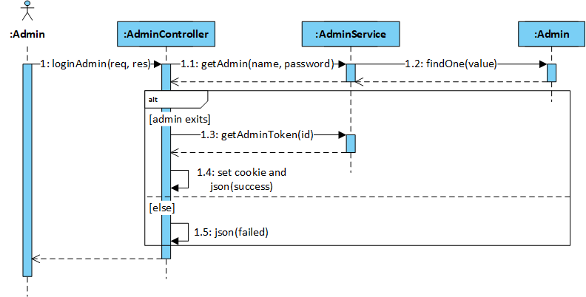

Figure 4‑124: Admin logins by KajKai admin account sequence diagram

* + - 1. Admin views Admin page

##### **Screen Design**

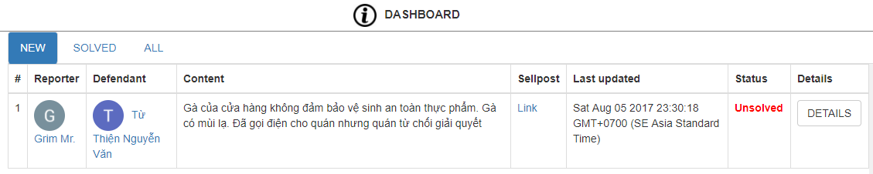

Figure 4‑125: Admin views Admin page screen design

##### **Class Diagram**

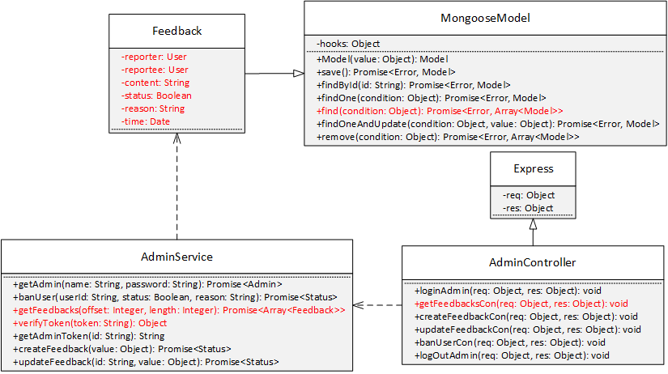

Figure 4‑90: Admin views Admin page class diagram

##### **Class Specification**

***Feedback***

|  |  |  |  |
| --- | --- | --- | --- |
| **Feedback** | | | |
| Physical address | Backend /models/Feedback.js | | |
| Base class | Mongoose Model | | |
| Attributes | | | |
| No | Name | Type | Description |
| 1 | reporterId | String |  |
| 2 | reporteeId | String |  |
| 3 | content | String |  |
| 4 | status | String |  |
| 5 | reason | String |  |
| 6 | time | Date |  |
| Operation | | | |
|  |  | | |

***AdminService***

|  |  |  |  |
| --- | --- | --- | --- |
| **AdminService** | | | |
| Physical address | Backend /services/AdminService.js | | |
| Base class |  | | |
| Attributes | | | |
| No | Name | Type | Description |
| Operation | | | |
| verifyToken |  |  |  |
| Return Type | Object |  |  |
| Parameters | Name | Type | Description |
|  | token | String |  |
| getFeedbacks |  |  |  |
| Return Type | Promise<Array<Feedback>> |  |  |
| Parameters | Name | Type | Description |
|  | offset | Integer |  |
|  | length | Integer |  |

***AdminController***

|  |  |  |  |
| --- | --- | --- | --- |
| **AdminController** | | | |
| Physical address | Backend /controllers/AdminController.js | | |
| Base class | Express | | |
| Attributes | | | |
| No | Name | Type | Description |
| Operation | | | |
| getFeedbacksCon |  |  |  |
| Return Type | void |  |  |
| Parameters | Name | Type | Description |
|  | req | object |  |
|  | res | object |  |

##### **Sequence Diagram**

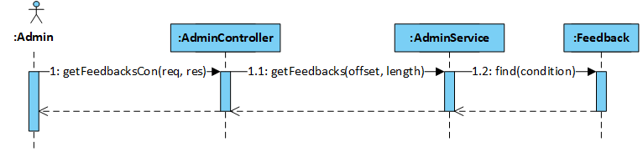

Figure 4‑126: Admin views Admin page sequence diagram

* + - 1. Admin manages user

##### **Screen Design**

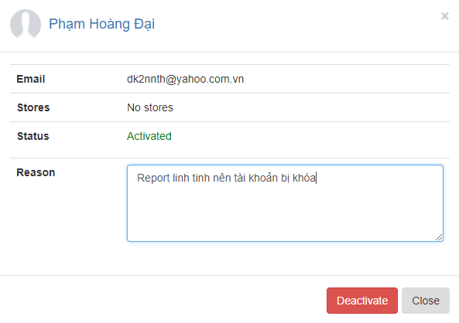

Figure 4‑127: Admin manages user screen design

##### **Class Diagram**

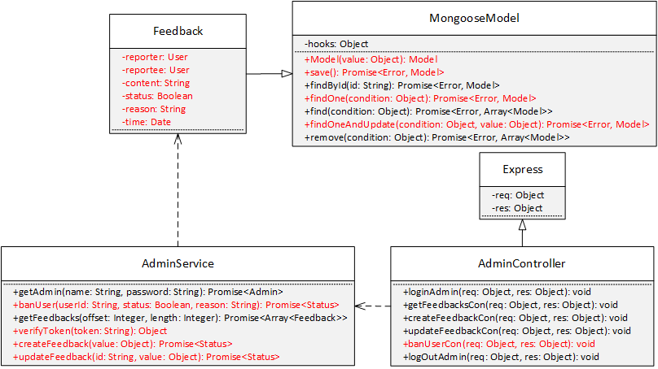

Figure 4‑128: Admin manages user class diagram

##### **Class Specification**

***Feedback***

|  |  |  |  |
| --- | --- | --- | --- |
| **Feedback** | | | |
| Physical address | Backend /models/Feedback.js | | |
| Base class | Mongoose Model | | |
| Attributes | | | |
| No | Name | Type | Description |
| 1 | reporterId | String |  |
| 2 | reporteeId | String |  |
| 3 | content | String |  |
| 4 | status | String |  |
| 5 | reason | String |  |
| 6 | time | Date |  |
| Operation | | | |
|  |  | | |

***AdminService***

|  |  |  |  |
| --- | --- | --- | --- |
| **AdminService** | | | |
| Physical address | Backend /services/AdminService.js | | |
| Base class |  | | |
| Attributes | | | |
| No | Name | Type | Description |
| Operation | | | |
| verifyToken |  |  |  |
| Return Type | Object |  |  |
| Parameters | Name | Type | Description |
|  | token | String |  |
| banUser |  |  |  |
| Return Type | Promise<Status> |  |  |
| Parameters | Name | Type | Description |
|  | userId | String |  |
|  | status | Boolean |  |
|  | reason | String |  |
| createFeedback |  |  |  |
| Return Type | Promise<Status> |  |  |
| Parameters | Name | Type | Description |
|  | value | Object |  |
| updateFeedback |  |  |  |
| Return Type | Promise<Status> |  |  |
| Parameters | Name | Type | Description |
|  | id | String |  |
|  | value | Object |  |

***AdminController***

|  |  |  |  |
| --- | --- | --- | --- |
| **AdminController** | | | |
| Physical address | Backend /controllers/AdminController.js | | |
| Base class | Express | | |
| Attributes | | | |
| No | Name | Type | Description |
| Operation | | | |
| banUserCon |  |  |  |
| Return Type | void |  |  |
| Parameters | Name | Type | Description |
|  | req | object |  |
|  | res | object |  |

##### **Sequence Diagram**

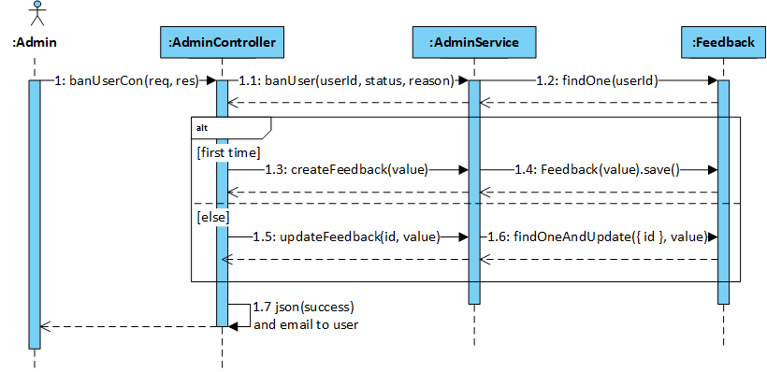

Figure 4‑129: Admin manages user sequence diagram

* + - 1. Admin manages feedback

##### **Screen Design**

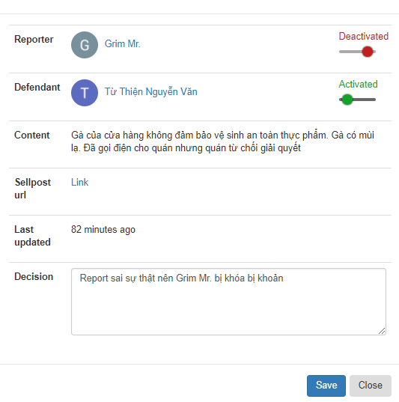

Figure ‑130: Admin manages feedback screen design

##### **Class Diagram**

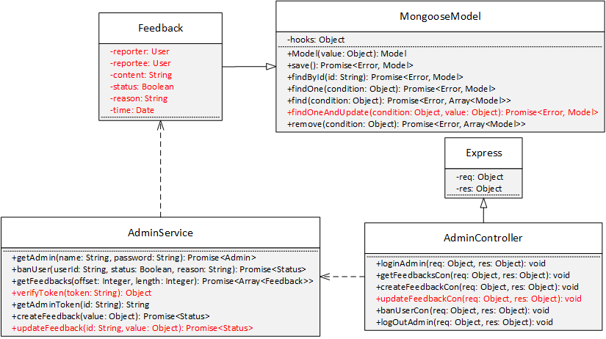

Figure 4‑131: Admin manages feedback class diagram

##### **Class Specification**

***Feedback***

|  |  |  |  |
| --- | --- | --- | --- |
| **Feedback** | | | |
| Physical address | Backend /models/Feedback.js | | |
| Base class | Mongoose Model | | |
| Attributes | | | |
| No | Name | Type | Description |
| 1 | reporterId | String |  |
| 2 | reporteeId | String |  |
| 3 | content | String |  |
| 4 | status | String |  |
| 5 | reason | String |  |
| 6 | time | Date |  |
| Operation | | | |

***AdminService***

|  |  |  |  |
| --- | --- | --- | --- |
| **AdminService** | | | |
| Physical address | Backend /services/AdminService.js | | |
| Base class |  | | |
| Attributes | | | |
| No | Name | Type | Description |
| Operation | | | |
| verifyToken |  |  |  |
| Return Type | Object |  |  |
| Parameters | Name | Type | Description |
|  | token | String |  |
| updateFeedback |  |  |  |
| Return Type | Promise<Status> |  |  |
| Parameters | Name | Type | Description |
|  | id | String |  |
|  | value | Object |  |

***AdminController***

|  |  |  |  |
| --- | --- | --- | --- |
| **AdminController** | | | |
| Physical address | Backend /controllers/AdminController.js | | |
| Base class | Express | | |
| Attributes | | | |
| No | Name | Type | Description |
| Operation | | | |
| updateFeedbackCon |  |  |  |
| Return Type | void |  |  |
| Parameters | Name | Type | Description |
|  | req | object |  |
|  | res | object |  |

##### **Sequence Diagram**

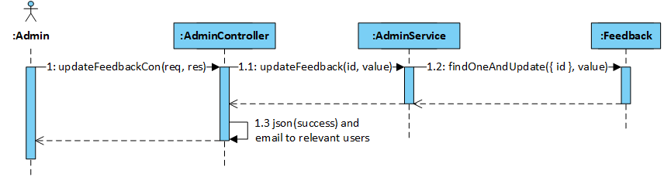

Figure 4‑132: Admin manages feedback sequence diagram

* + - 1. Admin logouts admin

##### **Screen Design**

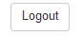

Figure 4-133: Admin logouts admin screen design

##### **Class Diagram**

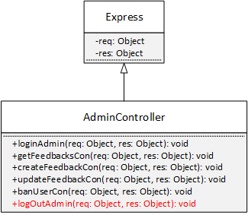

Figure 4‑134: Admin logouts admin class diagram

##### **Class Specification**

***AdminController***

|  |  |  |  |
| --- | --- | --- | --- |
| **AdminController** | | | |
| Physical address | Backend /controllers/AdminController.js | | |
| Base class | Express | | |
| Attributes | | | |
| No | Name | Type | Description |
| Operation | | | |
| logOutAdmin |  |  |  |
| Return Type | void |  |  |
| Parameters | Name | Type | Description |
|  | req | object |  |
|  | res | object |  |

##### **Sequence Diagram**

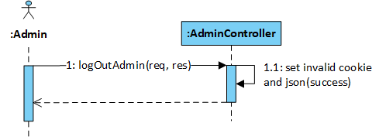

Figure 4‑135: Admin logouts admin sequence diagram

# : Software Testing Documentation

3. 1. Introduction
      1. Purpose

The primary purpose of this chapter is to detect and prevent defects which may be created by developers while developing the software and this may lead to software failures. On the other hand, another objective of this chapter is to provide information about the level of quality and to make sure that the end result meets the business and user requirements. It contains the following sections:

* Scope of Testing.
* Testing Tool and Environment.
* Resources and responsibilities.
* Test strategy: Test approach, test stages.
* Test schedule.
* Feature to be tested.
* Feature not to be tested.
* Defect Log.
* Test report.
  + 1. Scope of testing

#### Testing phases

There are 4 phases in Testing Process: Unit testing, Integration testing, System testing and Acceptance testing.

|  |  |  |
| --- | --- | --- |
| **ID** | **Testing Phase** | **Description** |
| **1** | **Unit testing** | The main aim of this endeavor is to determine whether the application functions as designed. In this phase, a unit can refer to a function, individual program or even a procedure, and a [White-box Testing](http://stackoverflow.com/questions/402161/black-box-vs-white-box-testing) method is usually used to get the job done. |
| **2** | **Integration testing** | Integration testing allows individuals the opportunity to combine all of the units within a program and test them as a group. This testing level is designed to find interface defects between the modules/functions. This is particularly beneficial because it determines how efficiently the units are running together. |
| **3** | **System testing** | System testing is the first level in which the complete application is tested as a whole. The goal at this level is to evaluate whether the system has complied with all of the outlined requirements and to see that it meets Quality Standards. |
| **4** | **Acceptance testing** | Acceptance testing (or User Acceptance Testing), is conducted to determine whether the system is ready for release. During this phase, the tester and some alpha test user will test the system to find out whether the application meets their business’ needs. |

#### Testing types

* GUI testing
* Function testing
* Performance testing
* Regression testing
* Acceptance testing including alpha testing
* Unit testing
* Load testing

#### Testing range

Team performs all functions defined in the SRS based on the approved version.

* 1. Test plan
     1. Testing tools and environment
        1. Testing tools
           1. KajKai Front-end and Project testing
* Chrome DevTools: To view logs, inspect elements.



Figure ‑: Chrome Developer Tools

* Redux DevTools: To view Redux action and state tree.
* JIRA: To manage bugs: Show all bugs and life cycle of process to resolve bug.



Figure ‑: JIRA

* Microsoft Excel: To manage test cases



Figure ‑: Microsoft Excel

* Postman: to manage the list of all APIs and manually test API



Figure ‑: Postman

* + - * 1. KAJKAI API testing
* Mocha [9]: a feature-rich JavaScript test framework running on Node.js and in the browser, using to make asynchronous testing simple.



Figure ‑: MochaJS

* Chaijs [10]: Chai is a BDD / TDD assertion library for node, to help assertion result in a test.



Figure ‑: ChaiJS

* Chai as Promised [11]: Chai as Promised extends Chai with a fluent language for asserting facts about promises, to assert result with Promises.
* SuperTest [12]: A Super-agent[13] driven library for testing Node.js HTTP servers using a fluent API, use to make a test with from high-level abstraction to the low-level API.
* Istanbul[14]: to observe code coverage.
* Nyc[15]: command-line-client for Istanbul works well with most JavaScript testing frameworks: tap, mocha, AVA, …
  + - 1. Testing environment

|  |  |  |
| --- | --- | --- |
| **Type of testing** | **Software** | **Hardware** |
| System test and Acceptance test | * Microsoft Office Excel 2013. * Microsoft Office Word 2013 * Chrome Version 59.0.3071.115 | Personal computer for developing with the minimum configuration:   * Windows 7 Professional 32-bit, Service Pack 1 * Intel® Core™ i3 * Installed memory (RAM): 4.00GB   or   * Ubuntu 14.04 64-bit * Intel® Core™ i3   Installed memory (RAM): 8.00GB |
| Unit testing and API testing | * Chaijs v3.5.0 * Chai as promised v5.3.0 * Mocha v2.4.5 * SuperTest v1.2.0 * istanbul v0.4.4 | Personal computer for developing with the minimum configuration:   * Windows 7 Professional 32-bit, Service Pack 1 * Intel® Core™ i3 * Installed memory (RAM): 4.00GB   or   * Ubuntu 14.04 64-bit * Intel® Core™ i3 * Installed memory (RAM): 8.00GB |

* + 1. Resources and responsibilities

|  |  |  |
| --- | --- | --- |
| **ID** | **Resources** | **Responsibilities** |
| 1 | Project Manager | * Responsible for Project Schedules and overall success of the project. * Review Test-case and report. |
| 2 | Tester | * Preforming the actual system testing. * Manage test resource and assign test tasks. * Create Test Plan. * Create Test Cases. * Create Test Report. * Execute Test. * Test Log report. |
| 3 | Developer | * Create unit test and integration test scripts. * Fix bugs. |

* + 1. Test strategy
       1. Testing model

Overall, KajKai project uses the Iterative and Incremental Software Process Model, KajKai is divided into 2 sub-systems: KajKai API and KajKai Frontend. In each phase of process, we use specific process for each sub-system team to fit the requirement, the characteristic and the human resource of each team.

Since APIs lack [GUI](https://en.wikipedia.org/wiki/Graphical_user_interface) and need to change source code rapidly as KajKai Frontend requires, so that KajKai API applies Test-driven development (TDD) and Behavior Driven Development (BDD) process, which covers source code by Unit testing and API testing at the message layer. In the development time, whenever we add a new feature or change the old features, we will add/modify the tests first, then write code to make the test pass then refactor the code and refactor the test at the last.

KajKai API has 2 levels of test:

* Unit testing: Automation tests that cover logic of XXXService.js files.
* API testing: Automation tests that involve testing APIs directly (in isolation) to determine whether APIs return the correct response (in the expected format) for a broad range of feasible requests, react properly to edge cases such as failures and unexpected/extreme inputs.

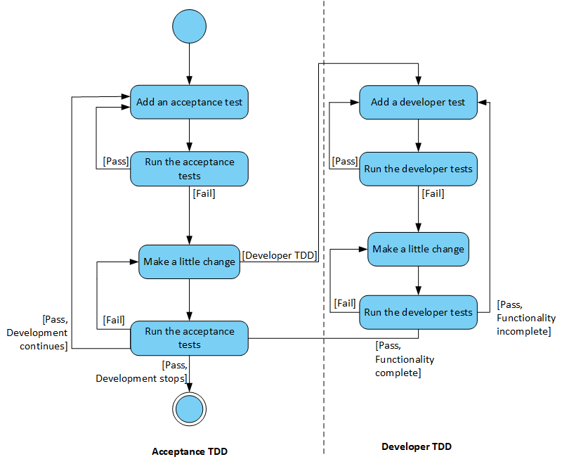

Figure ‑: KajKai API BDD and TDD activity diagram

KajKai Frontend works mostly with GUI instead of logic and it depends on KajKai API, so that KajKai Frontend applies System testing which covers the whole KajKai system.

* + - 1. Testing types

Testing KajKai Project will be carried out in each release package as defined in project plan and will depend on internal delivery by development side. Critical tests will be defined as any new or modified tests for the KajKai system. Project Manager will decide which closed defects the test team cannot determine.

Each type of KajKai Project Testing will be designated to cover a level of project, from each model level, API level, KajKai API sub-system level and KajKai Project level with Unit testing combined with Database testing, API testing, System testing and Acceptance testing. On the other hand, KajKai will use several of testing type to prevent defects from code modifications and latent bugs.

The different types of testing that will be carried out this project are:

* Unit testing:
  + Testing all individual implemented methods, functions of XXXService.js files.
  + Unit test also includes database testing to verify constraint, transaction, default value, data types, data format which are mentioned in database design and software requirement.
  + Test case will have to cover all logic branch that function or method could execute with difference data input. Another alternative logic branch should be covered if not, that logic branch should be detected at API testing level.
  + Implemented function’s error message and database error message will be included in this test.
* API testing:
  + Involves testing APIs directly to determine if they meet expectations for functionality, reliability, performance, and security. API testing will test all of individual implemented API of KajKai API.
  + Testing will mock all possible datasets and call to corresponding API with separate testing database by using Chaijs, SuperTest and Mocha.
  + Test case will verify constraint of data which be mention in Business rule.
  + Basically, almost all API test cases are executed as automation test. After that all API with standard sample datasets will be saved and confirmation tests will be executed by using Postman with developer’s local database.
* UI testing
  + User Interface testing verifies a user’s interaction with the software. The goal of GUI testing is to ensure that the GUI provides the user with an appropriate access and navigation through the functions of the target-of-test. In addition, GUI testing ensures that the objects within the GUI function as expected and conform to requirement.
  + This testing type targets to cover the verification of the overall look and feel of the KajKai system including initial position, font, text size, color, focus, initial button, tab order, label, screen sizes and sentences width.
  + Check all the GUI elements for size, position, width, length and acceptance of characters or numbers. For instance, it must be able to provide inputs to the input fields.
* Check if Error Messages are displayed correctly.
* Check if Font used in application is readable.
* Check if the alignment of the text is proper.
* Check if the Color of the font and warning messages is aesthetically pleasing.
* Check if images have good clarity.
* Check if images are properly aligned.
* Check the positioning of GUI elements for different screen resolution.
* Performance testing
  + The testing is to confirm to cover for response time for KajKai System with different network conditions with the throttling tool of Google Chrome
* Regression testing
  + The testing is to confirm that the bug was removed including the extent of the impact, when developers fix bug, developers and testers will confirm with each other what is the impacts of fix bug modification, after that all impact unit or function will be retested by developers then testers after that.
* Acceptance testing
  + This test type will be executed by tester with designed test cases, acceptance test is a test type conducted to determine if the requirements of a specification or contract are met.
  + It also includes alpha testing, alpha testing takes place at close relation user’s site and are free test to detect bug and strange behavior. By that, development team will improve UX and UI of system
* Load testing
  + The testing is executed by developers to estimate a web server performance in order to find if the server can serve sufficiently high workload by using Artillery[16]
    - 1. Testing phases

Table below are the stages in which common tests are executed:

|  |  |  |  |  |
| --- | --- | --- | --- | --- |
| **Testing type** | **Testing phase** | | | |
| **Unit testing** | **Integration testing** | **System testing** | **Acceptance testing** |
| Unit Testing | x | x | x |  |
| API Testing | x | x |  |  |
| UI Testing |  |  |  | x |
| Regression Testing | x | x | x | x |
| Performance Testing |  |  | x | x |
| Acceptance Testing |  |  | x |  |
| Load Testing |  |  | x | x |

Table ‑: Testing phase

* + - 1. Test schedule

Table below is the Test Schedule for KajKai Project:

|  |  |  |
| --- | --- | --- |
| **Test Schedule** | **Start Date** | **End Date** |
| *Phase 1: Authentication and Store’s related features* | 5/19/2017 | 6/30/2017 |
| Unit Testing and API Testing | 5/19/2017 | 6/29/2017 |
| User Interface Testing | 6/16/2017 | 6/27/2017 |
| System Testing | 6/15/2017 | 6/30/2017 |
| Performance Tests | 6/28/2017 | 6/29/2017 |
| Regression Tests | 6/30/2017 | 6/30/2017 |
| *Phase 2: Orders’ related features and optimization* | 7/10/2017 | 8/03/2017 |
| Unit Testing and API Testing | 7/10/2017 | 8/02/2017 |
| User Interface Testing | 7/28/2017 | 8/01/2017 |
| System Testing | 7/25/2017 | 8/03/2017 |
| Performance Tests | 8/01/2017 | 8/01/2017 |
| Regression Tests | 8/02/2017 | 8/02/2017 |
| Acceptance testing | 8/03/2017 | 8/03/2017 |

Table ‑: Test schedule

* + - 1. Deliverables

Table below is the Deliverables for KajKai Project:

|  |  |  |
| --- | --- | --- |
| **Deliverables** | **Responsibilities** | **Complete date** |
| *Phase 1* |  |  |
| Test Plan | Tester | 5/23/2017 |
| Test Cases | Tester | 6/13/2017 |
| Test case review | Tester + PM | 6/14/2017 |
| Defect report | All members | 6/23/2017 |
| *Phase 2* |  |  |
| Test Plan | Tester | 7/14/2017 |
| Test Cases | Tester | 7/24/2017 |
| Test case review | Tester + PM | 7/25/2017 |
| Defect report | All members | 8/01/2017 |
| Final test Summary report | PM | 8/04/2017 |

Table ‑3: Deliverables schedule

* + 1. Features to be tested

|  |  |
| --- | --- |
| **Actor** | **Name** |
| Guest | Sign up |
| Reset password |
| Login by KajKai user account |
| Login by Gmail |
| Login by Facebook |
| User | View Home page |
| View User page |
| Edit general info |
| Change password |
| Search user |
| Search store |
| Search sellpost |
| Chat |
| Comment |
| Reply comment |
| Like and unlike comment, reply |
| Like and unlike sellpost |
| Manage interest |
| Receive notification |
| View notification list |
| View notification detail |
| Turn on and off notification |
| Create store |
| Follow and unfollow store |
| Follow and unfollow sellpost |
| Feedback |
| Logout user |
| Seller | View Store page |
| Update Store Info |
| Manage sellpost |
| Manage order |
| View statistics |
| Admin | Login by KajKai admin account |
| View Admin page |
| Manage user |
| Manage feedback |
| Logout admin |

Table ‑4: Features to be tested

* + 1. Features not to be tested

All features are listed in 1.5.4 will not to be tested

* 1. Test Case
     1. Automation testing with API testing and Unit testing

Unit testing and API testing will be done by the developers and approved by team leader.

The KAJKAI development team embrace this feature to gain the following advantages:

* Reduce the level of bugs in production code.
* Save development time.
* Automation tests can be run as frequently as required.
* Make it easier to change and refactor code by improving the design of code especially with Test-Driven Development.
* Can easily form a document from the tests.
* Easier to maintain than [GUI tests](https://en.wikipedia.org/wiki/Graphical_user_interface_testing) which are difficult to maintain with the short release cycles and frequent changes and with a complex system
* Reduce cost of resource to corresponding GUI testing
  + - 1. Automation testing framework
* For API testing and Unit testing, we use Mocha testing framework combined with Chai assertion library and Istanbul for code coverage observation.
* All testing frameworks and libraries will be installed to KajKai APIs project automatically by using npm package manager:



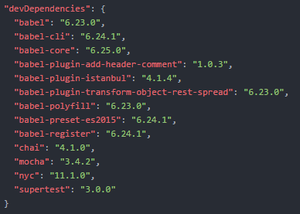

Figure ‑: Declare testing frameworks and libraries to project dependencies in **package.json** file

* Automation tests use a separate environment which is similar to production environment and including: database, Redis instance, Socket.IO.
* All automation test scripts will be created manually and saved to **tests** directory of KajKai API. Unit tests are stored in **api** and **service** folder, API tests will be storage in **api** folder

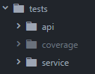

Figure ‑: Test directory structure

* Unit tests focus on individual functions in class and will be created simply as below

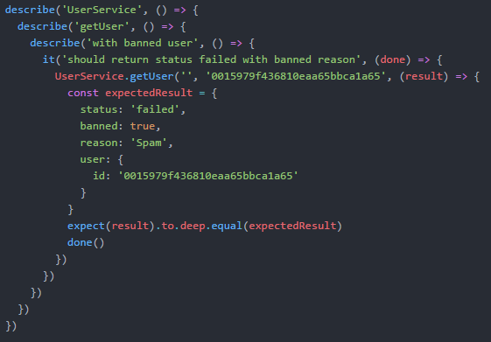

Figure ‑: Unit test case sample  
This getUser function is used to retrieve a user info.  
Test case will check if the getUser handles the case that user is banned.

* API tests focus on individual API and use SuperTest to test these API based on the business rule.

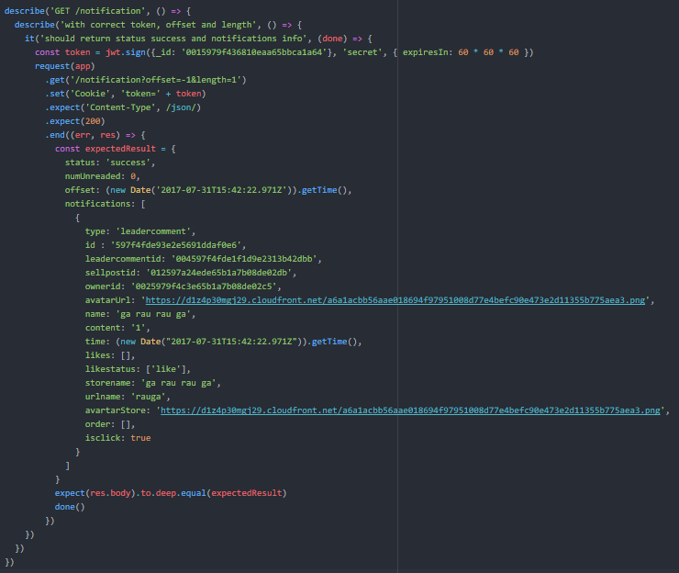

Figure ‑: API test case sample  
Test behavior of HTTP method which is used to get user notification list with correct token

* Test case are executed automatically by using Nyc (in command line).



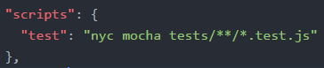

Figure ‑: Configure script in **package.json** file

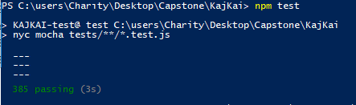

Figure ‑: Run test by npm command

By using Nyc combining with Istanbul, test report can be exportd in 2 formats: static html and console table.

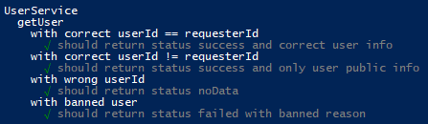

Figure ‑:Sample Unit test report

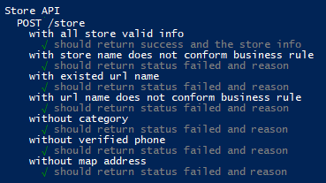

Figure ‑: Sample API test report

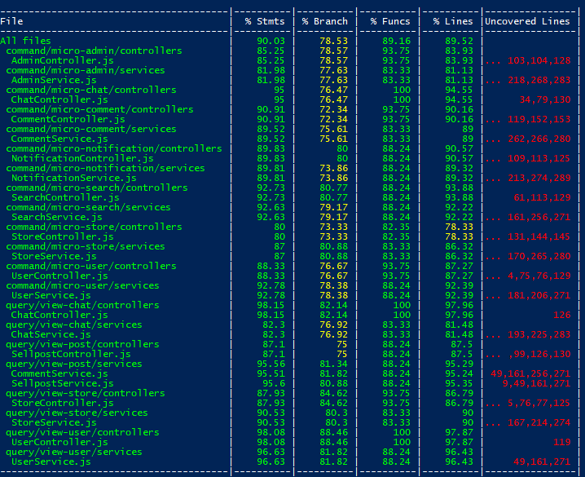

Figure ‑: Istanbul console test coverage report

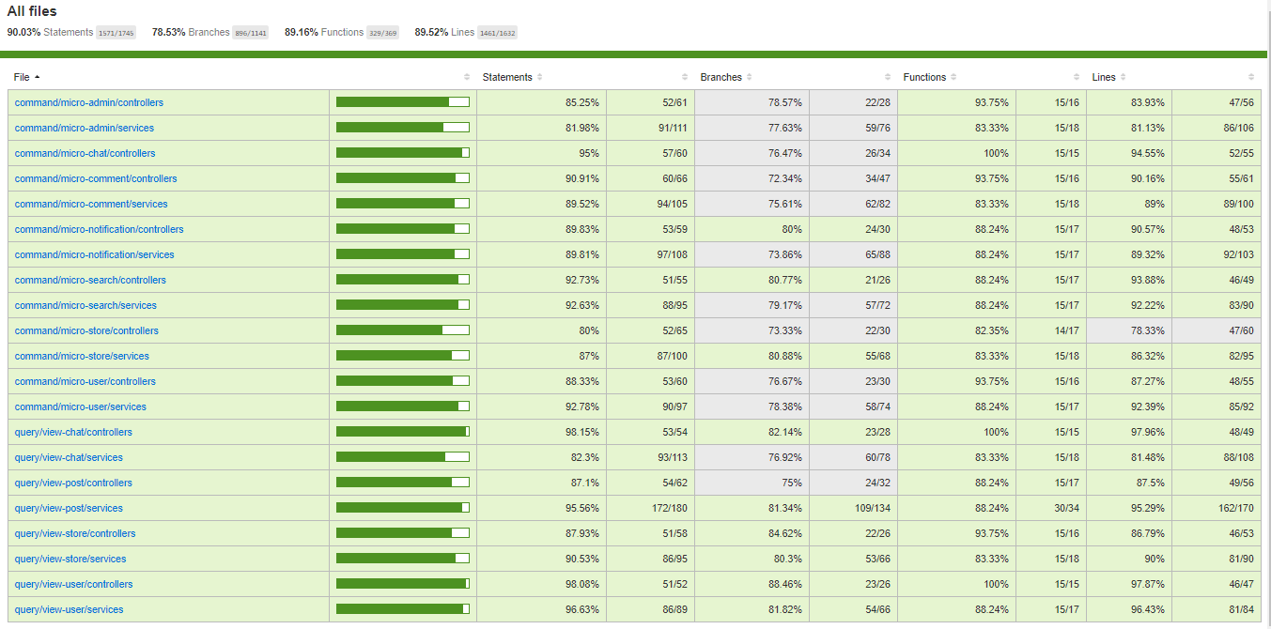

Figure ‑: Istanbul static html test coverage report

* + 1. System testing

Detailed Test cases will be described in ***KAJKAI_TestCase.xlsx*** file.

As a standard definition, KajKai Project defines that a test case is:

A set of test data and test programs (test scripts) and their expected results. A test case validates one or more system requirements and generates a pass or fail.

A good test case should follow two basic aspects, the Contents and the Style. Test cases for functional testing are derived from the target of test's use cases Test cases should be developed for each use case scenario. The use case scenarios are identified by describing the paths through the use case that traverse the basic flow and alternate flows start to finish through the use case.

By using good automation test, KajKai Project System testing will not focus on common logic of system like length of text but focus on behavior of website and aims to validate that all software module dependencies are functionally correct and that data integrity is maintained between separate modules for the entire solution.

* + 1. Acceptance testing

Acceptance Testing is a level of the software testing process where a system is tested for acceptability. The purpose of this test is to evaluate the system’s compliance with the business requirements and assess whether it is acceptable for delivery. But our project will use the Checklists as a substitute for Acceptance testing.

The content of the Checklist is shown in the table below

|  |  |  |  |
| --- | --- | --- | --- |
| **ID** | **Checklists** | **Yes** | **No** |
| **General** | | | |
| CL-001 | Text on all pages for spelling and grammatical errors. | √ |  |
| CL-002 | Functionality of buttons available on all pages. | √ |  |
| CL-003 | All mandatory fields are validated. | √ |  |
| CL-004 | Validation error messages are displayed properly below the field. | √ |  |
| CL-005 | All error messages are displayed in red color. | √ |  |
| CL-006 | Delete functionality for any record on page are asked for confirmation. | √ |  |
| CL-007 | All numeric values are formatted properly. | √ |  |
| CL-008 | Unavailable pages are redirected to not found page. | √ |  |
| **GUI and Usability** | | | |
| CL-009 | Screens are designed follow project standards. | √ |  |
| CL-010 | The screen are well organized. | √ |  |
| CL-011 | All fields on page (e.g. text box, radio options, dropdown lists) should be aligned properly. | √ |  |
| CL-012 | Information is arranged symmetrically with adequate spacing between components. | √ |  |
| CL-013 | The most important fields are located where they are easy to see. | √ |  |
| CL-014 | Information is presented in the order that the user needs it. | √ |  |
| CL-015 | Do not use slang, acronyms, and abbreviations. | √ |  |
| CL-016 | Icons and images are designed impression and copyright. | √ |  |
| CL-017 | Font size, style and color for headline, description test, labels, infield data, and grid information standard as specified in SRS. | √ |  |
| CL-018 | The static text is clear, concise, and meaningful. | √ |  |
| CL-019 | A list view is used to allow a collection of items that are on a single hierarchical level. | √ |  |
| CL-020 | A tree view is used to allow a collection of items to be displayed and manipulated within varying hierarchical levels. | √ |  |
| CL-021 | Pop-up menus are provided for the user to access information about an object's properties or perform specific tasks on the object. | √ |  |
| CL-022 | Command buttons are used to trigger application processes. | √ |  |
| CL-023 | Toggle buttons are used to show independent on/off choices. Can change status for different answer. | √ |  |
| CL-024 | System displays notification message when trouble or error occurs. | √ |  |
| **Database** | | | |
| CL-025 | Correct data is saved in database upon successful page submit. | √ |  |
| CL-026 | Columns does not accept null values. | √ |  |
| CL-027 | Data should be stored in single or multiple collections based on design. | √ |  |
| CL-028 | Input data is not truncated. Field length shown to user on page and in database schema should be same. | √ |  |
| CL-029 | Input numeric fields with minimum, maximum, and float values. | √ |  |
| CL-030 | Drop down list are saved correctly in database. | √ |  |
| CL-031 | Database fields are designed with correct data type and data length. | √ |  |
| **Performance** | | | |
| CL-032 | Real time connection | √ |  |
| CL-033 | Page load time is within acceptable range. | √ |  |
| CL-034 | Page load on slow connections. | √ |  |
| CL-035 | Response time for any action under light, normal, moderate and heavy load conditions. | √ |  |
| CL-036 | Database query execution time. | √ |  |
| CL-037 | Load testing of application. | √ |  |
| CL-038 | Stress testing of application. | √ |  |
| **Security** | | | |
| CL-039 | Test password security and password policy enforcement. | √ |  |
| CL-040 | Check application logout functionality. | √ |  |
| CL-041 | Cookie information should be stored in encrypted format only. | √ |  |

Table ‑: Check list table

* + 1. Defect Log

KajKai project used <https://www.atlassian.com/software/jira/bug-tracking> to manager tasks and defects.

PM created KajKai project in JIRA and add other members’ email to allow the team take part in activities: control bugs, fix bugs, re-test bugs and close bug. Bug will be logged by tester or developer in develop progress.

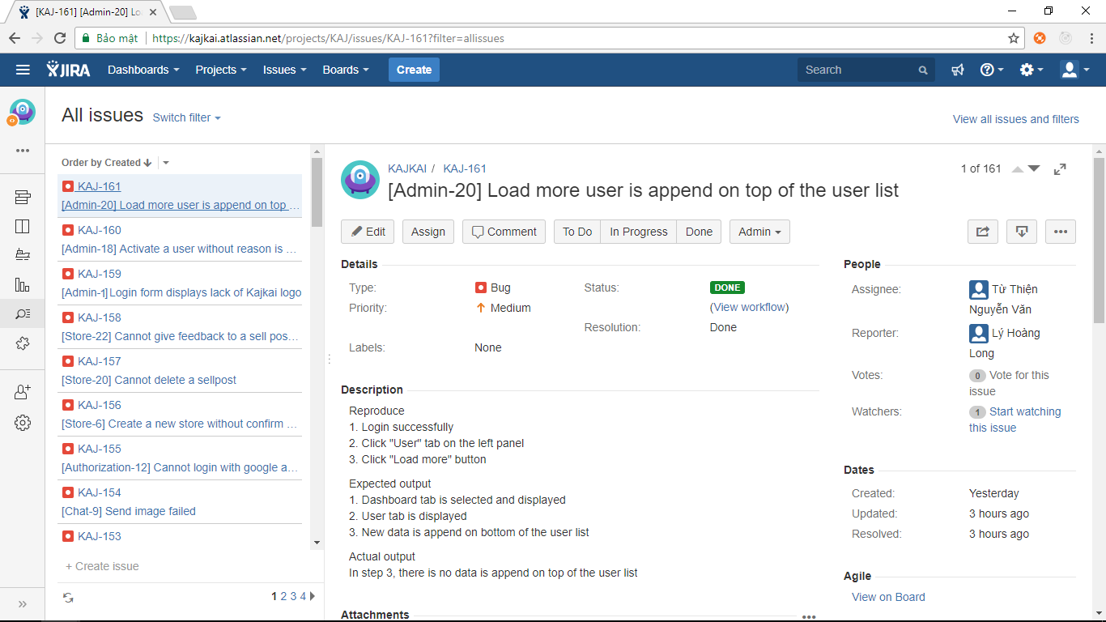

Figure ‑: Control task and bug with JIRA

* 1. Test Report
     1. Automation test case report

The contents of the Automation Test Case Report are shown in the table below:

|  |  |  |  |  |  |
| --- | --- | --- | --- | --- | --- |
| **Type of test case** | **Test Case** | **Pass** | **Fail** | **Not available** | **Number of Test Case** |
| API Test - Admin | Admin authentication | 4 | 0 | 0 | 4 |
| Admin manages user | 6 | 0 | 0 | 6 |
| Admin resolves feedback | 5 | 0 | 0 | 5 |
| **Total** | **15** | **0** | **0** | **15** |
| API Test - Chat | User creates chat | 8 | 0 | 0 | 8 |
| User edits group setting | 5 | 0 | 0 | 5 |
| User sends message | 13 | 0 | 0 | 13 |
| **Total** | **26** | **0** | **0** | **26** |
| API Test - Comment | User comments to order | 15 | 0 | 0 | 15 |
| User, Seller reply to comment | 13 | 0 | 0 | 13 |
| **Total** | **28** | **0** | **0** | **28** |
| API Test - Notification | User views notification | 5 | 0 | 0 | 5 |
| User receives notification | 10 | 0 | 0 | 10 |
| **Total** | **15** | **0** | **0** | **15** |
| API Test - Search | Search user | 3 | 0 | 0 | 3 |
| Search store | 4 | 0 | 0 | 4 |
| Search sellpost | 6 | 0 | 0 | 6 |
| **Total** | **13** | **0** | **0** | **13** |
| API Test - Store | Seller manages sellpost | 17 | 0 | 0 | 17 |
| Seller manages order | 20 | 0 | 0 | 10 |
| **Total** | **37** | **0** | **0** | **37** |
| API Test – User | User authentication | 6 | 0 | 0 | 6 |
| User updates info | 8 | 0 | 0 | 8 |
| User creates store | 13 | 0 | 0 | 13 |
| **Total** | **27** | **0** | **0** | **27** |
| Unit Test - Admin | Admin authentication | 4 | 0 | 0 | 4 |
| Admin manages user | 8 | 0 | 0 | 8 |
| Admin resolves feedback | 7 | 0 | 0 | 7 |
| **Total** | **19** | **0** | **0** | **19** |
| Unit Test - Chat | User creates chat | 10 | 0 | 0 | 10 |
| User edits group setting | 6 | 0 | 0 | 6 |
| User sends message | 14 | 0 | 0 | 14 |
| **Total** | **30** | **0** | **0** | **30** |
| Unit Test - Comment | User comments to order | 20 | 0 | 0 | 20 |
| User, Seller reply to comment | 16 | 0 | 0 | 16 |
| **Total** | **36** | **0** | **0** | **36** |
| Unit Test - Notification | User views notification | 9 | 0 | 0 | 9 |
| User receives notification | 36 | 0 | 0 | 36 |
| **Total** | **45** | **0** | **0** | **45** |
| Unit Test - Search | Search user | 5 | 0 | 0 | 5 |
| Search store | 7 | 0 | 0 | 7 |
| Search sellpost | 11 | 0 | 0 | 11 |
| **Total** | **23** | **0** | **0** | **23** |
| Unit Test - Store | Seller manages sellpost | 18 | 0 | 0 | 18 |
| Seller manages order | 24 | 0 | 0 | 24 |
| **Total** | **42** | **0** | **0** | **42** |
| Unit Test – User | User authentication | 6 | 0 | 0 | 6 |
| User updates info | 9 | 0 | 0 | 9 |
| User creates store | 14 | 0 | 0 | 14 |
| **Total** | **29** | **0** | **0** | **29** |
|  | |  |  |  |  |
| **Total of Test Case** | | **385** | **0** | **0** | **385** |

Table 5‑5: Automation test case report

* + 1. Automation test report

Automation test is an integral part of development process. So that, there are 2 phases as 2 phases of Iterative and Incremental Software Process Model.

|  |  |  |  |  |  |
| --- | --- | --- | --- | --- | --- |
| **Test case** | **Phase 1** | | **Phase 2** | | **Final** |
| Pass | Fail | Pass | Fail |
| API Test - Admin | 8 | 0 | 15 | 0 | 15 |
| API Test - Chat | 13 | 0 | 26 | 0 | 26 |
| API Test - Comment | 15 | 0 | 28 | 0 | 28 |
| API Test - Notification | 7 | 0 | 15 | 0 | 15 |
| API Test - Search | 6 | 0 | 13 | 0 | 13 |
| API Test - Store | 19 | 0 | 37 | 0 | 37 |
| API Test - User | 13 | 0 | 27 | 0 | 27 |
| Unit Test - Admin | 10 | 0 | 19 | 0 | 19 |
| Unit Test - Chat | 16 | 0 | 30 | 0 | 30 |
| Unit Test - Comment | 19 | 0 | 36 | 0 | 36 |
| Unit Test - Notification | 24 | 0 | 45 | 0 | 45 |
| Unit Test - Search | 10 | 0 | 23 | 0 | 23 |
| Unit Test - Store | 21 | 0 | 42 | 0 | 42 |
| Unit Test - User | 16 | 0 | 29 | 0 | 29 |
| Total all test case | 197 | 0 | 385 | 0 | 385 |

Table ‑: Automation test report

|  |  |  |  |  |
| --- | --- | --- | --- | --- |
| **Phase** | **Coverage** | | | |
| Statements | Branches | Functions | Lines |
| **Phase 1** | 89.01% | 78.23% | 90.31% | 91.18% |
| **Phase 2** | 90.03% | 78.53% | 89.16% | 89.52% |

Table 5‑7: Automation test coverage report

* + 1. System test case report

The contents of the System Test Case Report are shown in the table below:

|  |  |  |  |  |  |
| --- | --- | --- | --- | --- | --- |
| **Module** | **Test Case** | **Pass** | **Fail** | **Not available** | **Number of Test Case** |
| Authorization | View Login form | 2 | 0 | 0 | 2 |
| View Signup form | 2 | 0 | 0 | 2 |
| Signup | 6 | 0 | 0 | 6 |
| Login by KajKai account | 6 | 0 | 0 | 6 |
| Login by Facebook account | 3 | 0 | 0 | 3 |
| Login by Gmail account | 3 | 0 | 0 | 3 |
| Logout | 1 | 0 | 0 | 1 |
| Reset password | 2 | 0 | 0 | 2 |
| Deactivated user logins | 1 | 0 | 0 | 1 |
| Search | View homepage | 1 | 0 | 0 | 1 |
| View search bar | 5 | 0 | 0 | 5 |
| Search by category | 8 | 0 | 0 | 8 |
| Search store | 1 | 0 | 0 | 1 |
| Search user | 1 | 0 | 0 | 1 |
| User | View user page as owner | 9 | 0 | 0 | 9 |
| View user page as visitor | 7 | 0 | 0 | 7 |
| Change user cover | 9 | 0 | 0 | 9 |
| Change user avatar | 7 | 0 | 0 | 7 |
| View interested sellpost in user page | 6 | 0 | 0 | 6 |
| Load more interested sellpost in user page | 1 | 0 | 0 | 1 |
| Give feedback interested sellpost | 2 | 0 | 0 | 2 |
| Unfollow interested sellpost | 1 | 0 | 0 | 1 |
| Like interested sellpost | 4 | 0 | 0 | 4 |
| Comment interested sellpost | 2 | 0 | 0 | 2 |
| Order in interested sellpost | 2 | 0 | 0 | 2 |
| View more comment in interested sellpost | 1 | 0 | 0 | 1 |
| Block user in interested sellpost | 2 | 0 | 0 | 2 |
| Change user's setting | 6 | 0 | 0 | 6 |
| Reload user | 1 | 0 | 0 | 1 |
| Store | View create store page | 2 | 0 | 0 | 2 |
| Create store | 8 | 0 | 0 | 8 |
| View store as store's owner | 8 | 0 | 0 | 8 |
| View store as store visitor | 4 | 0 | 0 | 4 |
| Change store cover | 8 | 0 | 0 | 8 |
| Change store avatar | 8 | 0 | 0 | 8 |
| Send message to store | 1 | 0 | 0 | 1 |
| Follow a store | 2 | 0 | 0 | 2 |
| View store management | 5 | 0 | 0 | 5 |
| Like a comment in store management | 2 | 0 | 0 | 2 |
| Reply a comment in store management | 1 | 0 | 0 | 1 |
| Receive an order in store management | 2 | 0 | 0 | 2 |
| Mark an order as "Done" in store management | 1 | 0 | 0 | 1 |
| View store's location | 2 | 0 | 0 | 2 |
| Open store's photo | 2 | 0 | 0 | 2 |
| Change store's setting | 6 | 0 | 0 | 6 |
| Reload store page | 1 | 0 | 0 | 1 |
| View statistics | 10 | 0 | 0 | 10 |
| Sellpost | Create sellpost | 16 | 0 | 0 | 16 |
| View sellpost as store's owner | 6 | 0 | 0 | 6 |
| View sellpost as store visitor | 6 | 0 | 0 | 6 |
| Edit a sellpost | 4 | 0 | 0 | 4 |
| Delete a sellpost | 3 | 0 | 0 | 3 |
| Give feedback to a sellpost | 2 | 0 | 0 | 2 |
| Follow a sellpost | 4 | 0 | 0 | 4 |
| Load more sellpost | 1 | 0 | 0 | 1 |
| Like sellpost | 4 | 0 | 0 | 4 |
| Comment sellpost | 2 | 0 | 0 | 2 |
| Make an order in sellpost | 3 | 0 | 0 | 3 |
| Receive order | 2 | 0 | 0 | 2 |
| Mark an order as "Done" | 1 | 0 | 0 | 1 |
| View more comment | 1 | 0 | 0 | 1 |
| Block user | 2 | 0 | 0 | 2 |
| Turn on/off notification | 2 | 0 | 0 | 2 |
| Notification | View notification | 11 | 0 | 0 | 11 |
| Open event on notification | 6 | 0 | 0 | 6 |
| Notification quantity | 2 | 0 | 0 | 2 |
| View notification in details | 1 | 0 | 0 | 1 |
| See all | 1 | 0 | 0 | 1 |
| Chat | View chat | 12 | 0 | 0 | 12 |
| Create new chat | 3 | 0 | 0 | 3 |
| Send message | 2 | 0 | 0 | 2 |
| Send image | 3 | 0 | 0 | 3 |
| Send emotion icon | 2 | 0 | 0 | 2 |
| Add member | 2 | 0 | 0 | 2 |
| Change conversation name | 4 | 0 | 0 | 4 |
| Load more message | 1 | 0 | 0 | 1 |
| Load more chat | 1 | 0 | 0 | 1 |
| Message notification | 2 | 0 | 0 | 2 |
| Admin | View Login | 1 | 0 | 0 | 1 |
| Login | 5 | 0 | 0 | 5 |
| Dashboard view | 5 | 0 | 0 | 5 |
| Solve a feedback | 3 | 0 | 0 | 3 |
| Load more feedback | 2 | 0 | 0 | 2 |
| User view | 2 | 0 | 0 | 2 |
| Change user status | 5 | 0 | 0 | 5 |
| Load more user | 2 | 0 | 0 | 2 |
| Logout | 1 | 0 | 0 | 1 |
| Total of Test Case | | 320 | 0 | 0 | **320** |

Table 5‑8: System test case report

Test case list:

|  |  |  |  |  |  |
| --- | --- | --- | --- | --- | --- |
| **ID** | **Test Case Description** | **Test Case Procedure** | **Expected Output** | **Inter-test case Dependence** | **ID** |
|  | **View Login form** | |  |  |  |
| [View Login-1] | View Login | 1. Access https://www.kajkai.com 2. On navigation bar, click "Login" button | 1. Homepage is displayed 2. System displays with the following information:  - Title: Login  - Email field  - Password field  - Login button  - Login by Facebook button  - Login by Goggle button |  | Pass |
| [View Login-2] | Change language | 1. Open login page 2. Scroll to the bottom, click "Tiếng Việt" 3. Click "English" | 1. Login page is displayed 2. All text is translated into Vietnamese 3. All text is translated into English |  | Pass |
|  | **View Signup form** | |  |  |  |
| [View Login-3] | View Signup form | 1. Access https://www.kajkai.com 2. On navigation bar, click "Login" button | 1. The Homepage is displayed 2. System displays with the following information:  - Title: Signup  - Name field  - Email field  - Password field  - "Create Account" button |  | Pass |
| [View Login-5] | Change language | 1. Open login page 2. Scroll to the bottom, click "Tiếng Việt" 3. Click "English" | 1. Login page is displayed 2. All text is translated into Vietnamese 3. All text is translated into English |  | Pass |
|  | **Signup** |  |  |  |  |
| [View Login-6] | Signup with invalid name | 1. Open signup page 2. Enter invalid name 3. Enter valid email 4. Enter valid password 5. Click "Create Account" button | 1. Signup page is displayed 2. No error message is displayed 3. No error message is displayed 4. No error message is displayed 5. Name field must display error message: "Name can only contain letters, not too short or long or more space" | [Authorization-3] | Pass |
| [View Login-7] | Signup with invalid email | 1. Open signup page 2. Enter valid name 3. Enter invalid email 4. Enter valid password 5. Click "Create Account" button | 1. Signup page is displayed 2. No error message is displayed 3. No error message is displayed 4. No error message is displayed 5. Email field must display error message: "Your email is not available" | [Authorization-3] | Fail |
| [View Login-8] | Signup with invalid password | 1. Open signup page 2. Enter valid name 3. Enter valid email 4. Enter invalid password 5. Click "Create Account" button | 1. Signup page is displayed 2. No error message is displayed 3. No error message is displayed 4. No error message is displayed 5. Password field must display error message: "Password requires at least 6 characters" | [Authorization-3] | Pass |
| [Admin-2] | Signup successfully with valid information | 1. Open signup page 2. Enter valid name 3. Enter valid email 4. Enter valid password 5. Click "Create Account" button 6. Check email 7. Click on the confirmation link | 1. Signup page is displayed 2. No error message is displayed 3. No error message is displayed 4. No error message is displayed 5. System display: "Please check your mail to confirm, if not you can find in the spam mailbox" in new sub-page 6. Received email with confirmation link 7. Login successfully | [Authorization-3] | Pass |
| [View Login-10] | Resend confirmation email | 1. Open signup page 2. Enter valid name 3. Enter valid email 4. Enter valid password 5. Click "Create Account" button 6. Check email 7. Back to signup page, click "Resend confirmation email" 8. Check email | 1. Signup page is displayed 2. No error message is displayed 3. No error message is displayed 4. No error message is displayed 5. System display: "Please check your mail to confirm, if not you can find in the spam mailbox" 6. Received email with confirmation link 7. System displays "Confirmation email is resent" 6. Received email with confirmation link again | [Authorization-3] | Pass |
| [View Login-11] | Back to signup page | 1. Open signup page 2. Enter valid name 3. Enter valid email 4. Enter valid password 5. Click "Create Account" button 6. Click "Back" | 1. Signup page is displayed 2. No error message is displayed 3. No error message is displayed 4. No error message is displayed 5. System display: "Please check your mail to confirm, if not you can find in the spam mailbox" in new sub-page 6. System redirects to signup page | [Authorization-3] | Fail |
|  | **Login by KajKai account** | |  |  |  |
| [View Login-12] | Login by invalid email | 1. Open login page 2. Enter invalid email 3. Enter valid password 4. Click "Login" button | 1. Signup page is displayed 2. No error message is displayed 3. No error message is displayed 4. System display an error message: "Your email number are not available" | [Authorization-1] [Authorization-9] | Fail |
| [View Login-13] | Login by blank email | 1. Open login page 2. Do not fill email 3. Enter valid password 4. Click "Login" button | 1. Signup page is displayed 2. No error message is displayed 3. No error message is displayed 4. System display an error message: "Your email number are not available" | [Authorization-1] [Authorization-9] | Pass |
| [View Login-14] | Login by invalid password | 1. Open login page 2. Enter valid email 3. Enter invalid password 4. Click "Login" button | 1. Signup page is displayed 2. No error message is displayed 3. No error message is displayed 4. System display an error message: "Password requires at least 6 characters" | [Authorization-1] [Authorization-9] | Pass |
| [View Login-15] | Login by blank password | 1. Open login page 2. Enter valid email 3. Do not fill password 4. Click "Login" button | 1. Signup page is displayed 2. No error message is displayed 3. No error message is displayed 4. System display an error message: "Password requires at least 6 characters" | [Authorization-1] [Authorization-9] | Pass |
| [View Login-16] | Login by valid email and password | 1. Open login page 2. Enter valid email 3. Enter valid password 4. Click "Login" button | 1. Signup page is displayed 2. No error message is displayed 3. No error message is displayed 4. Login successfully | [Authorization-1] [Authorization-9] | Pass |
| [View Login-17] | Login by registered account but not confirmed yet | 1. Signup an account but do not check email for confirmation 2. Login by unconfirmed account | 1. No error message is displayed 2. System displays an error message: "Your account has not confirmed yet. Please check your email again." | [Authorization-1] [Authorization-9] | Fail |
|  | **Login by Facebook account** | | |  |  |
| [View Login-18] | Login by invalid Facebook account | 1. Open login page 2. Click "Facebook" button 3. Enter invalid email or password 4. Click "Login" button | 1. Login page is displayed 2. Facebook login tab is displayed 3. No error message is displayed 4. Facebook login tab displays error message. Login to System unsuccessfully | [Authorization-1] | Pass |
| [View Login-19] | Login by valid Facebook account | 1. Open login page 2. Click "Facebook" button 3. Enter valid email or password 4. Click "Login" button | 1. Login page is displayed 2. Facebook login tab is displayed 3. No error message is displayed 4. Facebook login tab is hided. Login to System successfully | [Authorization-1] | Pass |
| [View Login-20] | Cancel login by Facebook account | 1. Open login page 2. Click "Facebook" button 3. Enter valid email or password 4. Click close icon | 1. Login page is displayed 2. Facebook login tab is displayed 3. No error message is displayed 4. Facebook login tab is hided. There is no login action | [Authorization-1] | Pass |
|  | **Login by Gmail account** | |  |  |  |
| [View Login-21] | Login by invalid google account | 1. Open login page 2. Click Google button 3. Enter invalid email or password 4. Click "Login" button | 1. Login page is displayed 2. Google login tab is displayed 3. No error message is displayed 4. Google login tab displays error message. Login to System unsuccessfully | [Authorization-1] | Pass |
| [View Login-22] | Login by valid google account | 1. Open login page 2. Click Google button 3. Enter valid email or password 4. Click "Login" button | 1. Login page is displayed 2. Google login tab is displayed 3. No error message is displayed 4. Google login tab is hided. Login to System successfully | [Authorization-1] | Pass |
| [View Login-23] | Cancel login by Gmail account | 1. Open login page 2. Click Google button 3. Enter valid email or password 4. Click close icon | 1. Login page is displayed 2. Google login tab is displayed 3. No error message is displayed 4. Google login tab is hided. There is no login action | [Authorization-1] | Pass |
|  | **Logout** |  |  |  |  |
| [View Login-24] | Logout | 1. Login successfully 2. On navigation bar, click option icon 3. Click Logout | 1. User page is displayed 2. A modal is displayed with following information  - "Create a new store" button  - Store list  - Homepage  - Setting  - Logout 3. Login page is displayed | [Authorization-16] [Authorization-19] [Authorization-22] | Pass |
|  | **Reset password** | |  |  |  |
| [View Login-25] | Reset password | 1. Create KajKai account successfully 2. Open Login page 3. Click "Forgot your password" 4. Type email that used to register account then click "Done" | 1. New account is created 2. Login page is displayed 3. A modal is displayed 4. New message is displayed: "Please check your mail to confirm, if not you can find in the spam mailbox" | [Authorization-1] [Authorization-9] | Pass |
| [View Login-26] | Reset password with invalid email | 1. Create KajKai account successfully 2. Open Login page 3. Click "Forgot your password" 4. Type invalid email then click "Done" | 1. New account is created 2. Login page is displayed 3. A modal is displayed 4. An error message is displayed: "Your email number are not available" | [Authorization-1] [Authorization-9] | Pass |
|  | **Deactivated user logins** | |  |  |  |
| [View Login-27] | Deactivated user login | 1. Create a valid account 2. Admin deactivate this user 3. User login | 1. Account is created 2. User status is deactivated 3. Login failed. Error message is displayed: "" | [Authorization-9] [Admin-19] | Pass |

For more details about all test suites, please look at file “**KAJKAI_TestCase.xlsx”**

* + 1. System test report

We execute test in 2 phases of process model, to finish project. With 2nd phase, we test with 2 small task:

The first one: re-test phase 1 and implemented function of phase 2

The last one: test all test case and re-test to confirm bug

The contents of the Test Report are shown in the table below

|  |  |  |  |  |  |  |  |
| --- | --- | --- | --- | --- | --- | --- | --- |
| Module | **Phase 1** | | **Phase 2-1** | | **Phase 2-2** | | **Final** |
| Pass | Fail | Pass | Fail | Pass | Fail |
| Authorization | 22 | 5 | 27 | 0 | 27 | 0 | 27 |
| Search | 10 | 6 | 12 | 4 | 16 | 0 | 16 |
| User | 50 | 11 | 56 | 5 | 61 | 0 | 61 |
| Store | 44 | 30 | 66 | 8 | 74 | 0 | 74 |
| Sellpost | 48 | 12 | 59 | 1 | 60 | 0 | 60 |
| Notification | 10 | 11 | 21 | 1 | 22 | 0 | 22 |
| Chat | 30 | 3 | 30 | 0 | 30 | 0 | 30 |
| Admin | 14 | 13 | 25 | 0 | 27 | 0 | 27 |
| **Total all Test Case** | **228** | **91** | **296** | **19** | **317** | **0** | 320 |

Table ‑: System test report

* + 1. Benchmarks
       - 1. Requirements

We did some benchmarks to see if we have any issues with performance of the system. Because of limited resource, out target is that the system should be able to serve **0.5 user can do the search request, visit store and make an order per second with the response time less than 500ms**

* + - * 1. Benchmark Tool



Figure ‑: Artillery

We use **Artillery** to do our benchmark. **Artillery** is a modern load-testing framework. It offers rich functionality, has a strong focus on developer happiness, and is open-source. It supports: **HTTPS, WebSockets, Scriptable, HTML reports.**

* + - * 1. Benchmark implementation

With **Artillery** we can write a benchmark script that simulates realistic user behavior with scenarios.

We will configure the **Artillery** as following:

* + Run on address: <https://g9fd0yor1e.execute-api.ap-southeast-1.amazonaws.com/kajkai> for REST API and <https://socket.kajkai.com> for socket.IO
  + We include a valid token to every requests
  + There are 2 scenarios of testing:
    - user searches and visits store for REST API
    - user comments to order for socket.IO
  + Each scenarios, there will be 150 virtual users created and lasts for 300 seconds, so the arrival rate is 0.5 user/second

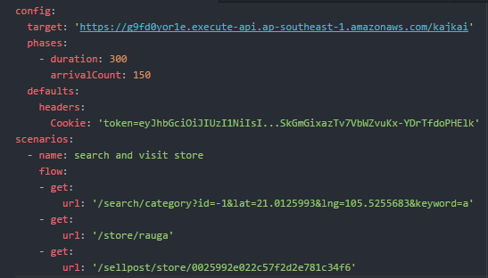

Figure ‑: Artillery configuration for REST API

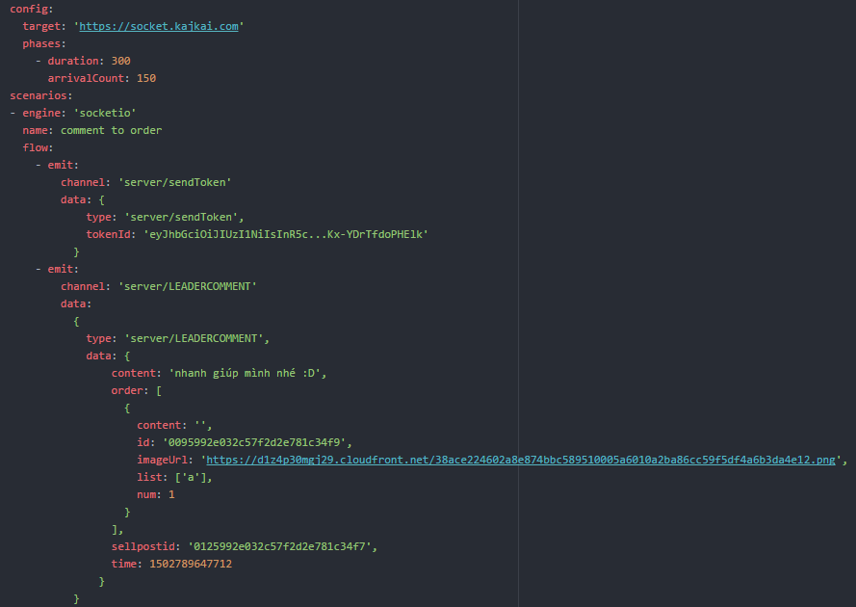

Figure ‑1: Artillery configuration for socket.IO

Then we run the benchmark with commands:





* + - * 1. Benchmark result

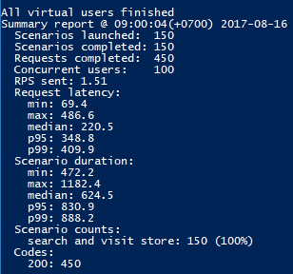

Figure ‑: REST API benchmark result

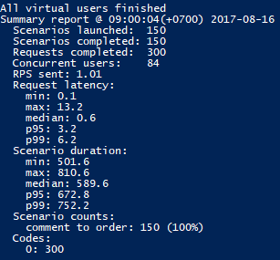

Figure ‑: Socket.IO benchmark result

**The benchmark shows that our system works as expected** as we defined in the first place:

At request latency, the maximum response time is 486.6ms for REST API and 13.2ms for socket.IO

The median response time is 220.5ms for REST API and 0.6ms for socket.IO

The p99 latency is 409.9ms for REST API and 6.2ms for socket.IO (p99 means that 99% of the requests should be faster than given latency)

# : User manual

3. 1. Deployment guidelines
      1. Environment for development

* Apple Macbook with OS Sierra 10.12.5
* HP Laptop with Microsoft Windows 10
* Integrated Development Environment: Atom 1.18.0
* MongoDB Management Tool: Robomongo 1.0
* Git for Windows 2.13.3
  + - 1. Setup development environment
         1. Install Atom

Go to [https://atom.io](https://atom.io/), click on “Download” button to start download the installation file and follow the instruction to install.

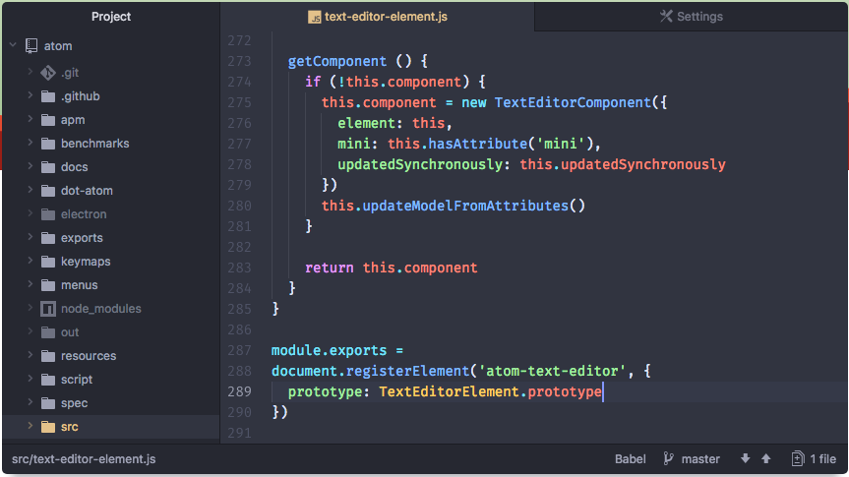

Figure 6‑1: Atom

* + - * 1. Install Robomongo
* Go to https://robomongo.org/download , click on “Download” button to start download the installation file and follow the instruction to install.

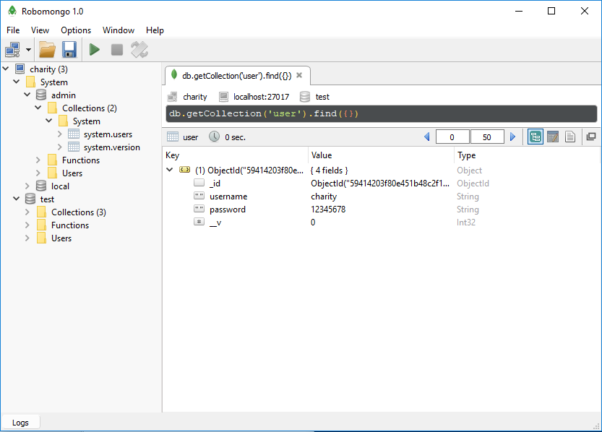

Figure 6‑2: Robomongo

* + - * 1. Install Git for Windows
* Go to https://git-scm.com/download/win to download the installation file and follow the instruction to install.

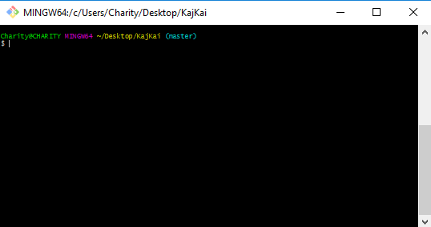

Figure ‑3: Git for Windows

* + - 1. Run tests in development environment

To run all test suites, run the follow command in the source code directory:



* + 1. Environment for deployment
* Ubuntu 16.04 (provided by Amazon EC2) (**KAJKAI Microservices)**
  + KajKai Microservices
  + MongoDB
* Amazon Elasticsearch **(for full-text search feature)**
* Amazon ElastiCache for Redis **(Event Store for microservice architecture)**
* Amazon API Gateway **(routing request to correct KAJKAI microservice)**
* Amazon Application Load Balancer **(for the availability of KAJKAI)**
* Amazon S3 **(KAJKAI Frontend and media storage**)
* Amazon Cloudfront **(HTTPS traffic and caching for lowest latency)**
* Amazon Route 53 **(Domain name registration)**
  + - 1. Setup deployment environment for KAJKAI Backend
         1. Launch new Ubuntu on Amazon Webservice Service (AWS)
* After register an account on AWS, open Amazon EC2 console at https://console.aws.amazon.com/ec2.
* From the console dashboard, choose **Launch Instance**
* Select Ubuntu Server 16.04 as Amazon Machine Image
* Choose suitable **Instance Type**, in this project we will create 4 t2.micro (1 vCPUs, 2.5 GHz, 1 GiB memory) instances: each for 2 – 3 KajKai microservices.
* Finally **Review** and **Launch**
* We will have 4 Amazon EC2 instances like this:

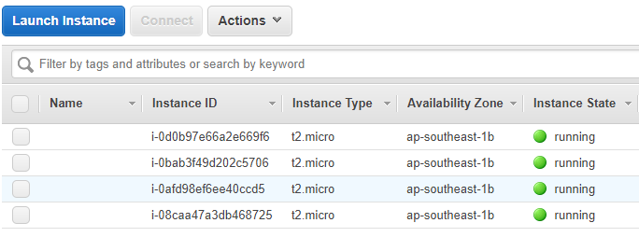

Figure ‑4: Amazon EC2 Instance Dashboard

* + - * 1. Configure MongoDB
* Go to https://docs.mongodb.com/manual/tutorial/install-mongodb-on-ubuntu/, follow the instruction to install and configure MongoDB for Ubuntu.
  + - * 1. Create Amazon Elasticsearch Domain
* After register an account on AWS, open Amazon Elasticsearch console at https://console.aws.amazon.com/es.
* On the **Define domain** page, for **Domain name**, type a name for the domain.
* For **Version**, choose Elasticsearch version 5.3
* Choose suitable **Instance Type**, in this project we will create **1** t2.small.elasticsearch (1 vCPUs, 2.5 GHz, 2 GiB memory) instance with 10G volume.
* Finally **Review** and **Create**.
  + - * 1. Launch Amazon ElastiCache for Redis cluster
* After register an account on AWS, open Amazon ElastiCache console at <https://console.aws.amazon.com/elasticache>.
* Choose **Launch Cluster**.
* For **Cluster engine**, choose **Redis**.
* From the **Engine version compatibility** list, choose 3.2.4.
* In **Port**, accept the default port, 6379.
* Choose suitable **Node Type**, in this project we will create 1 cache.t2.micro.elasticsearch (1 vCPUs, 0.5 GiB memory) instance.
* Finally **Review** and **Create**.
  + - * 1. Create API in Amazon API Gateway
* After register an account on AWS, open Amazon API Gateway console at <https://console.aws.amazon.com/apigateway>.
* Choose **Create API**.
* Under **Create new API**,select **New API** option.
* Name the API and choose **Create API**.
* Create **Resource** and **Method** using **Actions** panel as figure below.
* In this project, we create 2 APIs: kajkai-dev (for development) and kajkai-prod (for production).
* Finally **Deploy API**.

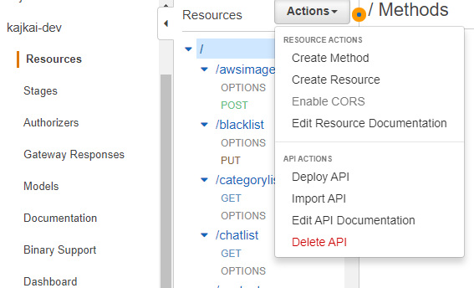

Figure ‑5: Actions panel in Amazon API Gateway

* + - * 1. Create Amazon Application Load Balancer
* After register an account on AWS, open Amazon EC2 console at <https://console.aws.amazon.com/ec2>.
* On the navigation pane, under **LOAD BALANCING**, choose **Load Balancers**.
* Choose **Create Load Balancer**.
* Choose **Application Load Balancer**, and then choose **Continue**.
* For **Name**, type kajkai-alb.
* Choose **NEXT** until **Configure a Target Group**.
* For **Target Group Name**, type kajkai-target-group.
* Choose **NEXT** to configure **Register Targets**.
* In this project, we create kajkai-alb for Socket.IO service, so that we register EC2 instance and corresponding port for Socket.IO as target in kajkai-target-group
* Finally **Review** and **Create**.

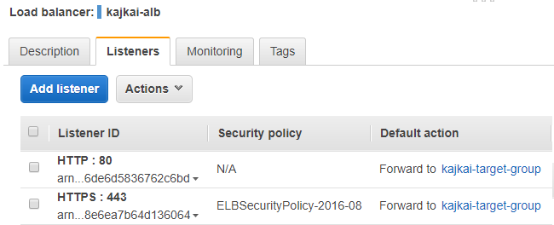

Figure 6-6: Amazon Application Load Balancer Dashboard

* + - 1. Setup deployment environment for KAJKAI Frontend
         1. Create Amazon S3 Bucket
* After register an account on AWS, open Amazon S3 console at <https://console.aws.amazon.com/s3>.
* Choose **Create bucket**.
* Type Bucket name and select Singapore region.
* Click **Next** and accept default settings.
* Finally **Create Bucket.**
* In this project, we create 3 buckets: kajkai-frontend (for KajKai frontend hosting), kajkai-admin (for Admin website hosting), kajkai-media (for media file storing).

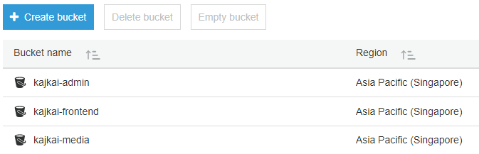

Figure ‑7: Amazon S3 console

* + - * 1. Create Amazon Cloudfront Web Distribution
* After register an account on AWS, open Amazon Cloudfront console at <https://console.aws.amazon.com/cloudfront>.
* Choose **Create Distribution**.
* Under **Web**, choose **Get Started**.
* Choose Amazon S3 bucket for **Origin Domain Name**.
* Select Redirect HTTP to HTTPS under **Viewer Protocol Policy**.
* For **Alternate Domain Names**, type [www.kajkai.com](http://www.kajkai.com) for kajkai-frontend bucket and [admin.kajkai.com](https://d.docs.live.net/609da91d4a96bba8/admin.kajkai.com) for kajkai-admin bucket.
* In this project, we create 2 Web Distributions for [www.kajkai.com](http://www.kajkai.com) and [admin.kajkai.com](https://d.docs.live.net/609da91d4a96bba8/admin.kajkai.com).

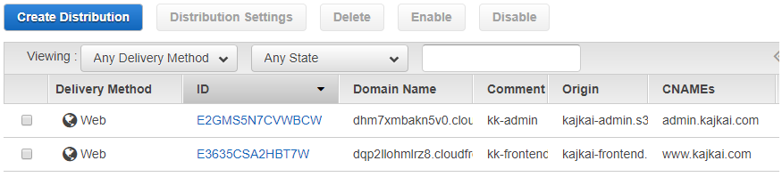

Figure ‑8: Amazon Cloudfront console

* + - * 1. Register Domain name using Amazon Route 53
* After register an account on AWS, open Amazon Cloudfront console at <https://console.aws.amazon.com/route53>.
* Choose **Register Domain**.
* Under **Choose a domain name**, type kajkai.com.
* Choose **Continue**, fill in contact detail.
* **Review** and **Purchase** to register the domain.
* Then go to **Hosted zone**, choose kajkai.com
* Choose **Create Record Set**, enter subdomain and alias.
* Choose **Save Record Set** to create the 3 subdomains.
* In this project, we use 2 aliases from 2 Amazon Cloudfront Web Distributionin the section above and 1 alias from the socket.io server to create 3 subdomains: www.kajkai.com, admin.kajkai.com, socket.kajkai.com.
  1. User guidelines
     1. Guest
        1. Homepage
        2. User accesses website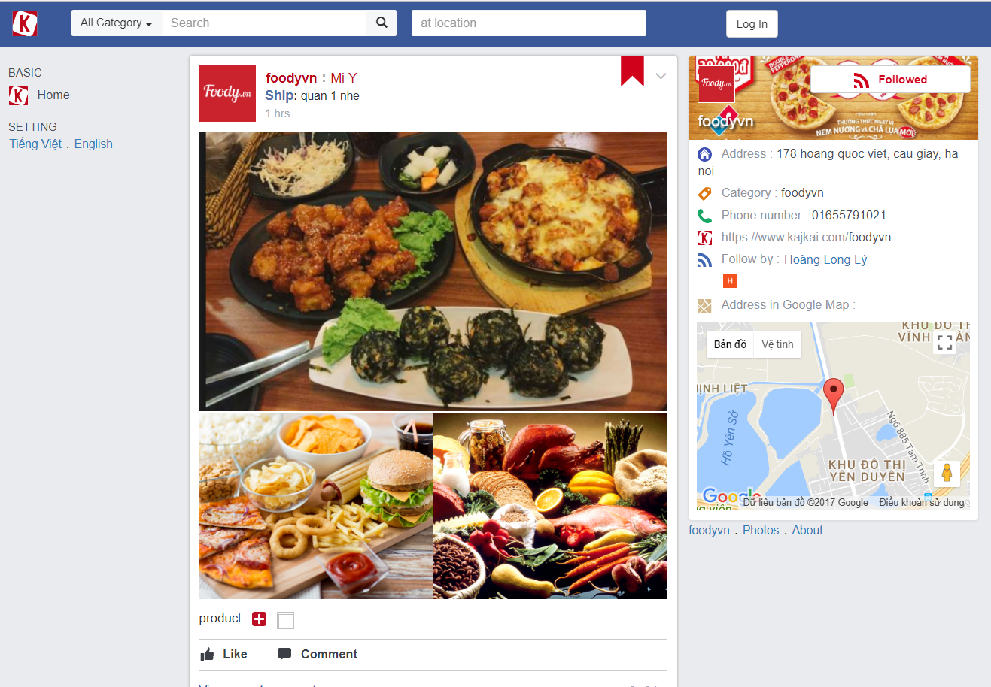
        3. Search

On navigator, guest selects category and location then press Enter



Search results are displayed.

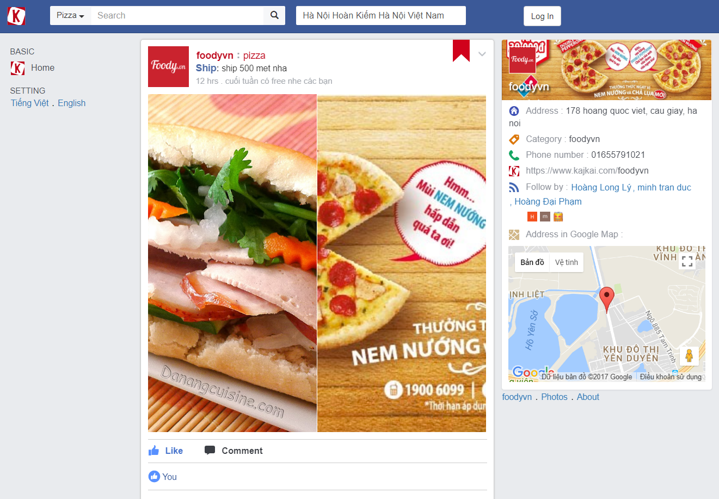

* + - 1. Login

1. On navigator, guest clicks Log In button
2. Login page is displayed. Guest clicks Facebook button in order to login by Facebook account

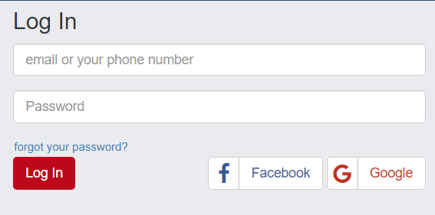

1. Facebook login popup is displayed. Guest fills valid account then clicks Login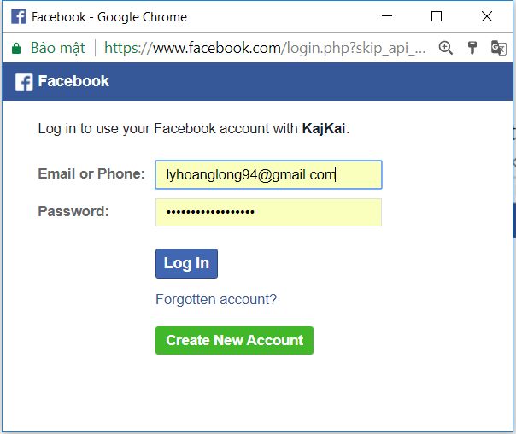
2. User page is displayed after login successfully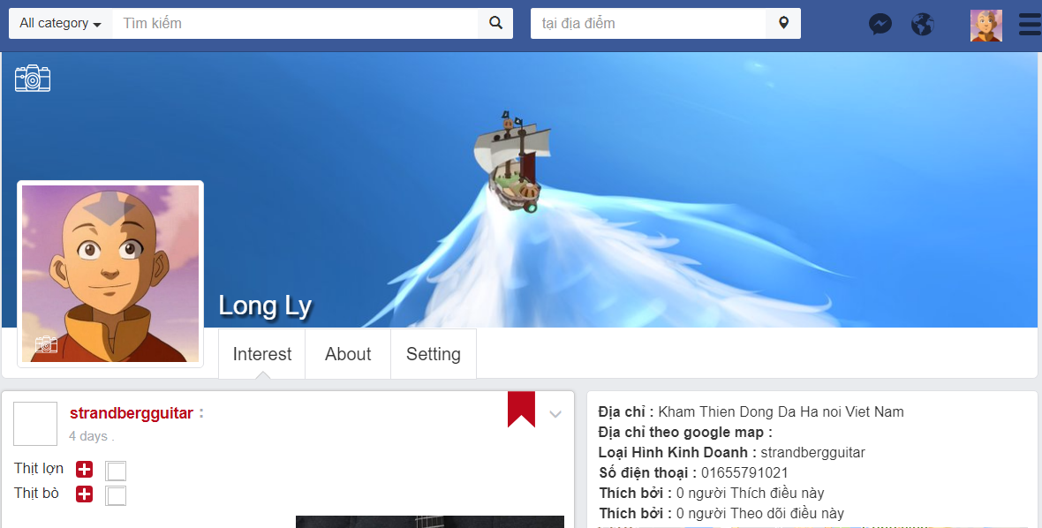
   * 1. User
        1. Update user profile information
3. In navigation bar, user clicks avatar icon to open user page
4. User page is displayed. User clicks Setting page to edit profile information

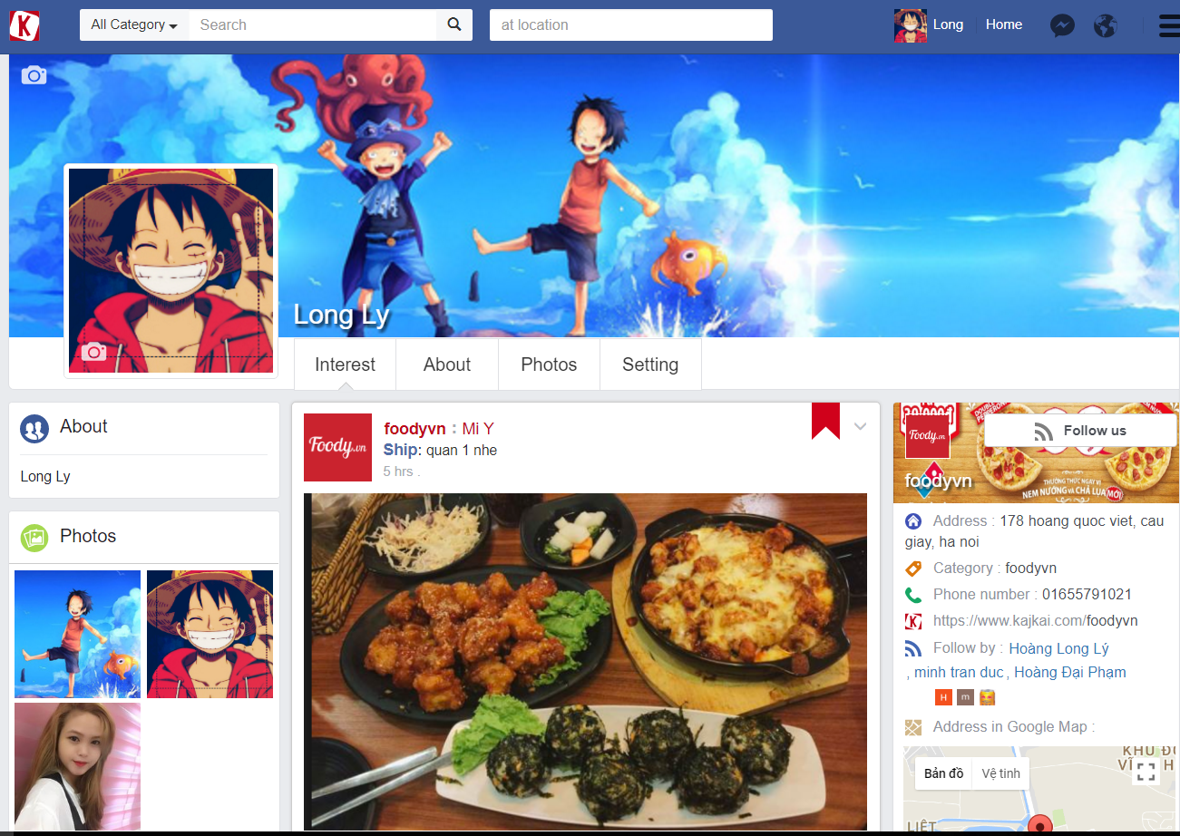

1. Setting tab is displayed. User clicks Edit button in corresponding row to edit profile information

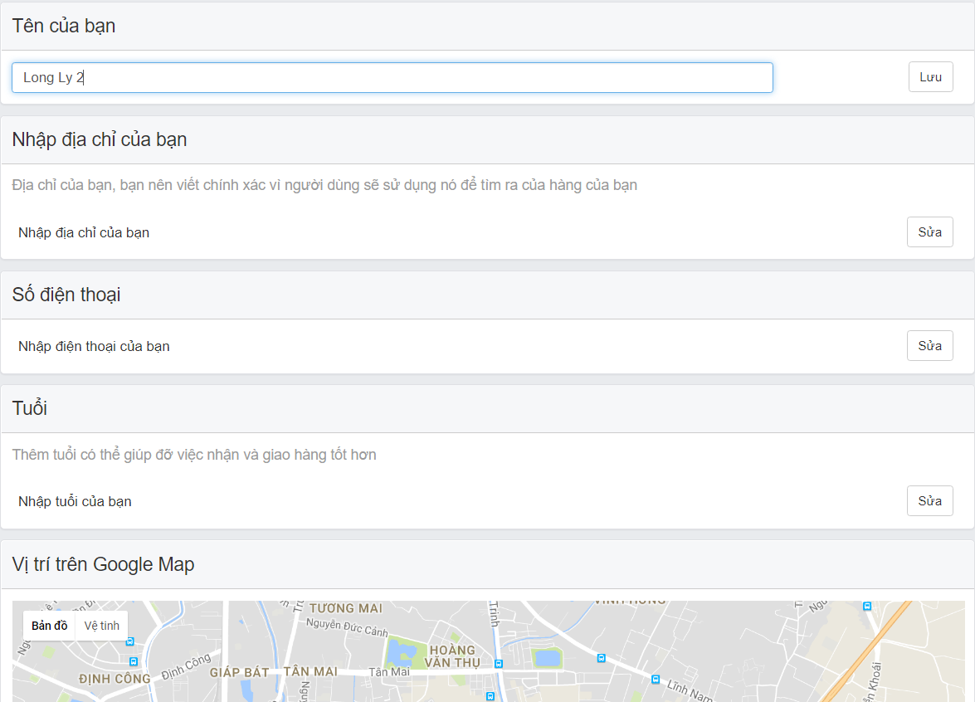

* + - 1. Create new store

1. In navigator, user clicks option icon then select “Create new store”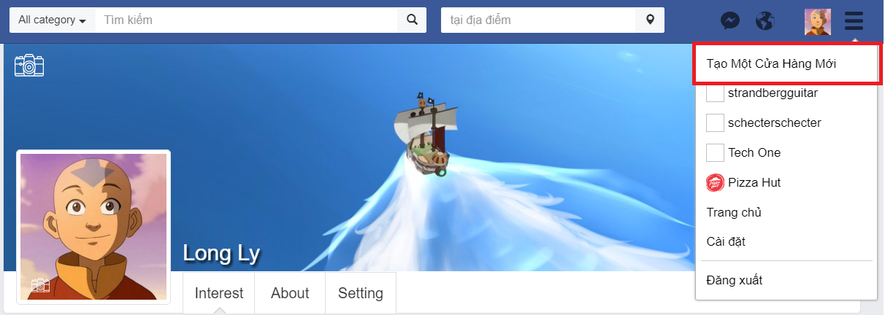
2. Store register form is displayed. User fills valid information then submit by clicking “Create New Store” button

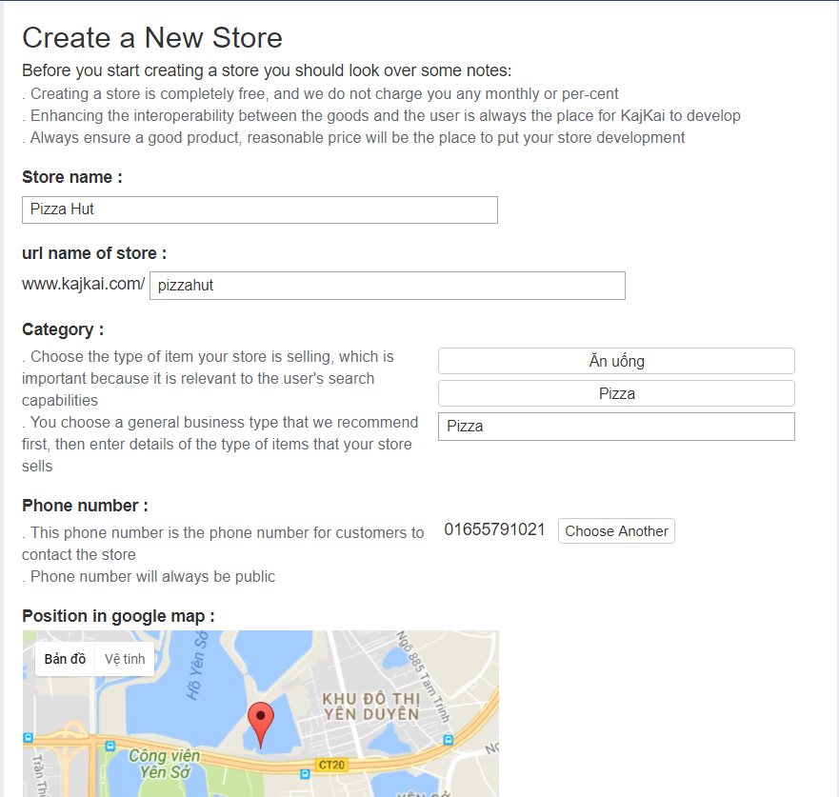

1. New store is displayed. 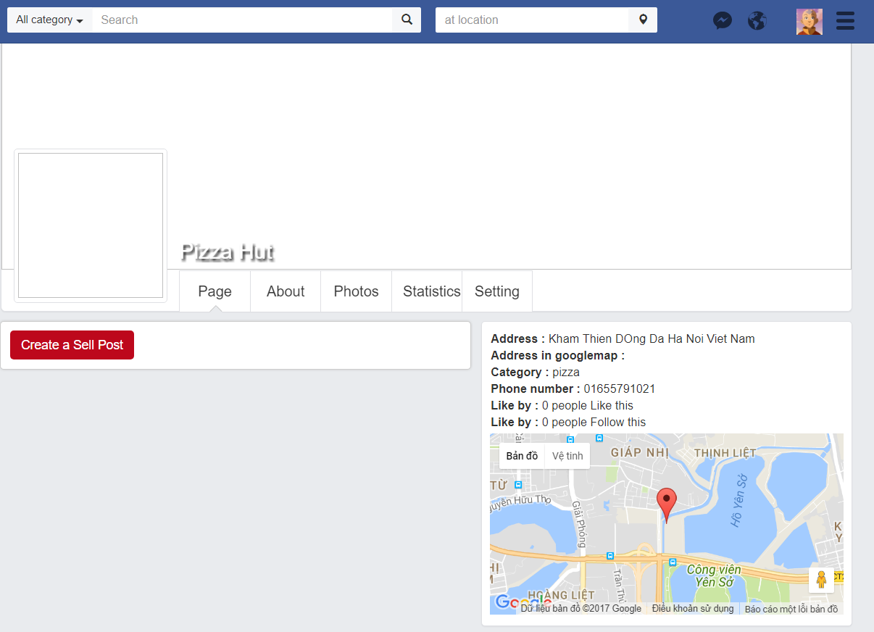
2. User is allowed to customize store interface and information by changing avatar, cover and store setting

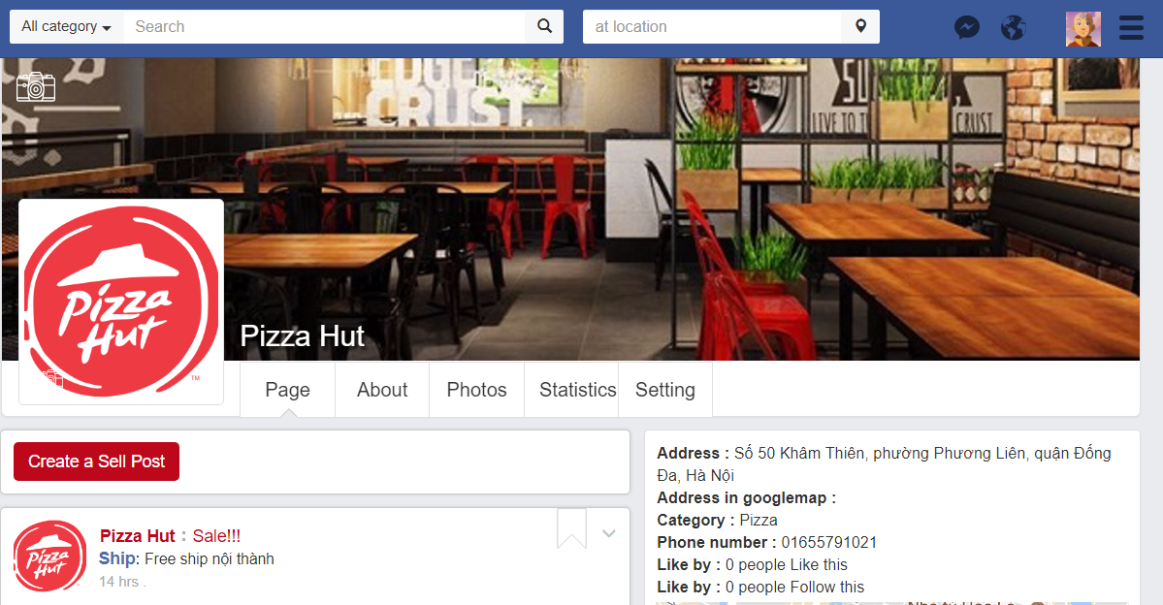

* + - 1. Make an order

1. Open a store as a visitor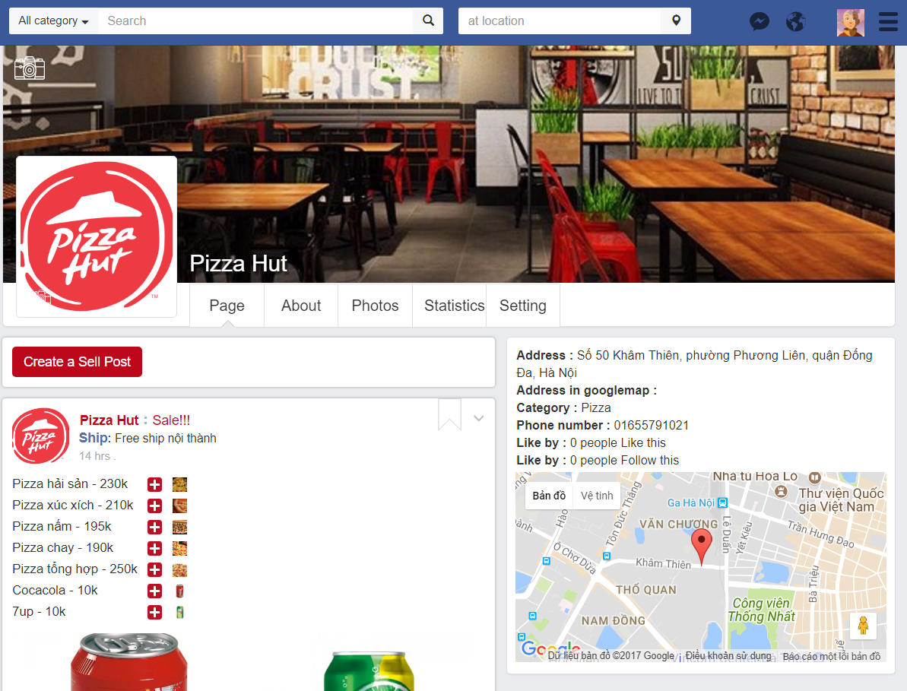
2. Scroll down to an interested sellpost

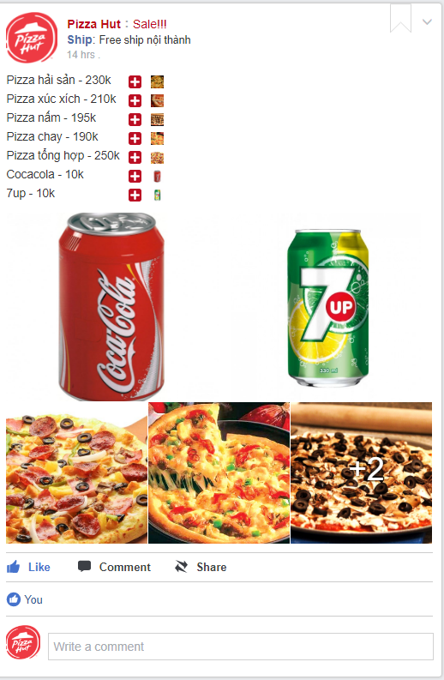

1. Click on plus icon next by product to add to list. Click on minus icon to remove from list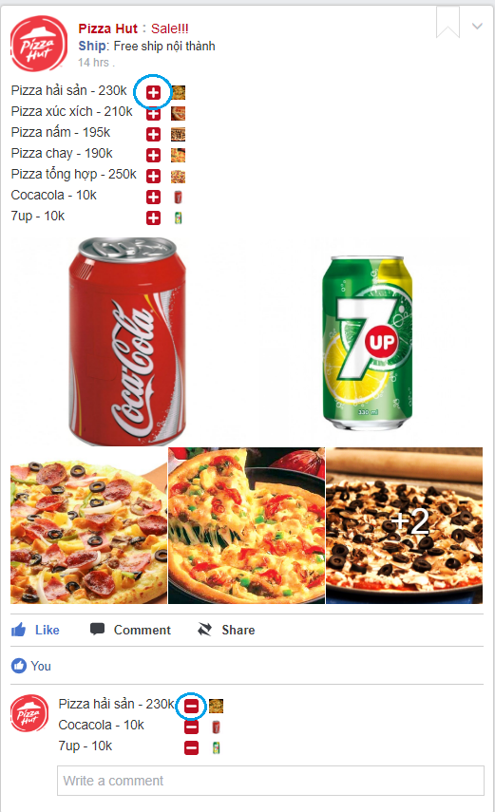
2. Buyer can optionally comment on this order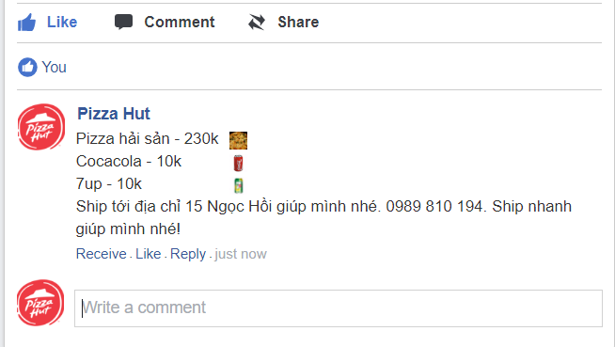
3. Buyer receives notification when seller receives an order

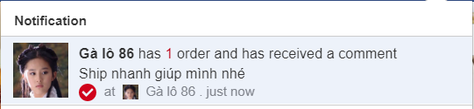

1. Buyer is allowed to interact more with seller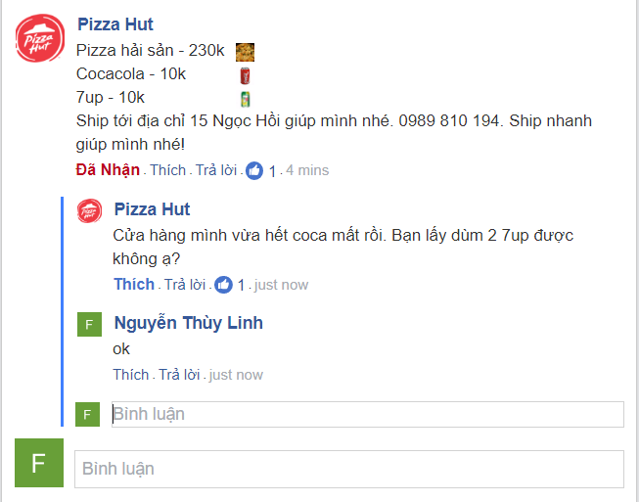
   * 1. Seller
        1. Create new sellpost
2. On existed store, seller clicks “Create a Sellpost” to create new sellpost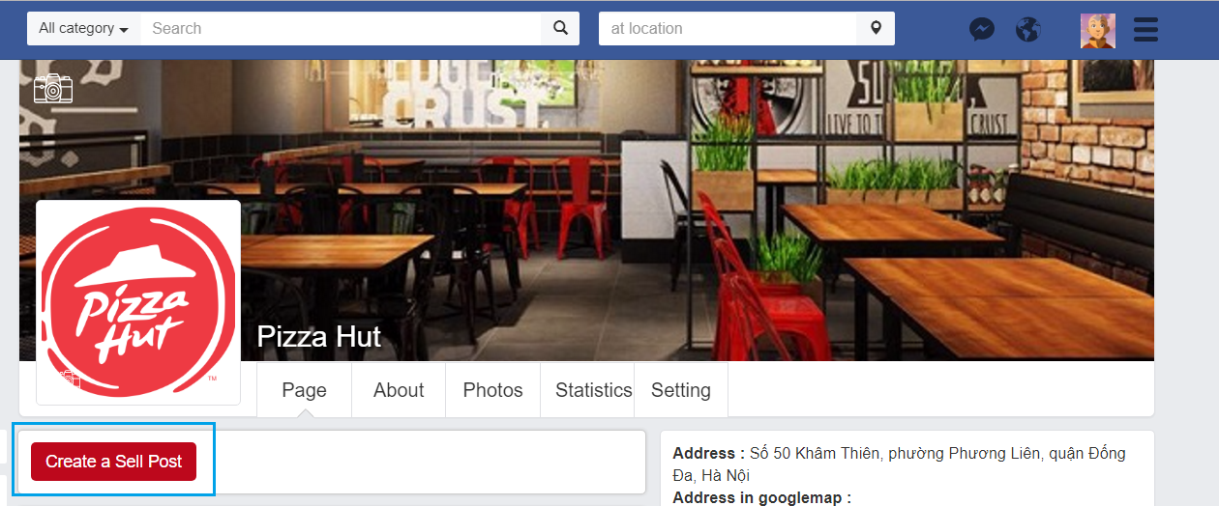
3. Sellpost creator is displayed. Seller clicks “Add new content” to create post’s layout and add product

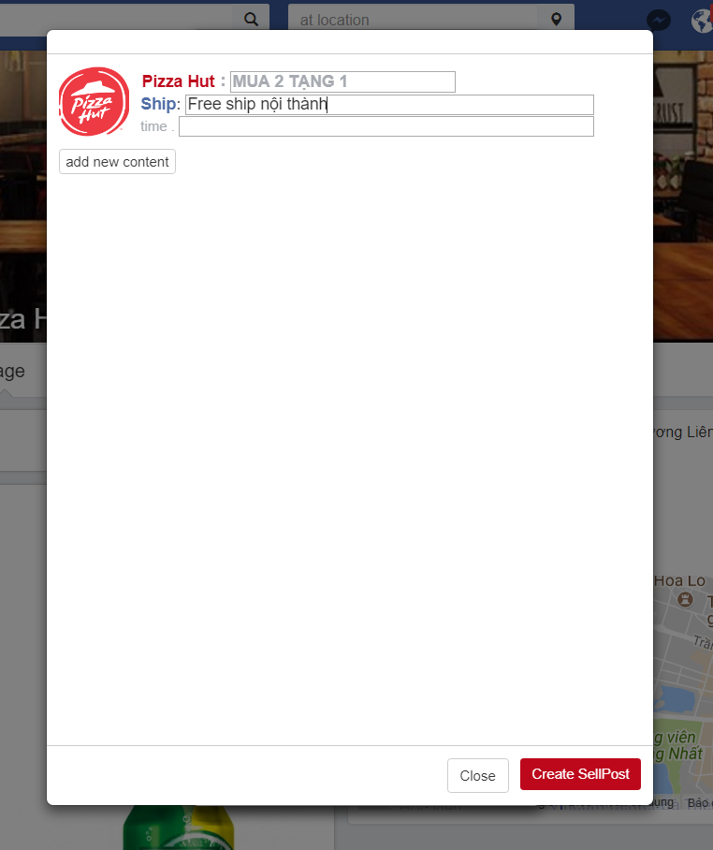

1. Layout list is displayed. There are some difference layouts that allows seller to create an attractive sellpost

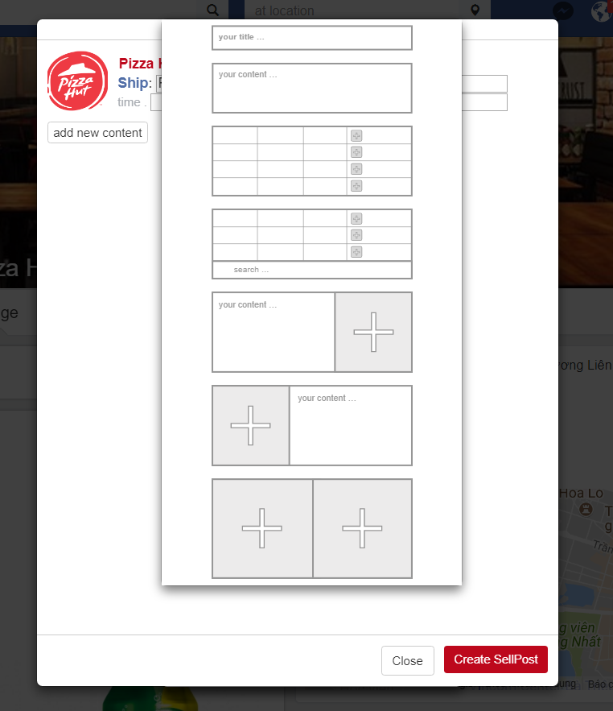

1. After selecting a layout, seller fills all needed information such as product, demonstration product image, price and so on

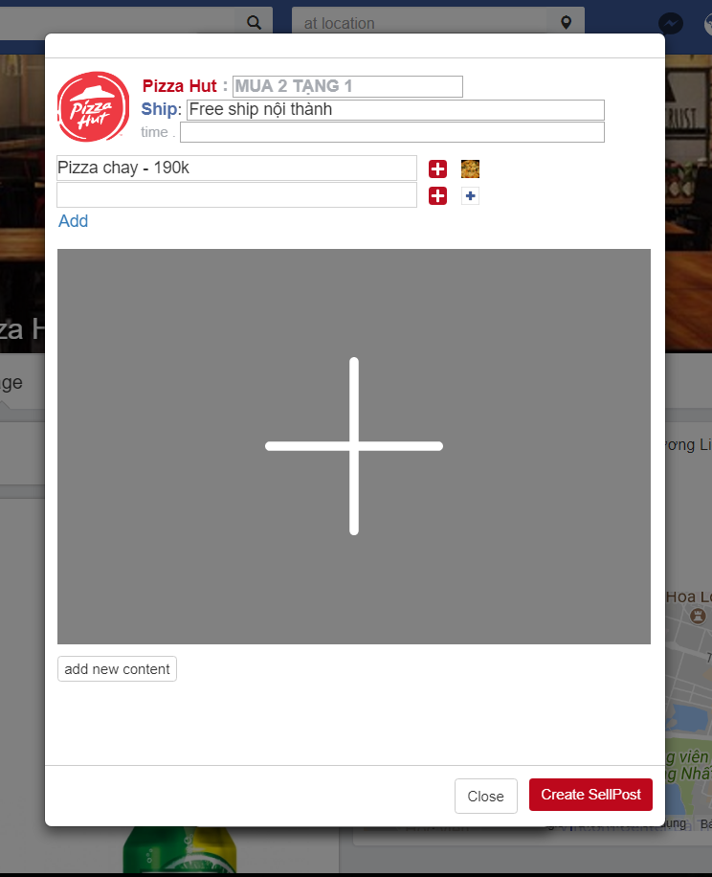

1. Click “Create Sellpost” after customizing the sellpost. Now the sellpost is public and ready for order



* + - 1. Process an order

1. Seller receives notification whenever buyer make an order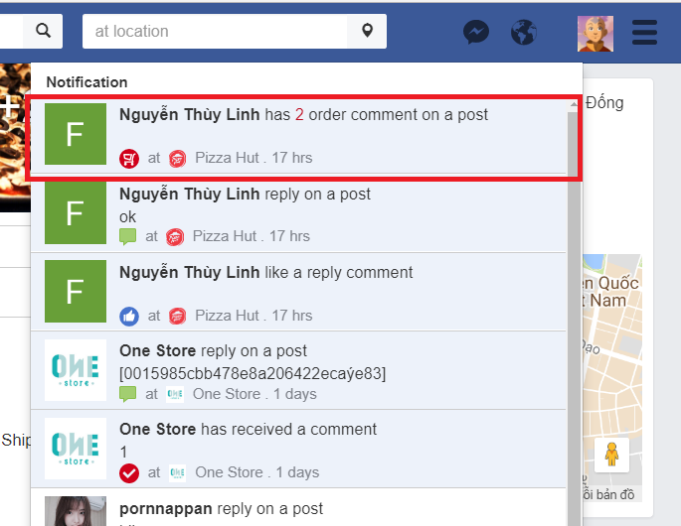
2. Seller clicks notification to view order in details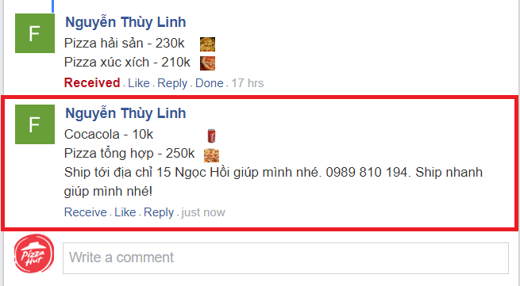
3. Seller clicks Receive button to notice buyer that this order is accepted by seller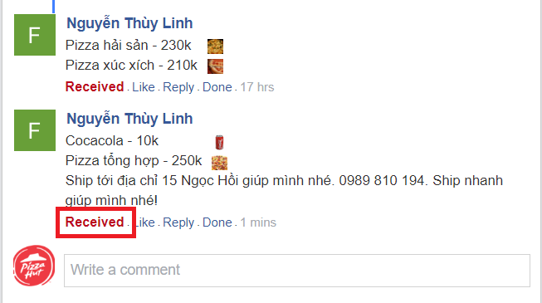
4. Buyer receives notification that seller has received this order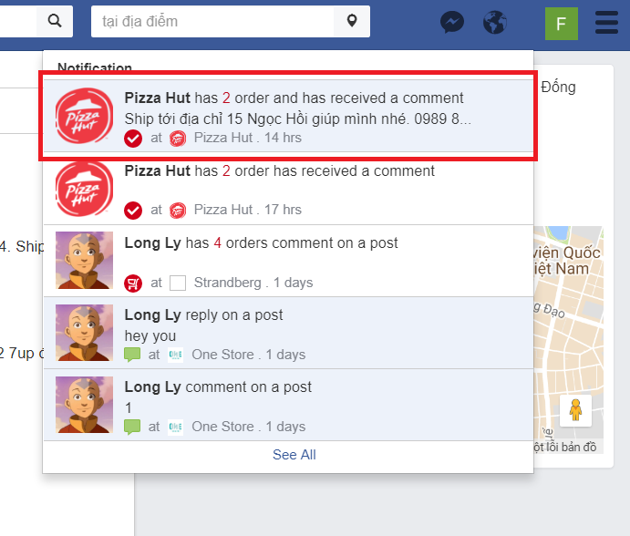
5. After shipper deliveries successfully, seller marks the order as Done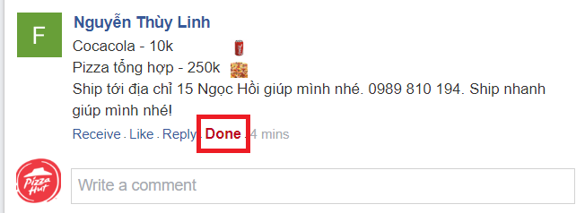
   * + 1. Manage store
6. Right panel is store management panel with undone order list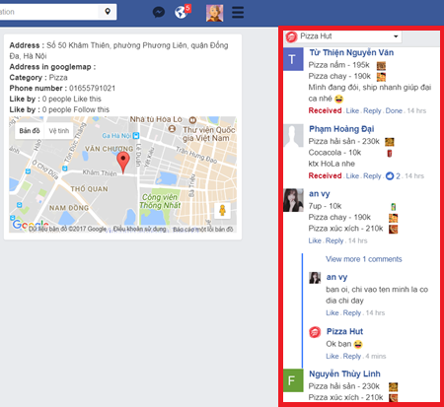
7. Seller is allowed to switch among many stores by clicking on store list button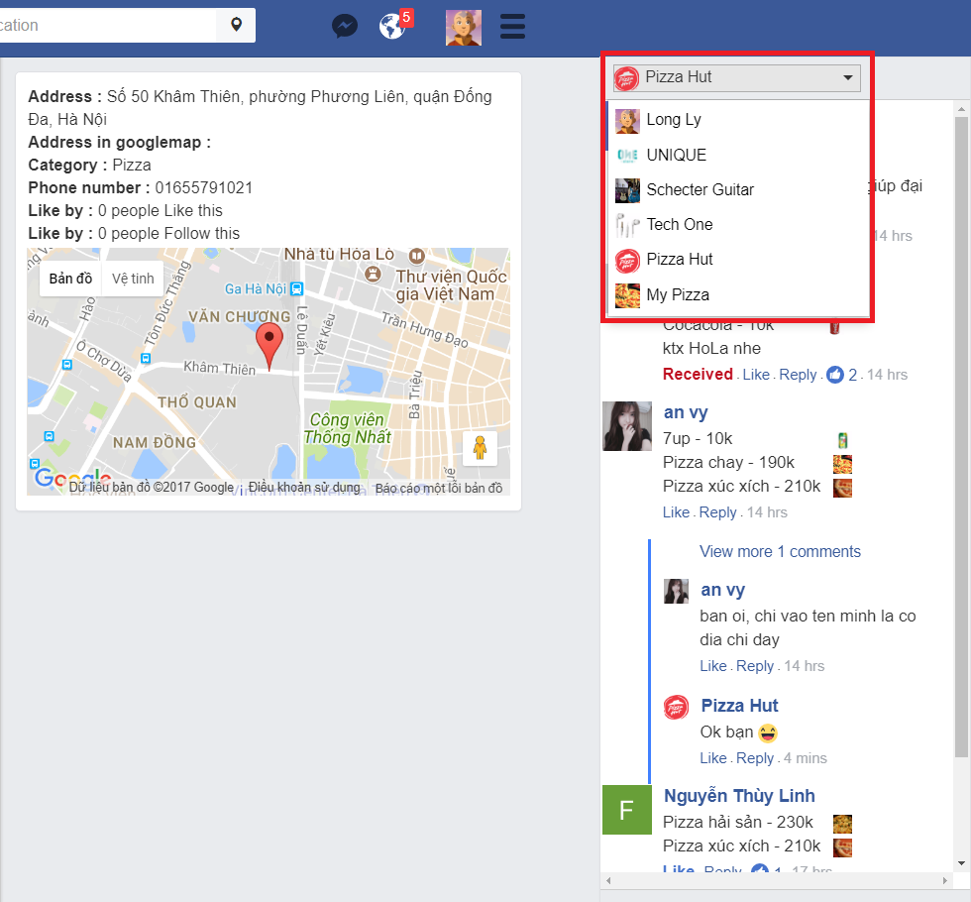
   * 1. Admin
        1. Manage feedback
8. Admin opens Dashboard/New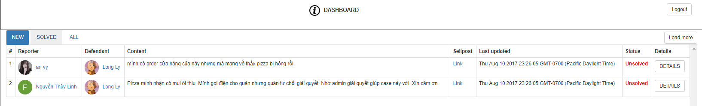
9. To read more information and make decision, admin clicks Details button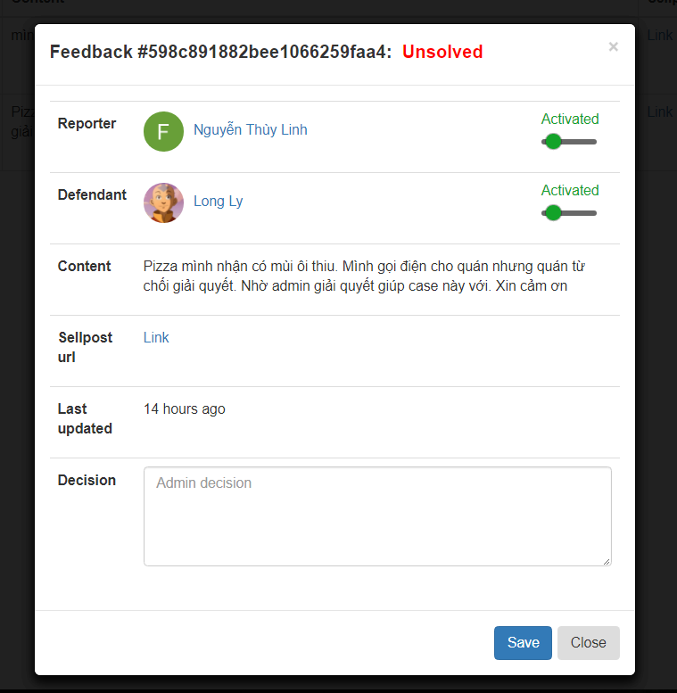
10. Admin is allowed to change user permission after making decision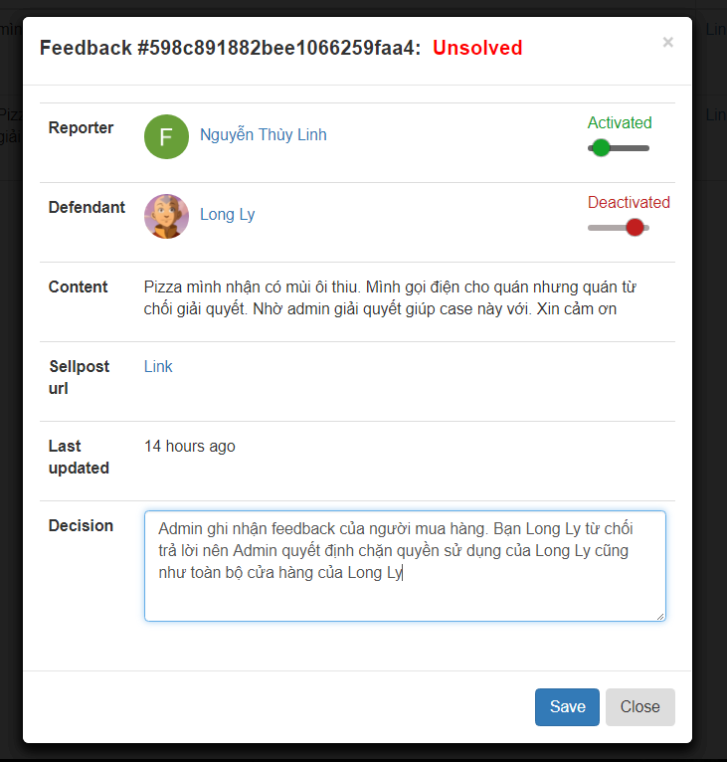
    * + 1. Manage user
11. Admin opens User tab

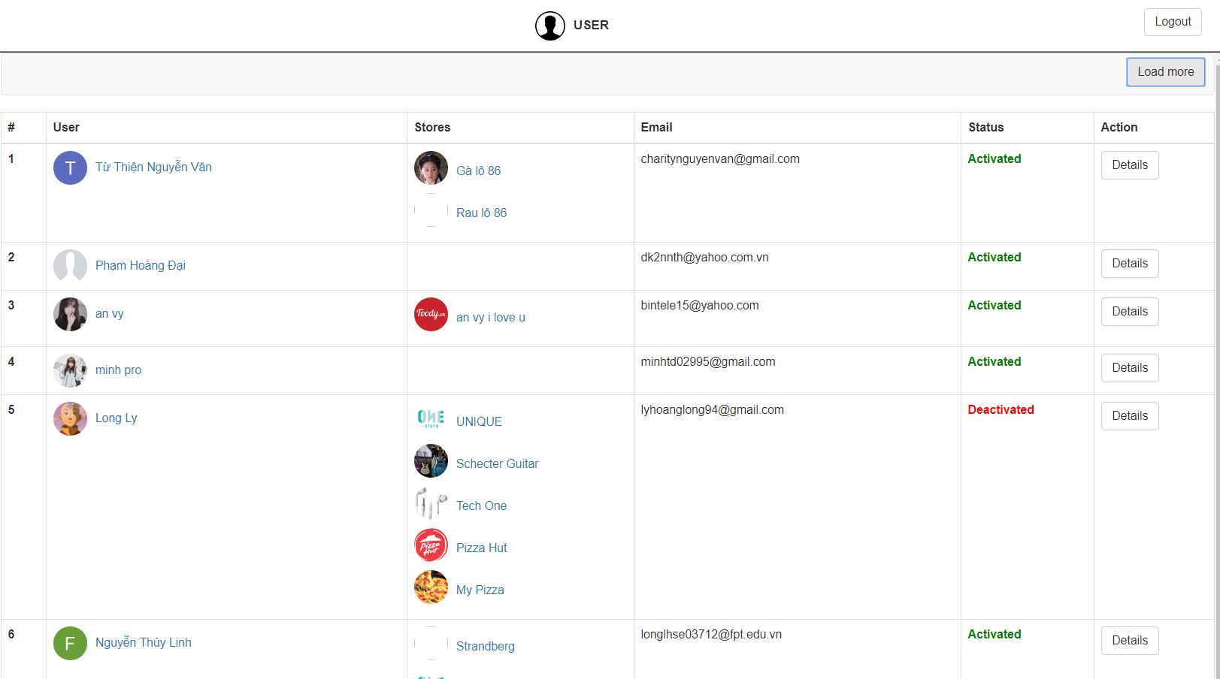

1. To read more details about a user and change user’s permission, admin clicks Details button

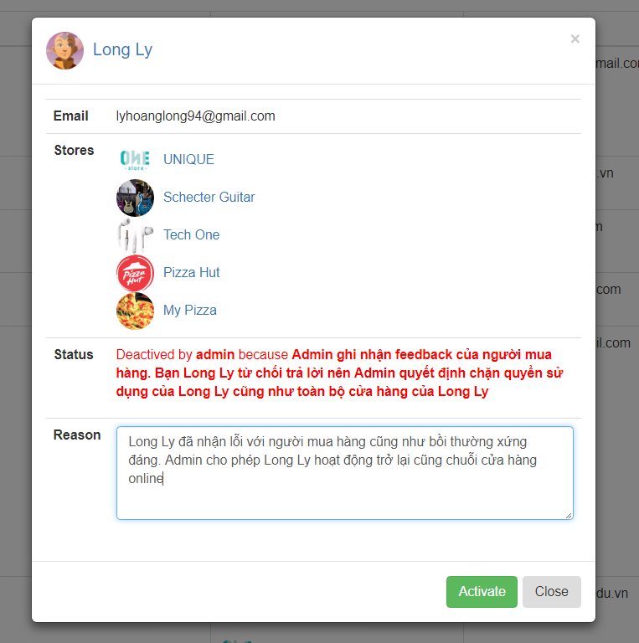

1. Google Map API: <https://developers.google.com/maps/documentation/javascript>
2. Sign a S3 URL: [http://docs.aws.amazon.com/AWSJavaScriptSDK/latest/AWS/S3.html#getSignedUrl-property](http://docs.aws.amazon.com/AWSJavaScriptSDK/latest/AWS/S3.html%23getSignedUrl-property):
3. OAuth 2.0 for Client: <https://developers.google.com/identity/protocols/OAuth2UserAgent>
4. Facebook Login for Client: <https://developers.facebook.com/docs/facebook-login/web/login-button>
5. OAuth 2.0 for Backend: <https://developers.google.com/identity/sign-in/ios/backend-auth>
6. Facebook Login for Backend: <https://developers.facebook.com/docs/facebook-login/web/accesstokens>
7. Twilio: <https://www.twilio.com/docs/quickstart/node/programmable-sms>
8. gmail-send library: <https://www.npmjs.com/package/gmail-send>
9. Mocha main page: <https://mochajs.org>
10. Chai assertion library main page: <http://chaijs.com>
11. Chai as promised project: <https://github.com/domenic/chai-as-promised>
12. SuperTest project: <https://github.com/visionmedia/supertest>
13. SuperAgent main page: <http://visionmedia.github.io/superagent>
14. Istanbul main page: <https://istanbul.js.org>
15. Nyc project: <https://github.com/istanbuljs/nyc>
16. https://artillery.io